# Normal distribution

## Plotting the distribution

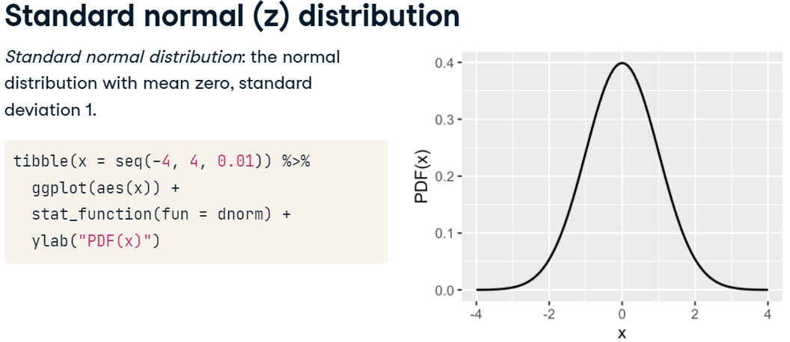

## Estimating parameters

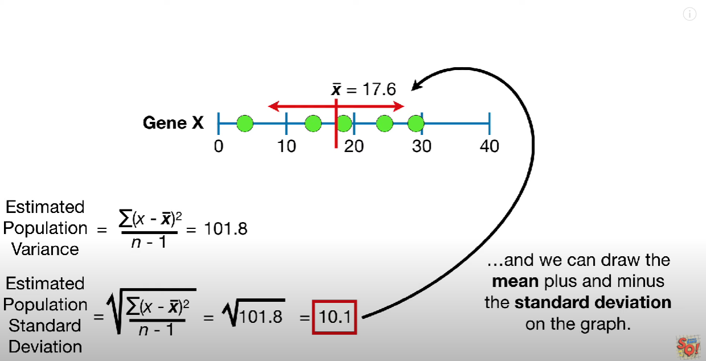

But we can use bootstrap to estimate parameters if we want to confirmate the SD.

# Other continuous distributions

## Exponential distribution

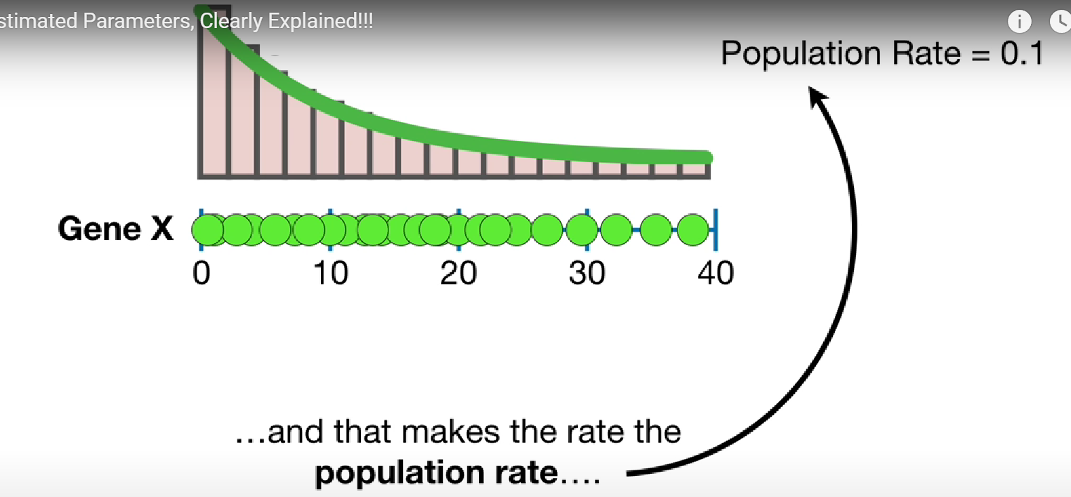

## Gamma distribution

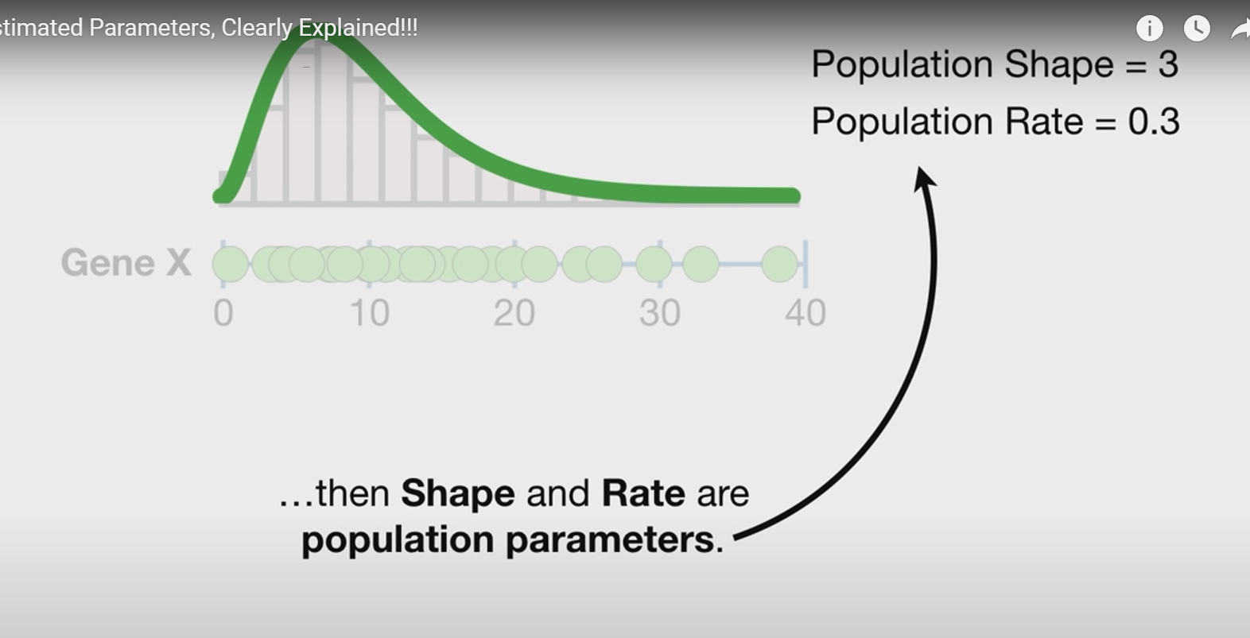

# Binomial distribution

## Calculo de parámetros

### Cálculos por formula o simulación

|  |  |
| --- | --- |
|  |  |

### Propiedades

|  |  |
| --- | --- |
|  |  |

## Densidad de un número

|  |  |
| --- | --- |
|  |  |

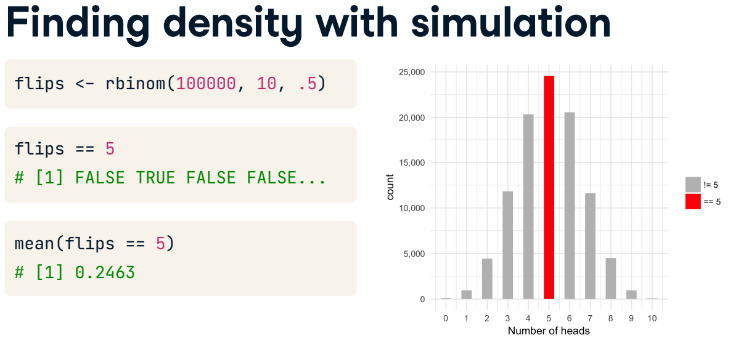

## Probabilidad acumulada

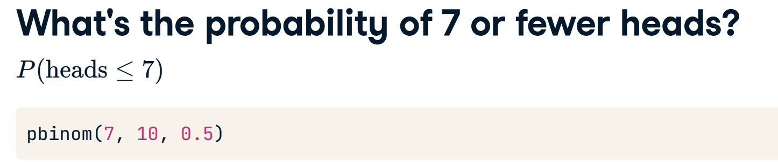

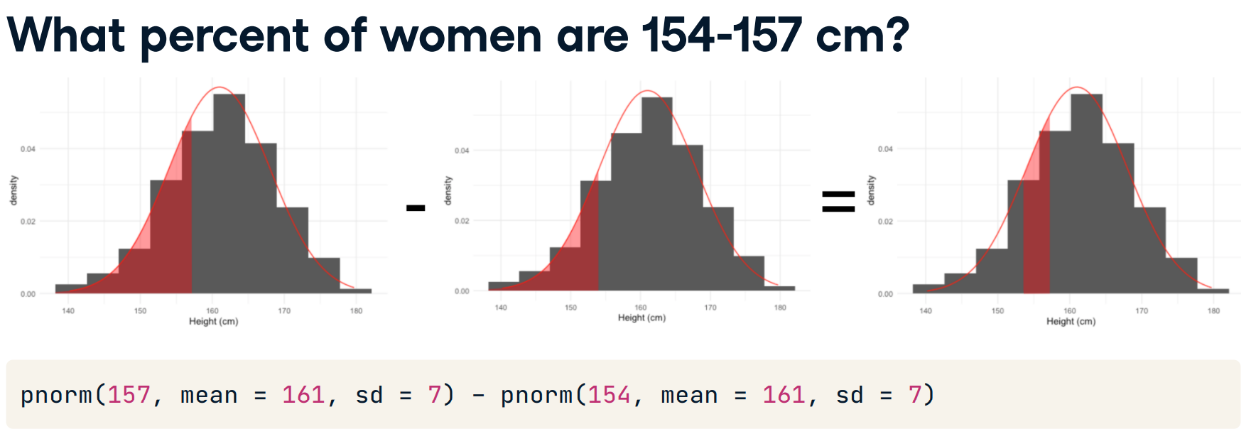

## Simulación de probabilidad de varios eventos

|  |  |
| --- | --- |
|  |  |

|  |  |
| --- | --- |
|  |  |

## Bayes theorem

Asumimos que es poco probable que la modena este bisiada, es decir, un **10%.**

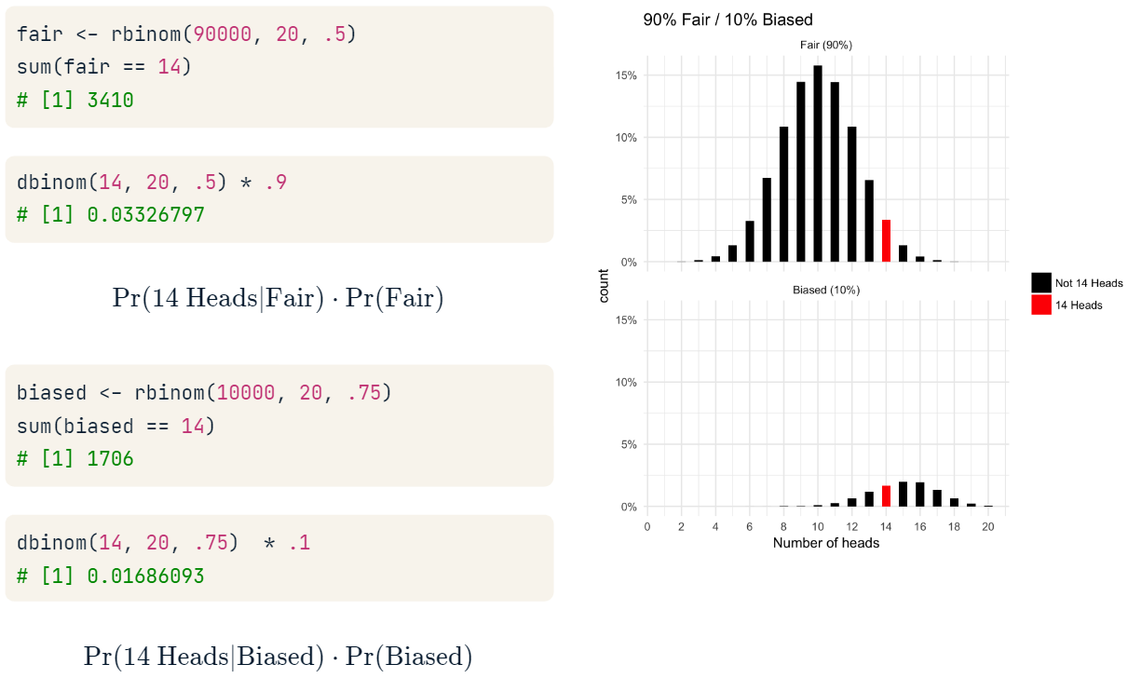

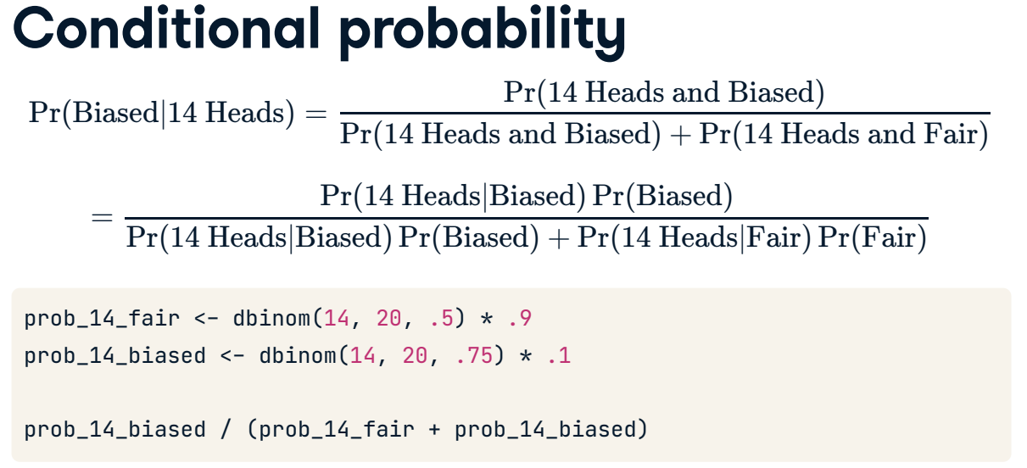

## Aproximación a la distribución normal

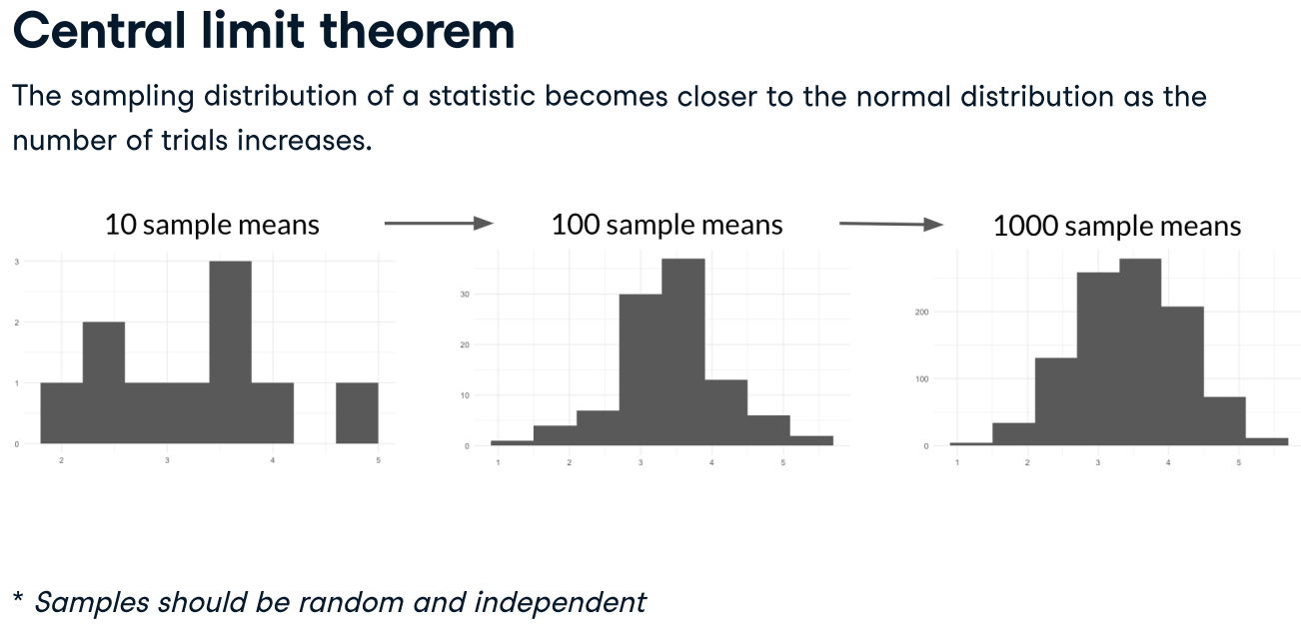



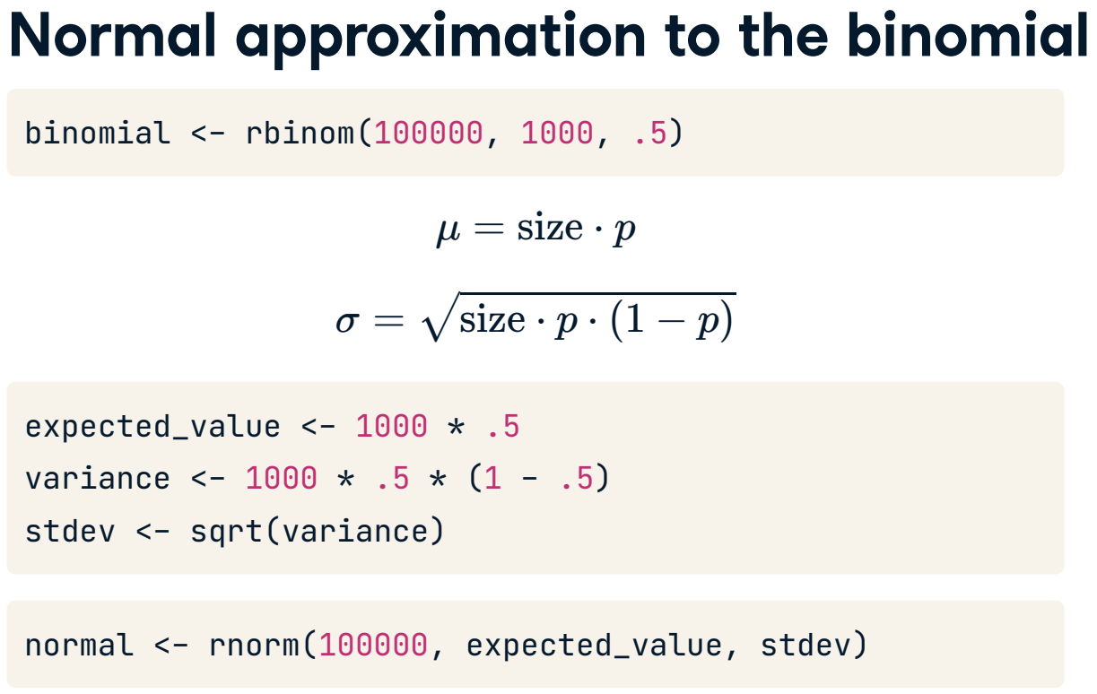

## Aproximación a distribución de Poisson

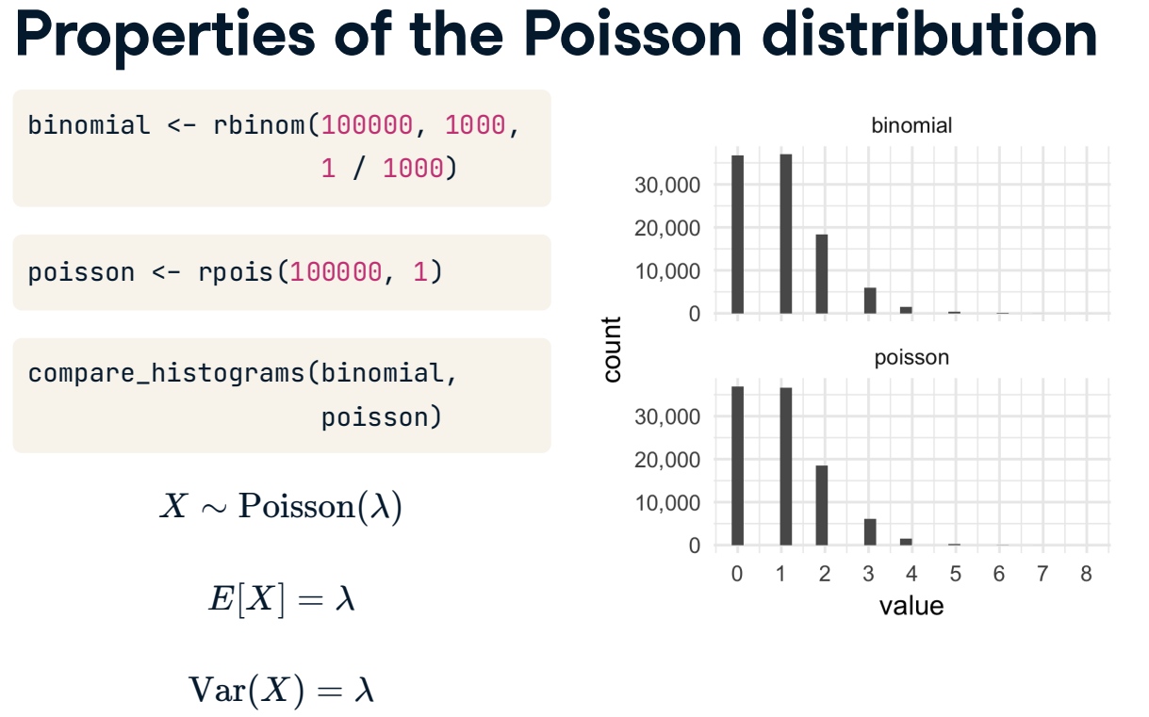

$λ=size*p$

### Aproximación a distribución exponencial

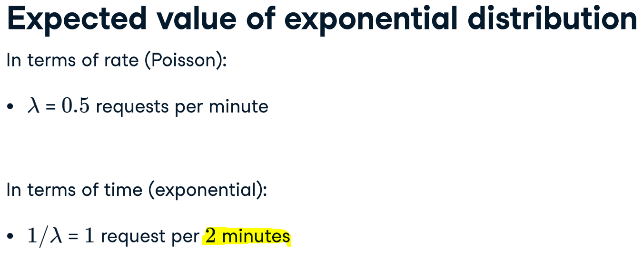

## Aproximación a la distribución geométrica

Esta distribución cuenta la cantidad de intentos necesarios para obtener un éxito.

### Simulación con rbim

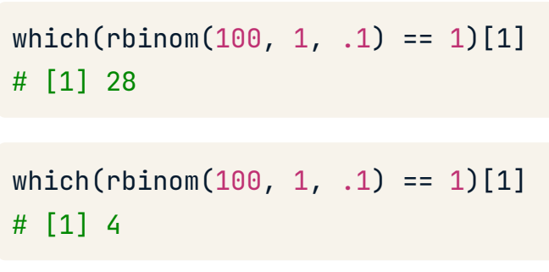

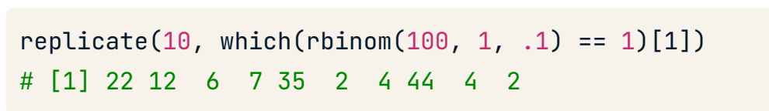

### Simulación con rgeom

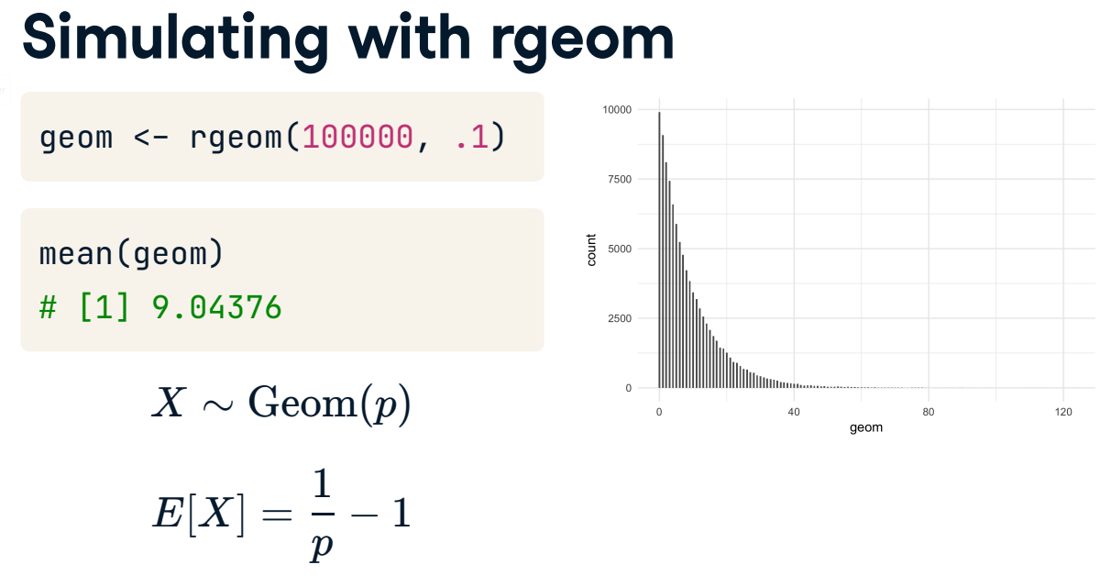

# Experiment Design

## Key components

* **Randomization:**  helps spread any variability that exists naturally between subjects evenly across groups.
* **Replication:** means you need to conduct an experiment with an adequate number of subjects to achieve an acceptable statistical power.

count(supp,dose, .drop = TRUE)

* **Blocking:** We take in account the effect of a blocked variable. We added as an extra X variable.

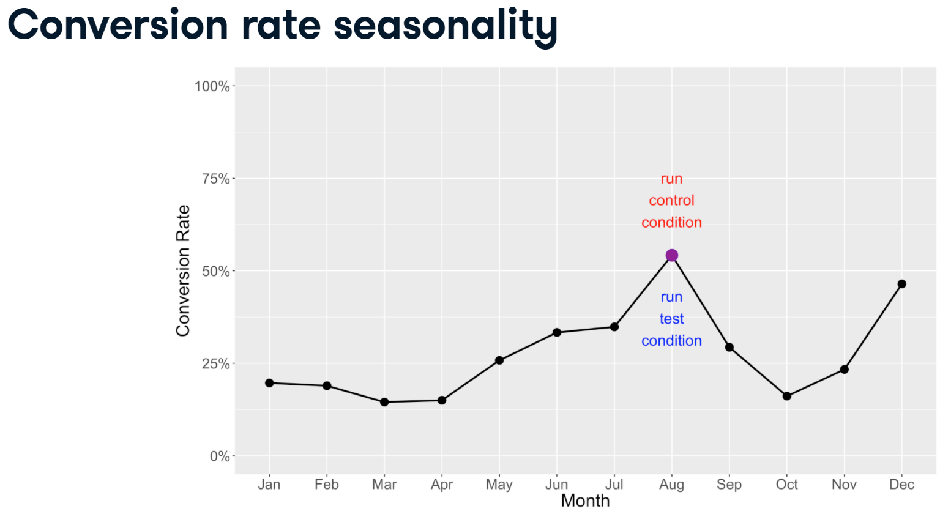

***Running both conditions simultaneously*** is best because they are exposed to the same seasonal and other variables. Waiting a year would require too much time to analyze your experiment, and a lot of other variables can change in a year!

## Hypothesis creation

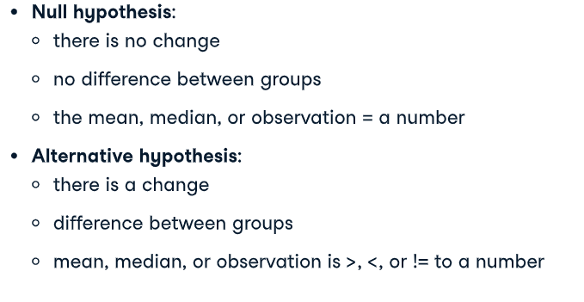



## Test assumptions

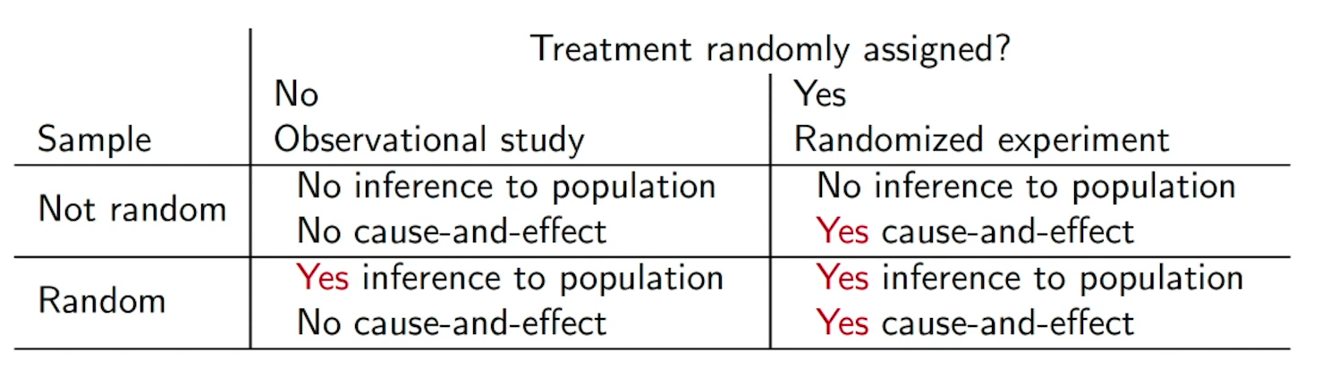

### Randomness

Whether it uses one or two samples, every hypothesis test assumes that each sample is randomly sourced from its population.

### Each observation is independent

Tests also assume that each observation is independent. There are some special cases like *paired t-tests* where dependencies between two samples are allowed.

### T-test or ANOVA

1. You can't compensate for one small group sample by making the other one bigger.
2. Each group should be normal. We can checked with **shapiro.test()**
3. We can test for homogeneity of variances using **bartlett.test(),** which takes a formula and a dataset as inputs.

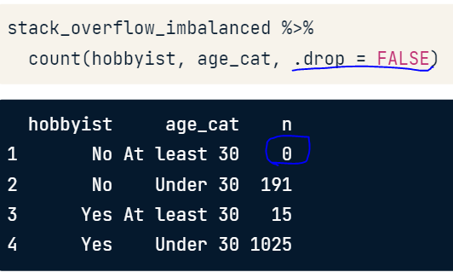

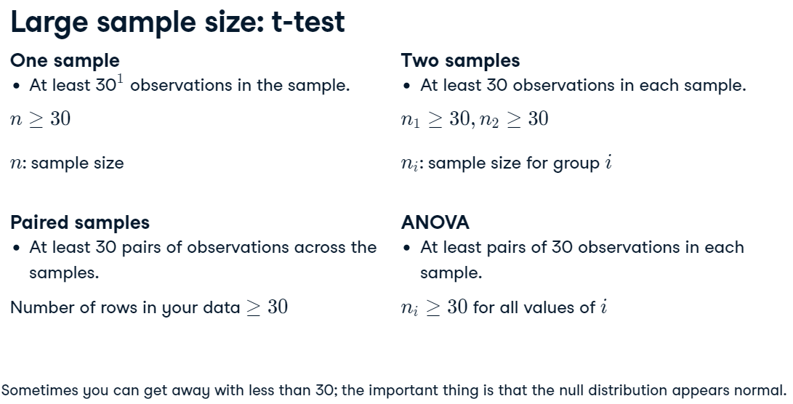

### Proportion tests

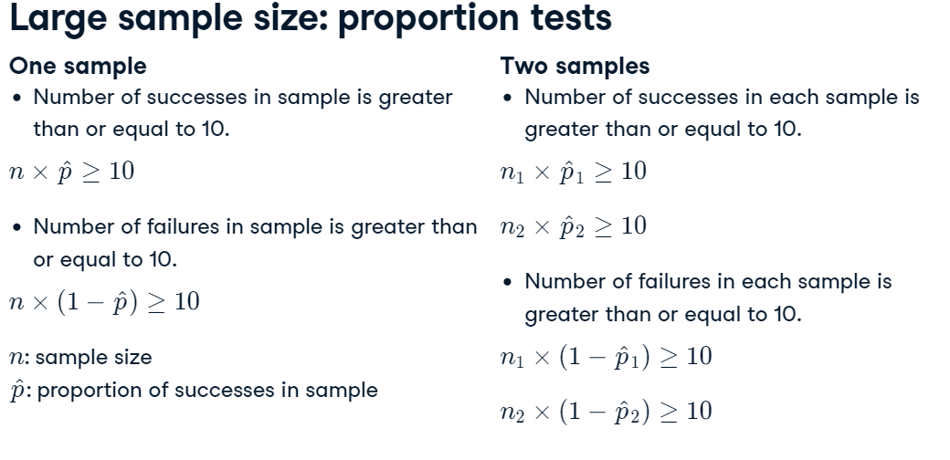

### Chi-square test

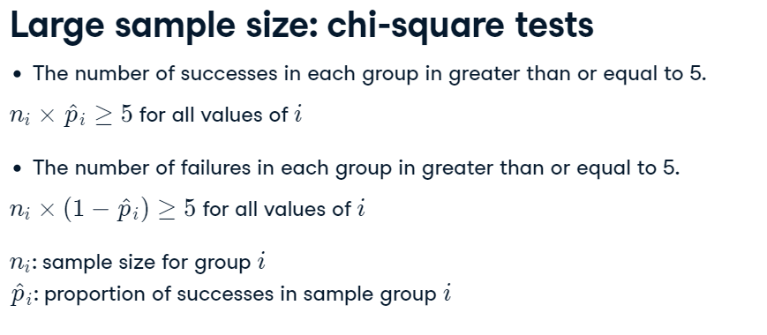

## Applying test

### One sample continues variable

#### The graphic way

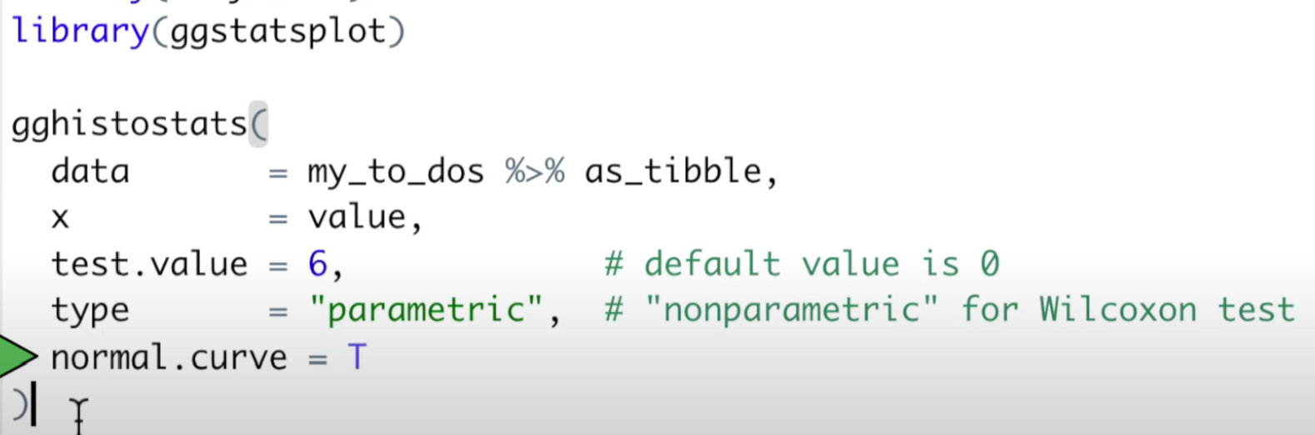

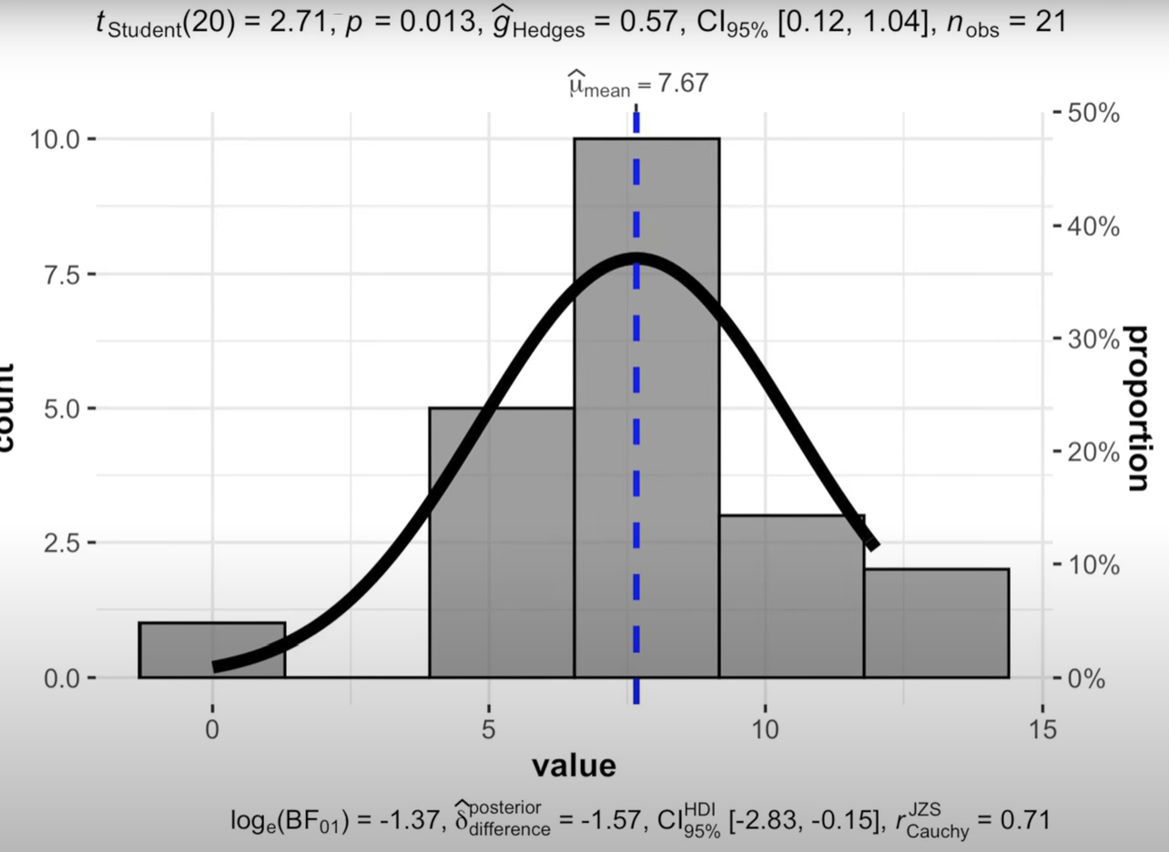

#### Manual (bootstrap) way

1. Getting a bootstrap distribution of mean

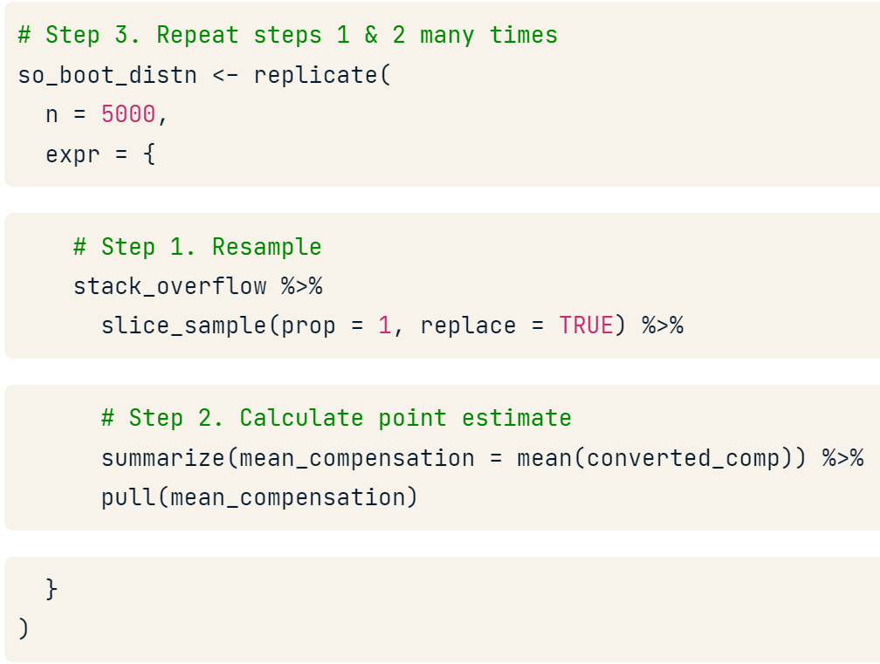

1. Getting the standard error

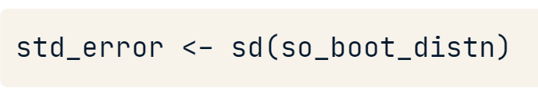

1. Normalize the values

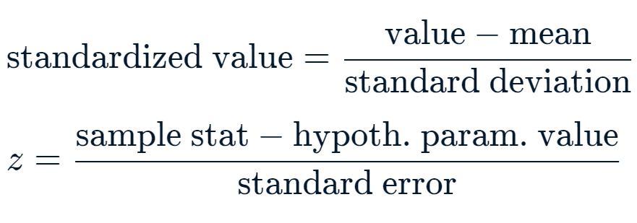

1. Get the p-value (integrate the normalized curve of the null hypothesis)

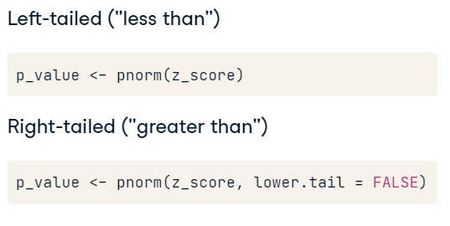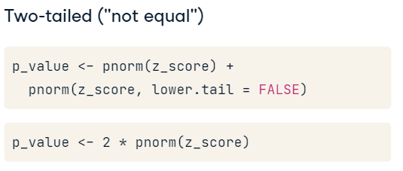

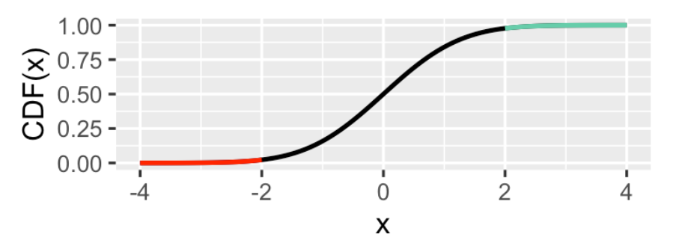

1. Make a conclusion

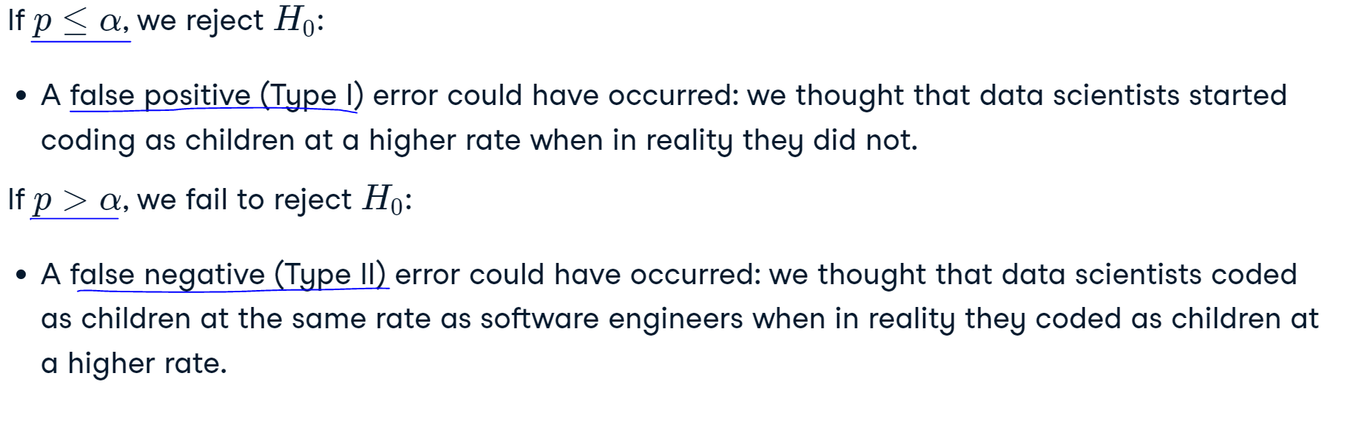

### One sample proportion

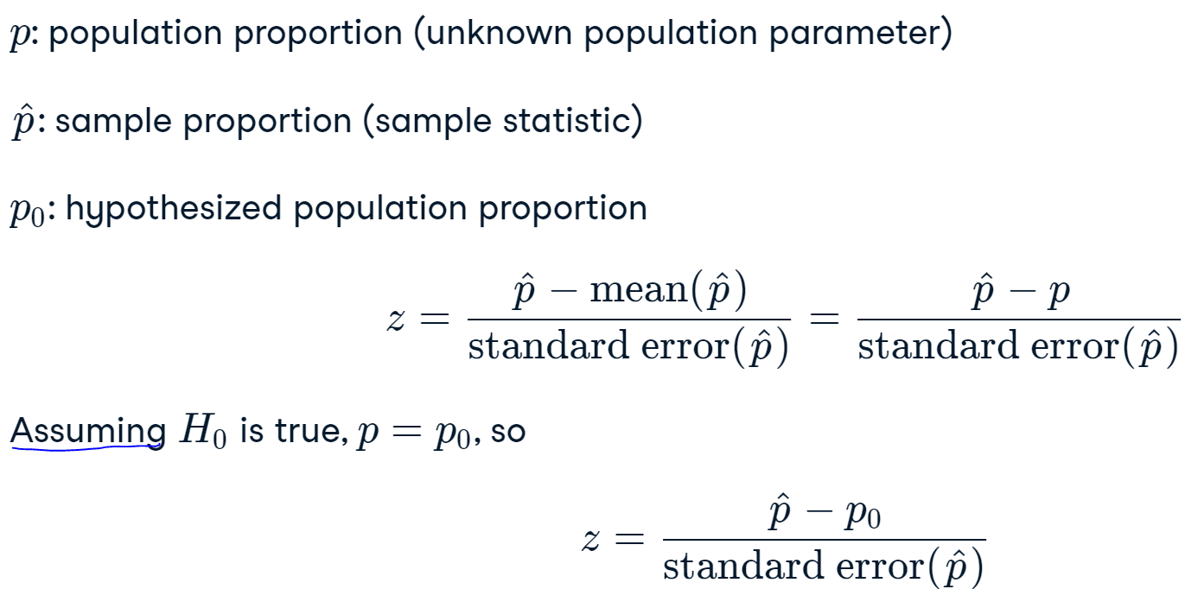

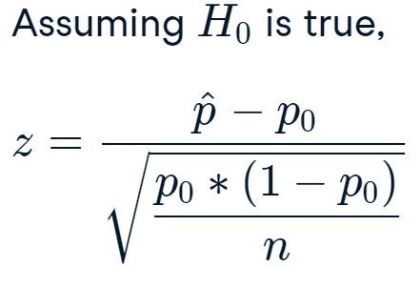

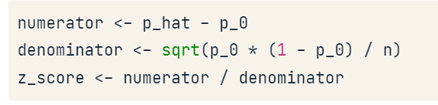



### Two-sample

#### Not paried

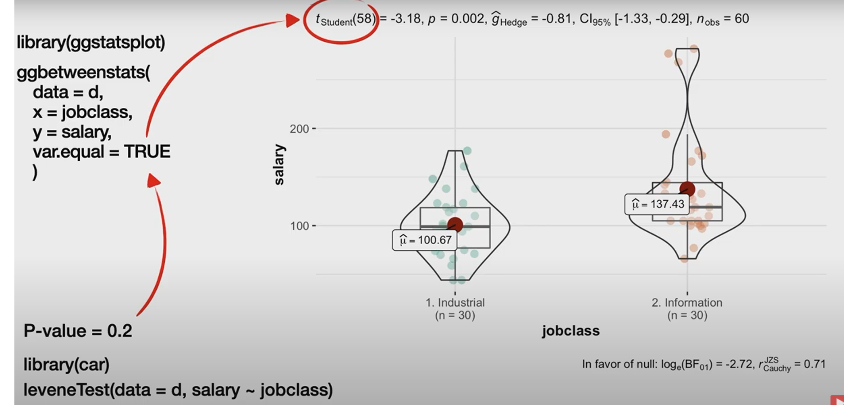

Way 1



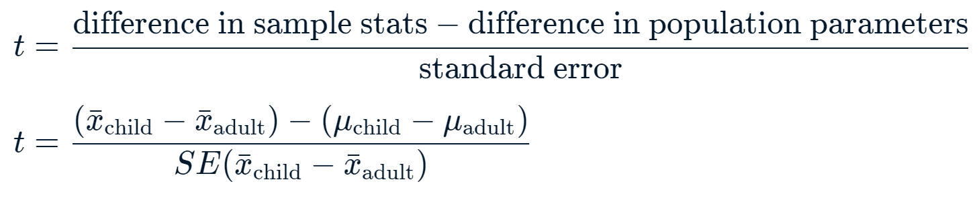

To calculate the Standard Error (SE) we can use bootstrapping or the next formula:

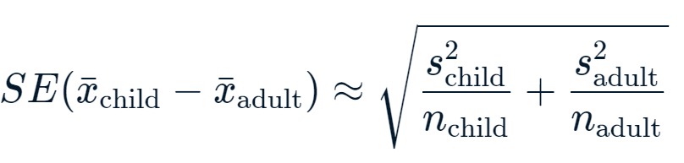

The degrees of freedom

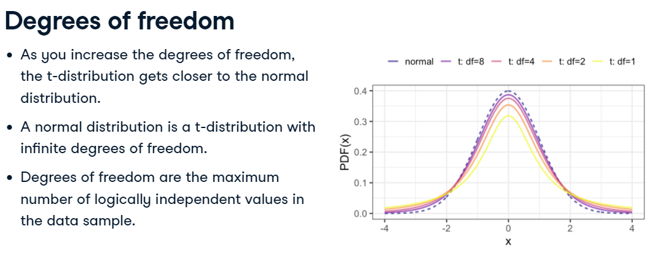



p-value

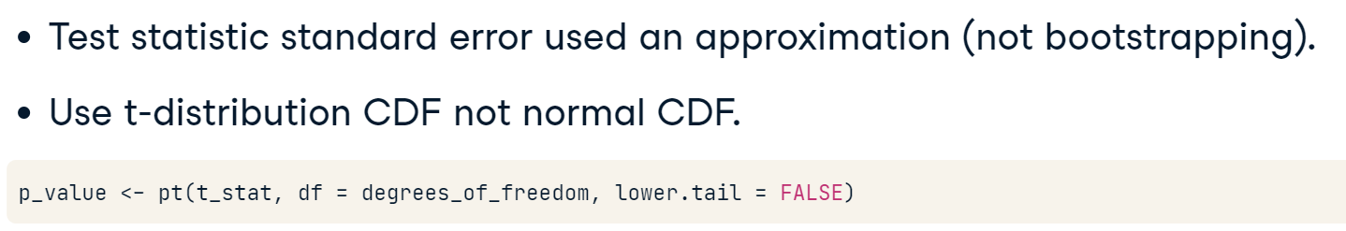

Or

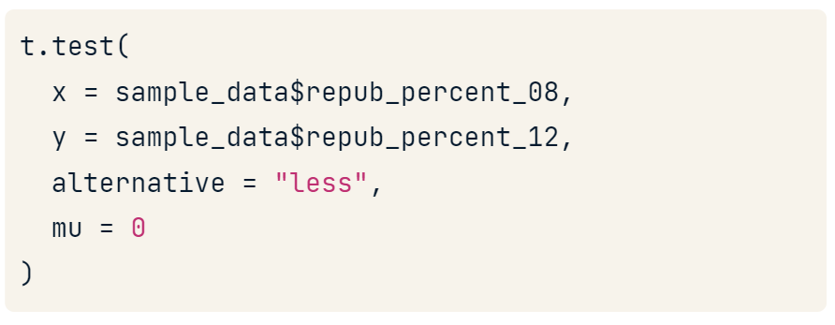

Way2

We can run a bootstrap in both samples so we can check if the confident intervals overlap each other. In this example they don’t so the is a statistical difference.

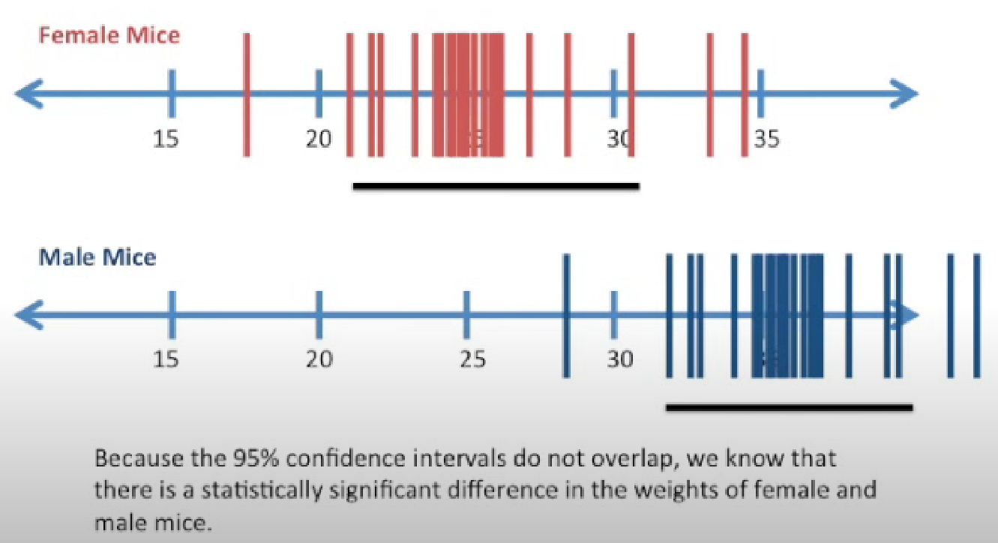

But if they overlap just a little we should check with a t-test.

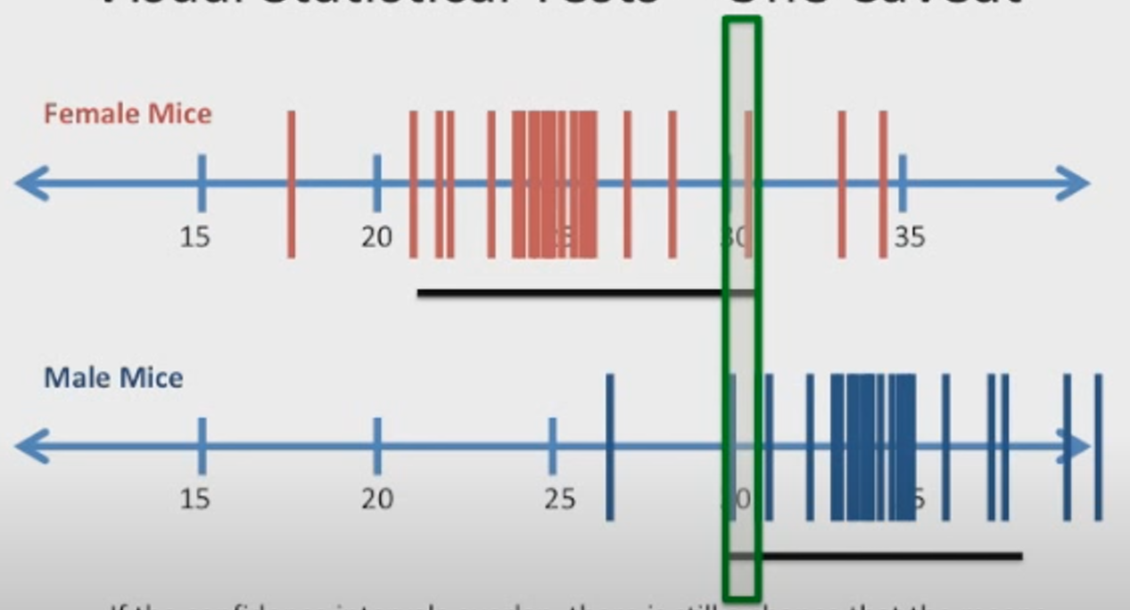

##### Proportion

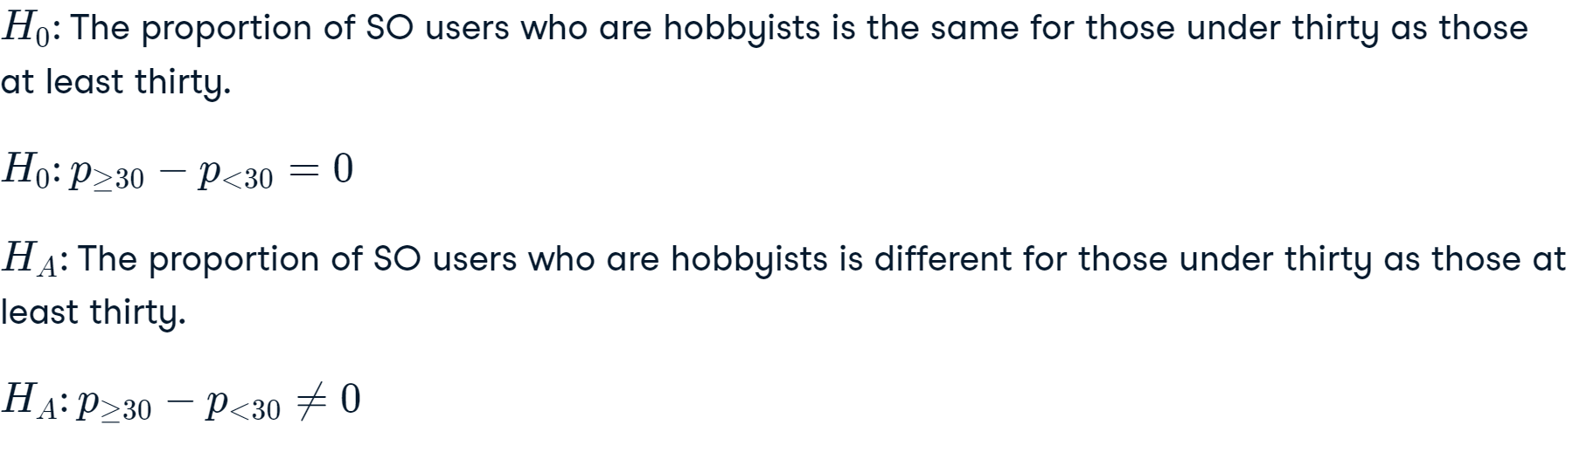

Way 1

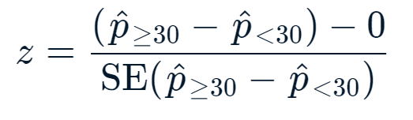

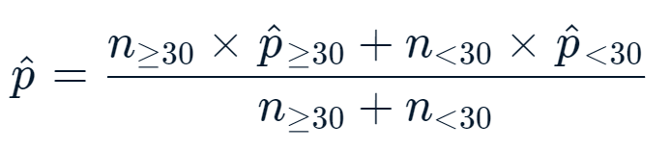

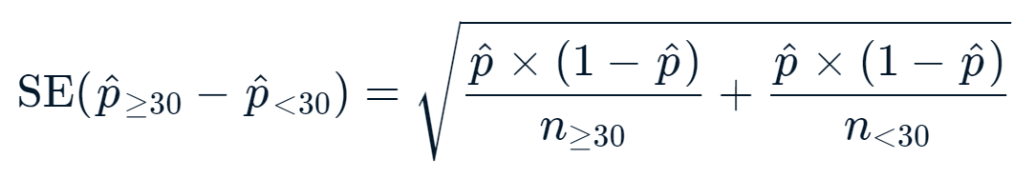



Way 2

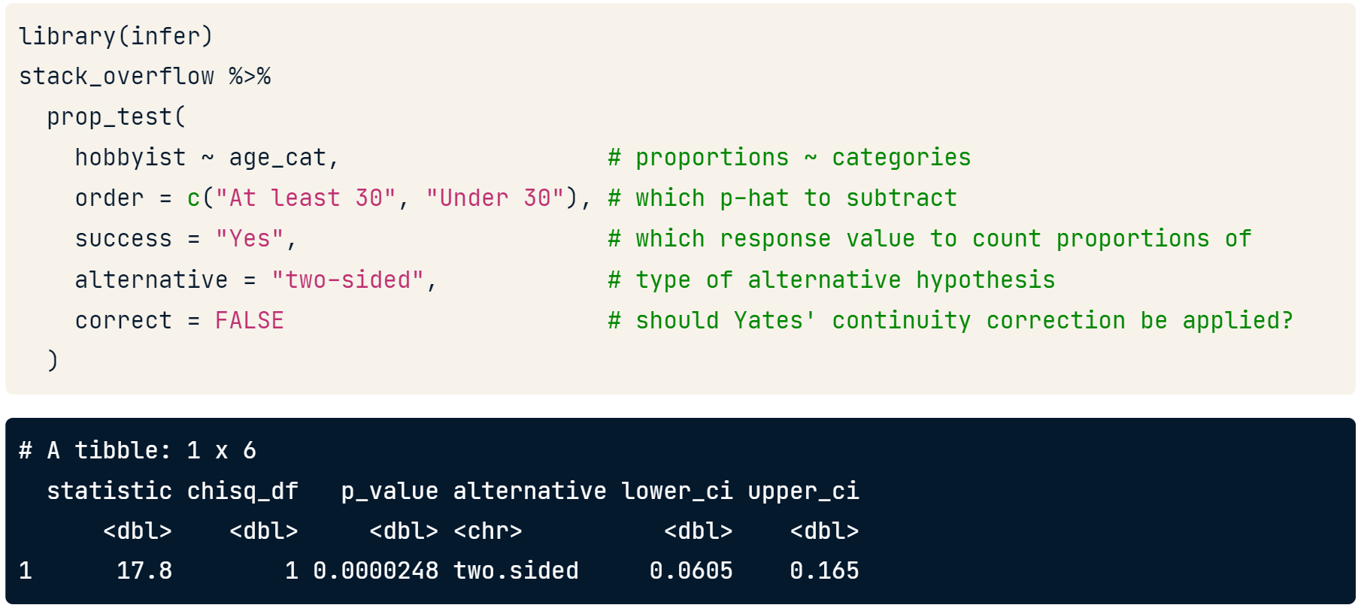

#### Las mismas personas en test1 y test2

Question

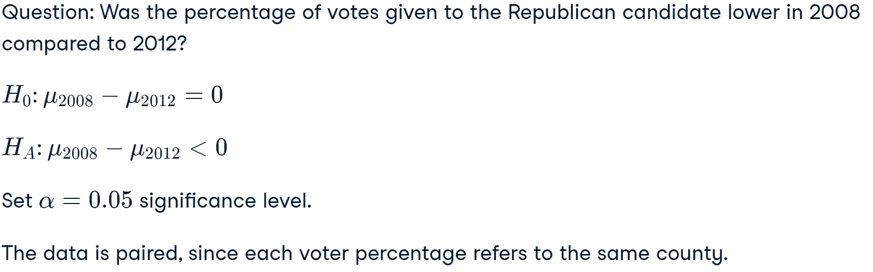

1 way

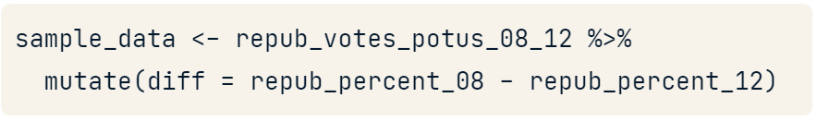

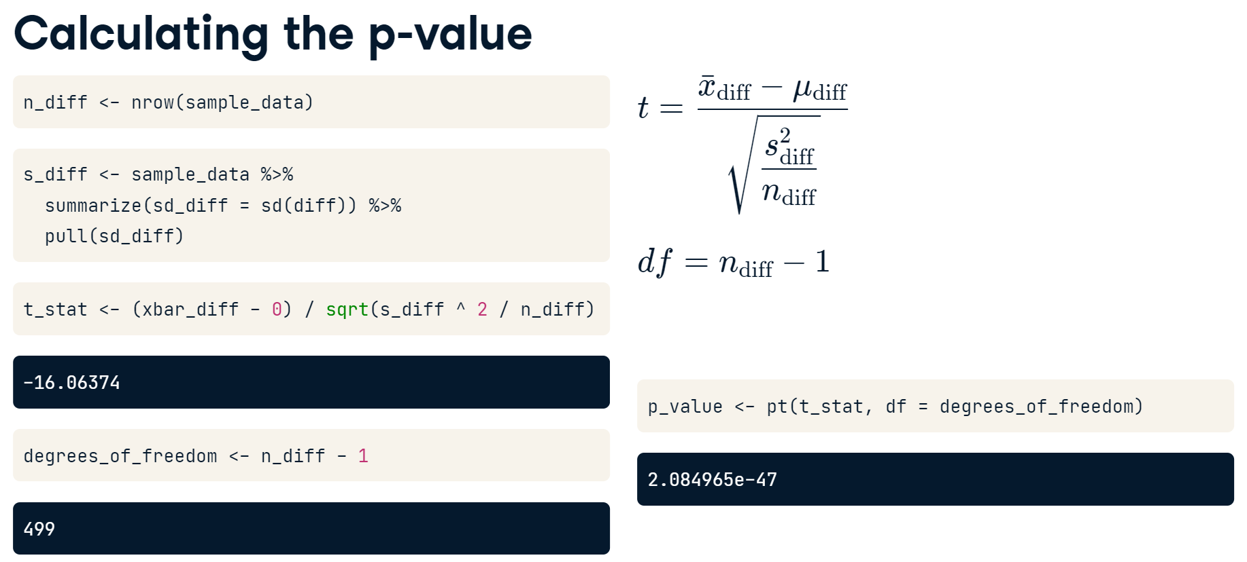

2 way

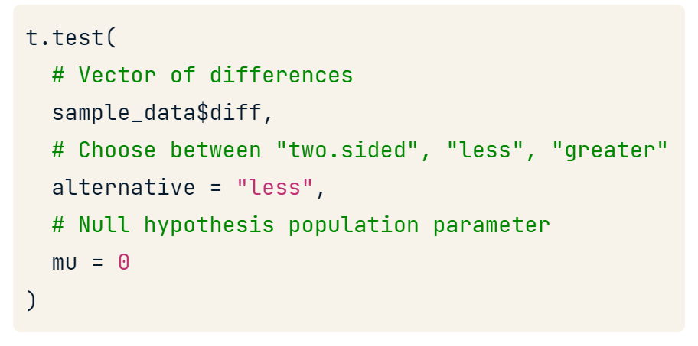

3 way

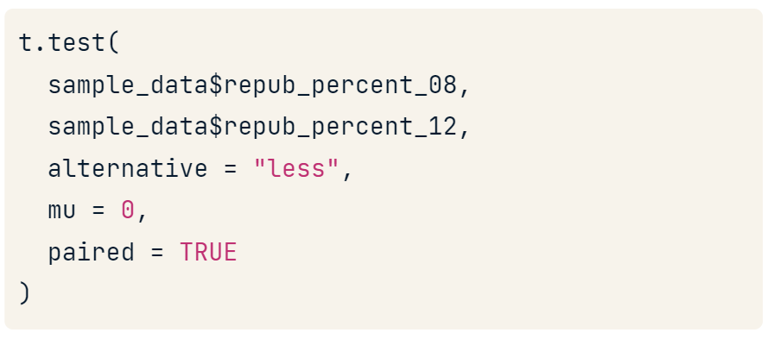

### t-distribution vs z-distribution

1. When a sample standard deviation is used in estimating a standard error. But we can use the bootstrap

### Test many levels

#### ANOVA (continues)

1. First calculate ANOVA for that variable

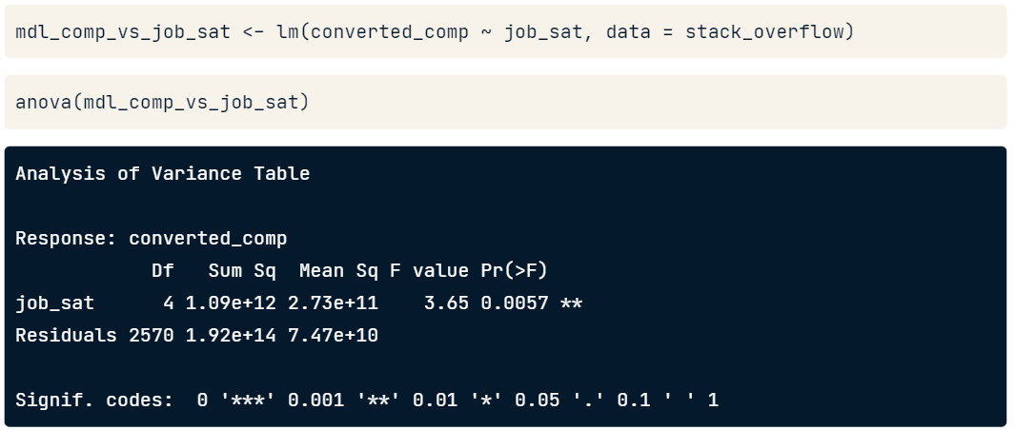

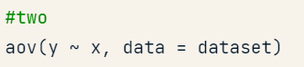

**Interaction plot**

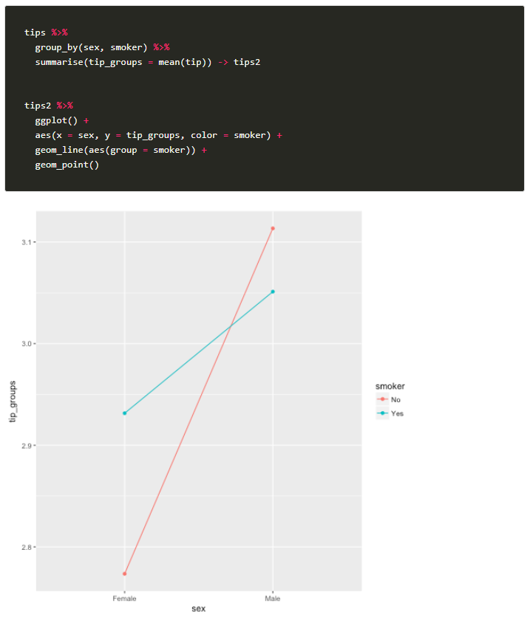

1. Secund use the pairwise the detect where the difference is.

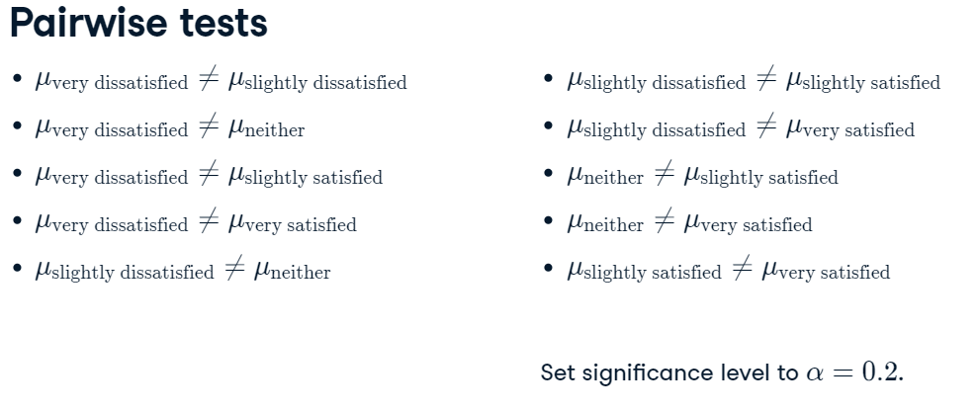

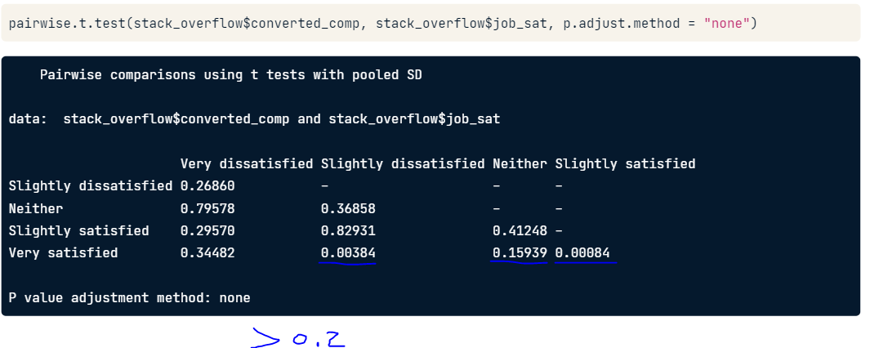

Para este ejemplo con alpha de 0.2 cuando temenos 20 grupos estamos seguros de que tendremos al menos una prueba que resulte ser un falso positivo.

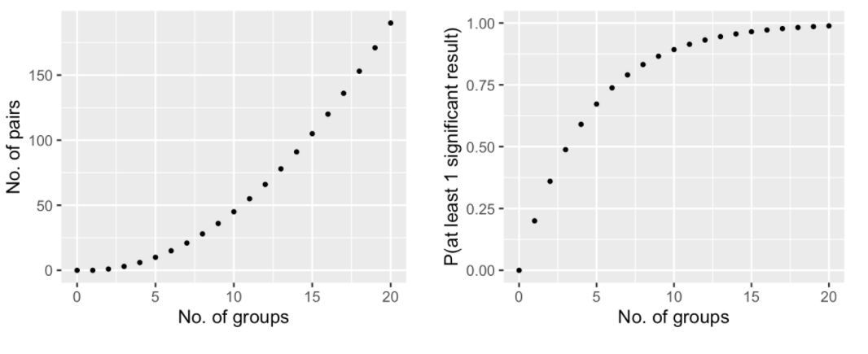

Los adjustment methods incrementan el p-value.

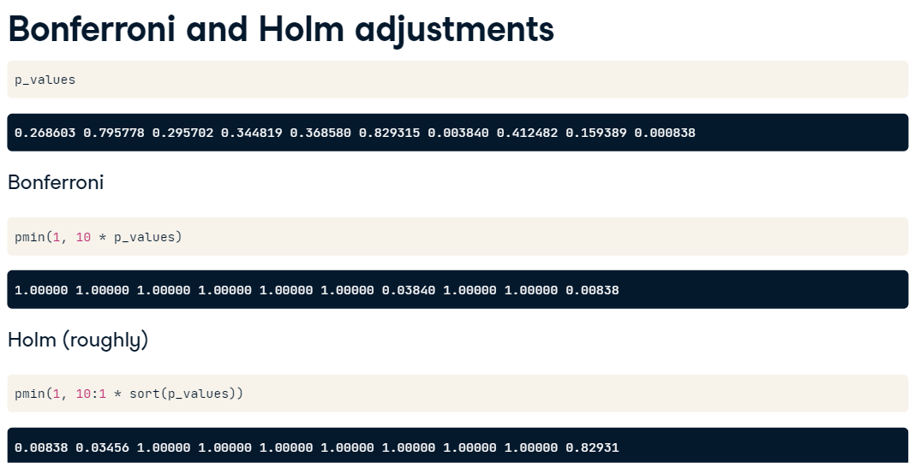

Bonferroni es algo conservative, por lo que se puede usar para cosas de dinero.

Pero fdr reduce menos los p-value

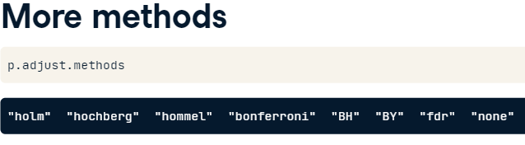

1. **3er**

purpose_aov <- aov(funded_amnt ~ purpose_recode, data = lendingclub)

tukey_output<-TukeyHSD(purpose_aov, conf.level = 0.95)

tidy(tukey_output)

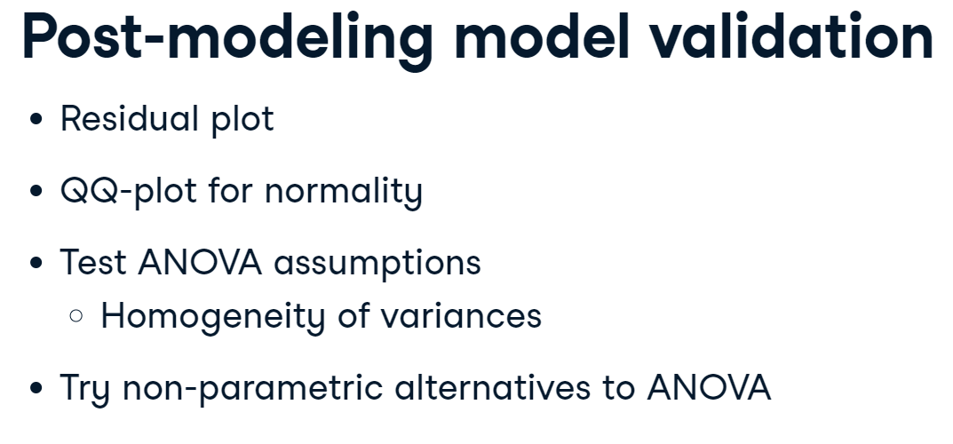

#### Independence of variables (proportions)

**Statistical independence** of two categorical variables is when the proportion of successes in the response variable (Y) is the same across all categories (levels) of the explanatory variable.

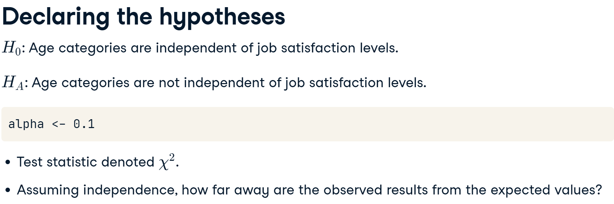

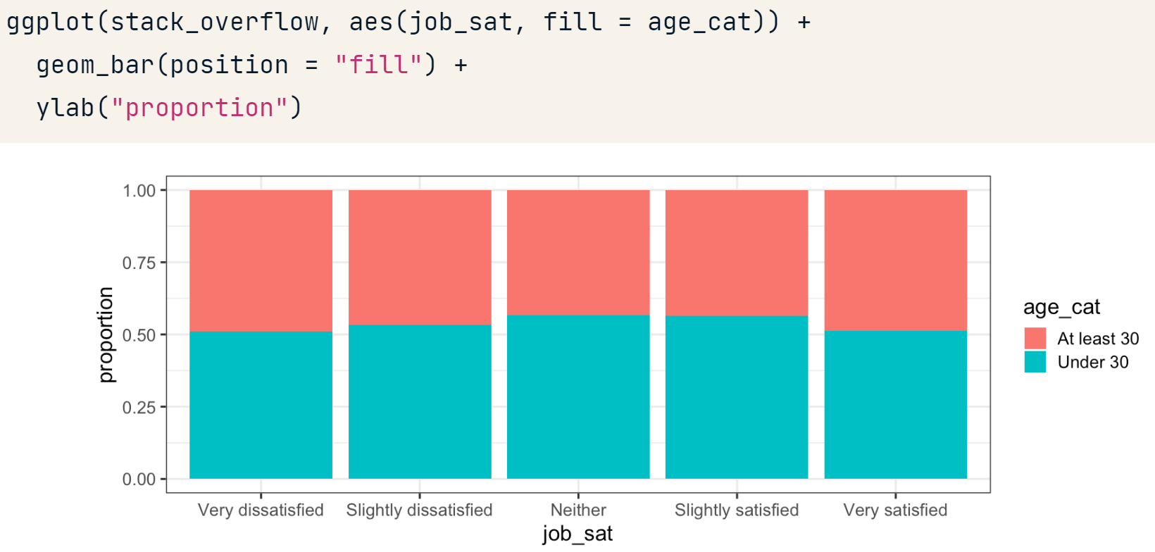

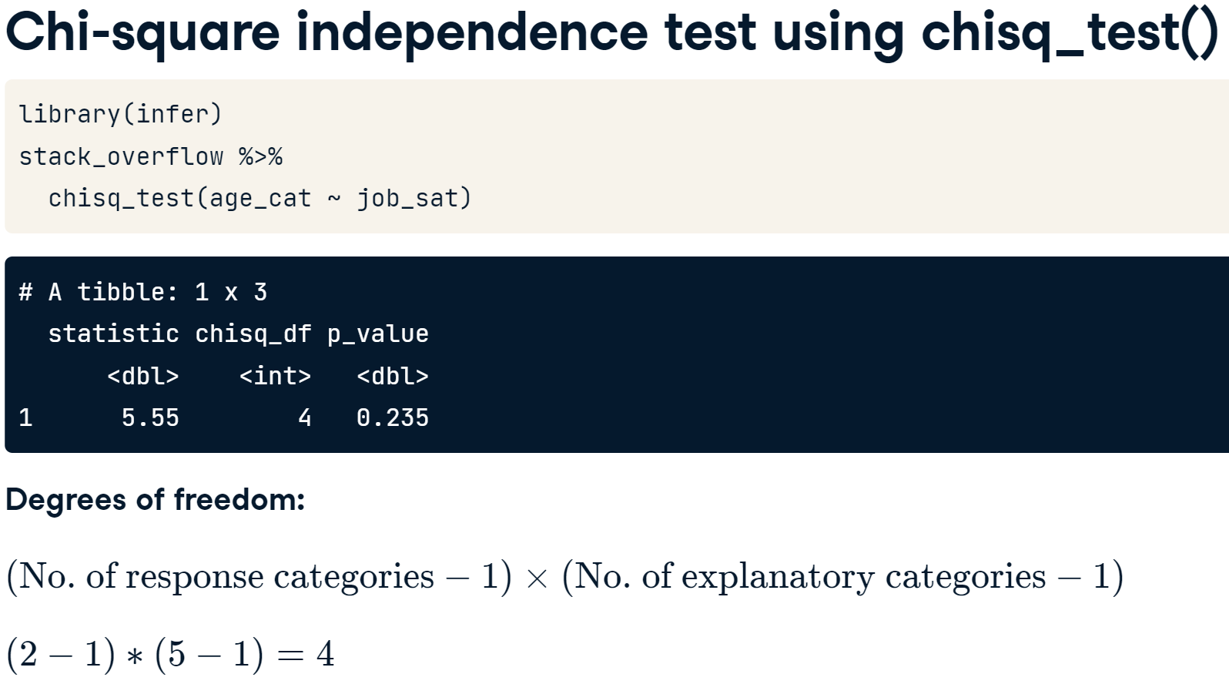

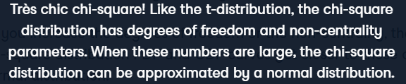

The test statistic is based on the square of observed and expected counts, and square numbers are non-negative. That means that chi-square tests tend to be **right-tailed** tests.

### Chi-square goodness of fit test

#### Discrete distribution

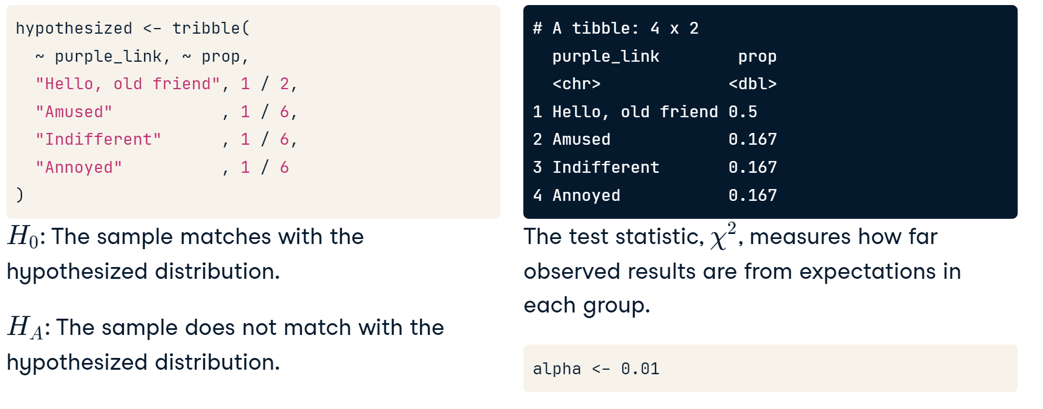

First we need to plot.

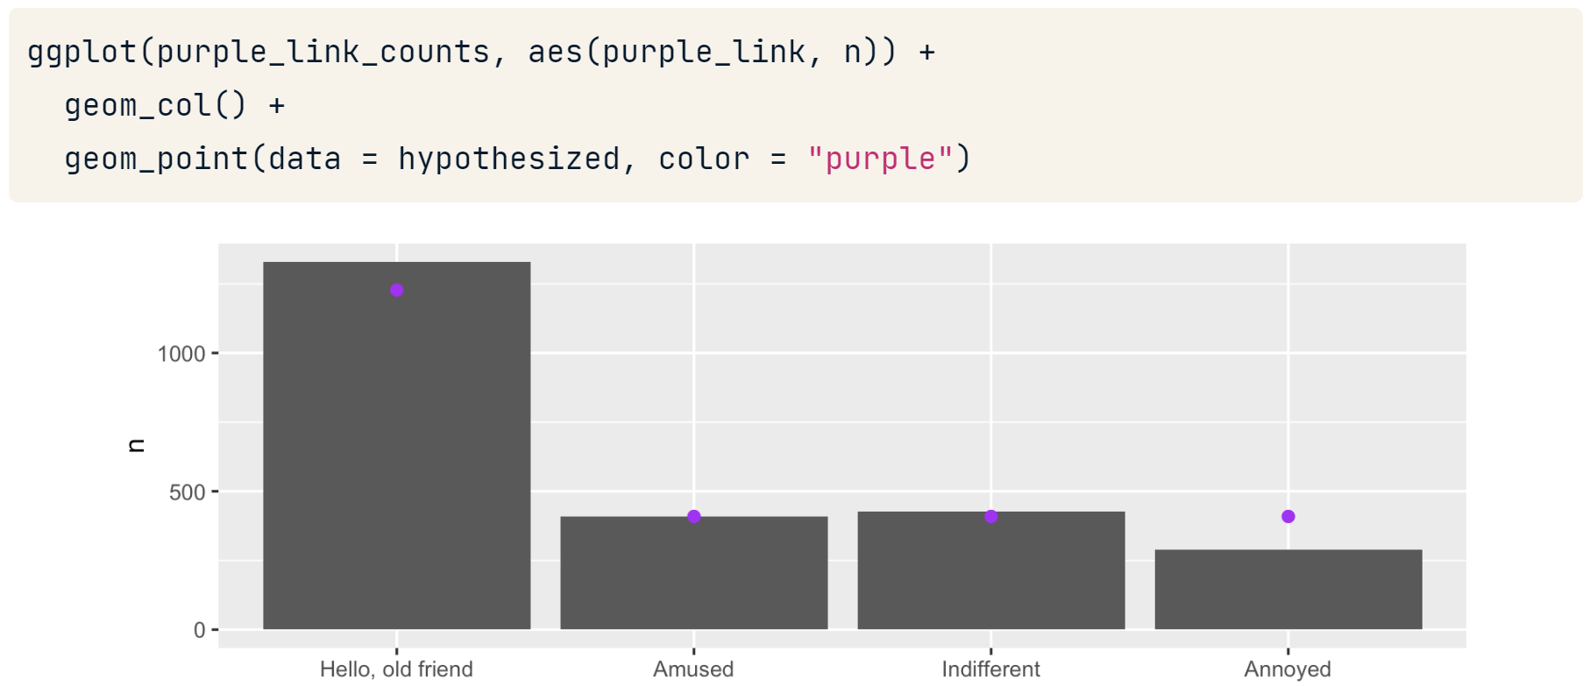

Apply the test

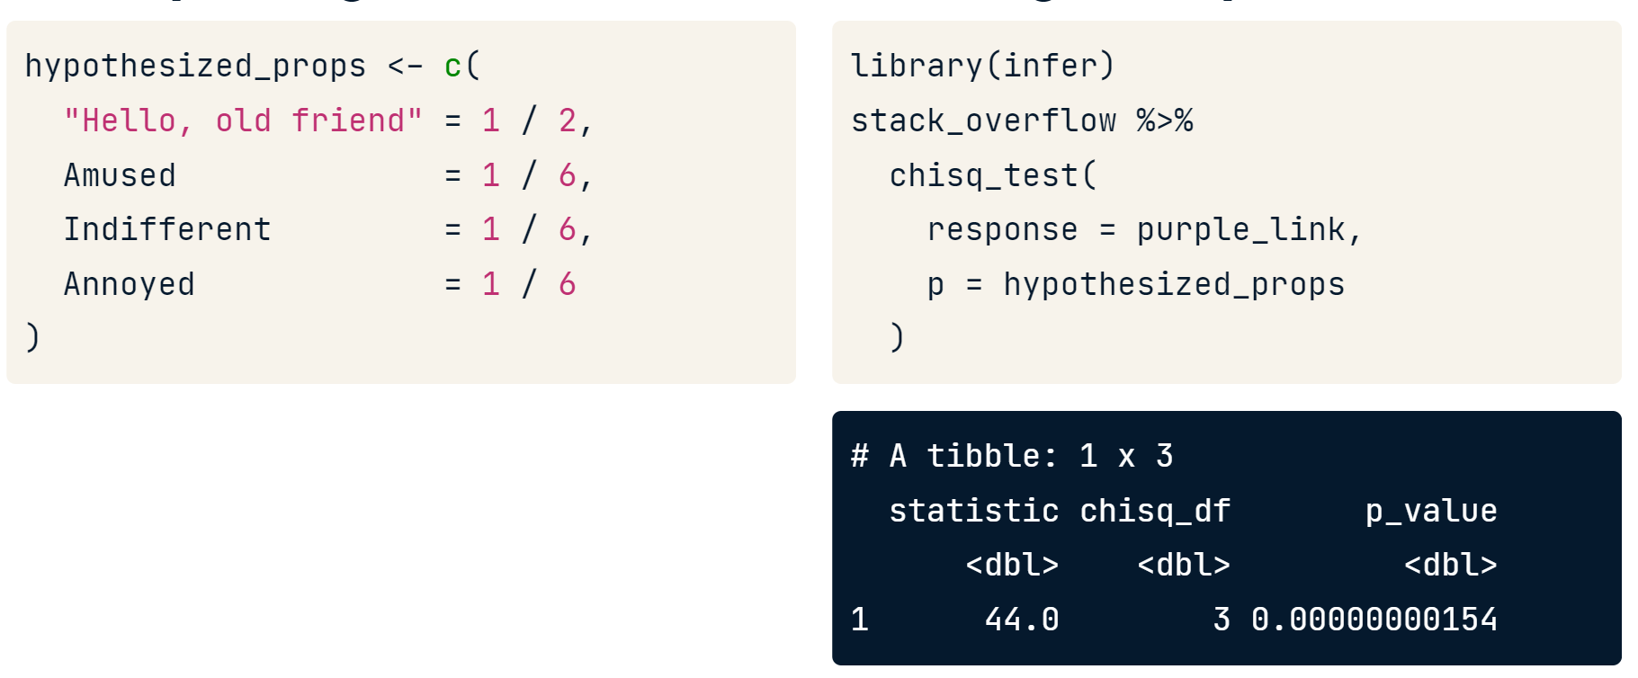

## Relative error vs. sample size

Relative_error = 100 * abs(population_mean - sample_mean) /

population_mean

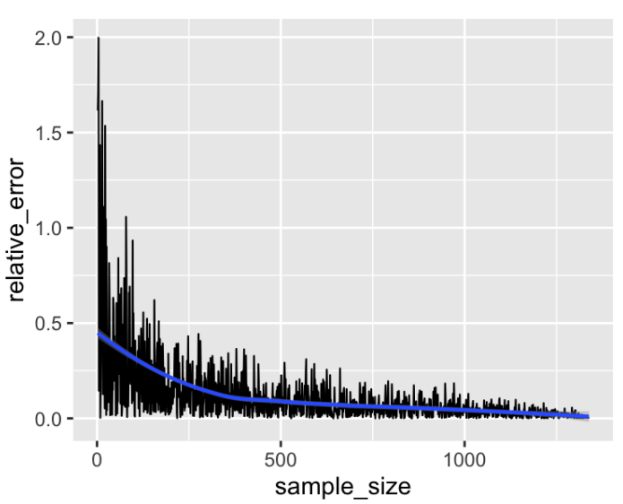

## Sample techniques

1. **Simple random sampling:** Every member of the population has equal change to being selected. It is used to estimate the ***parameter of a variable***.

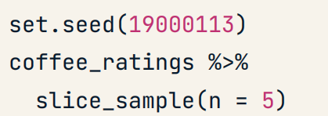

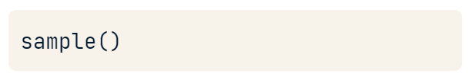

1. **Systematic sampling:** Useful to track a variable over time. It is only safe if you don't see a pattern in this scatter plot “y ~ rowid". Se implementa mejor con una función personalizada y es el más usado en las industrias.

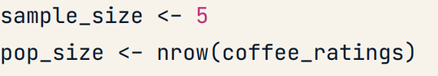





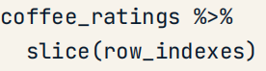

1. **Stratified sampling:** It is very useful if we want to estimate the parameter of a variable and the parameter of ***every x group***.

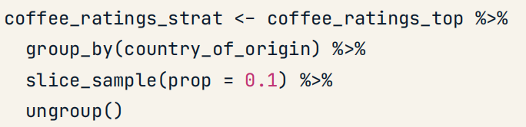

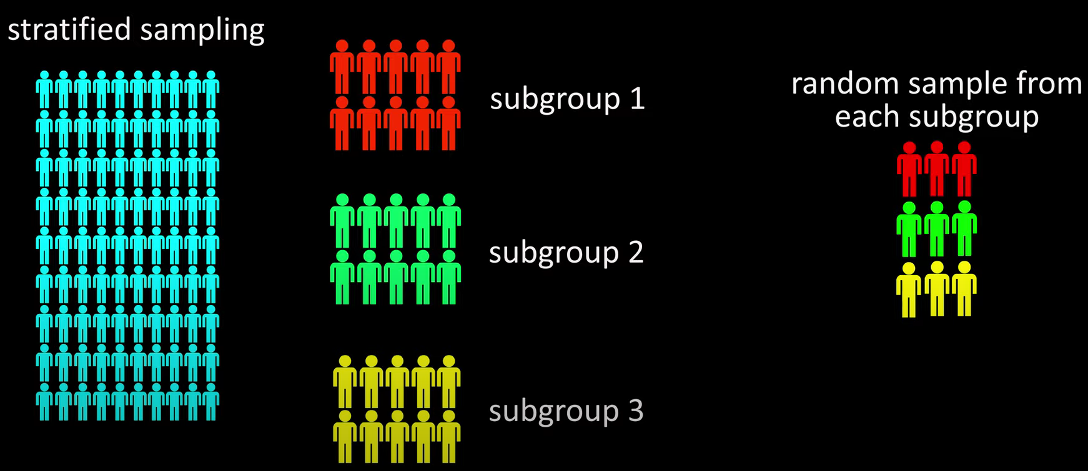

1. **Cluster sampling:** It is very useful if we want to estimate the parameter of a variable and the parameter of ***some x group***. En este tomamos todas las personas de cada grupo.

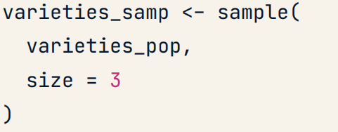

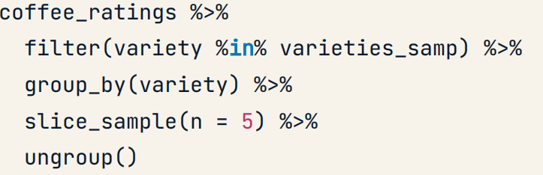

**library(sampling)**

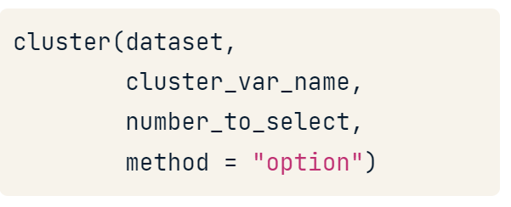

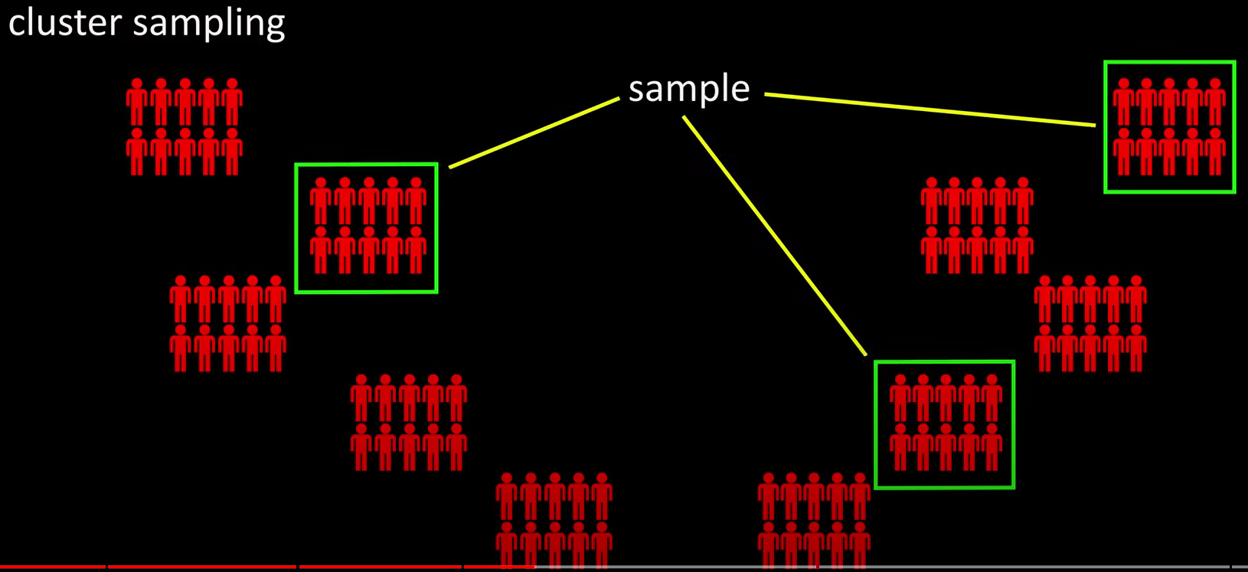

## Power calculation or sample size

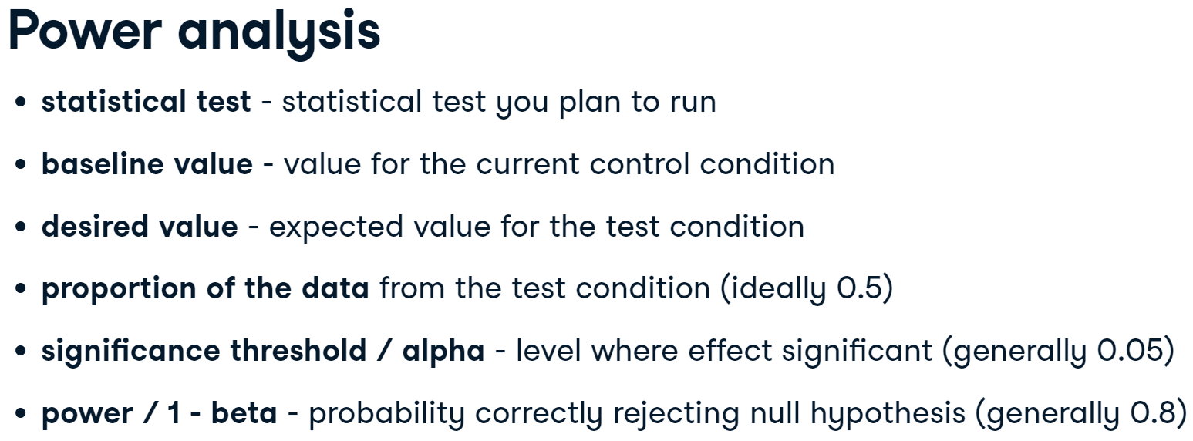

* **Effect size:** It is a standardized measure of the difference you're trying to detect, calculated as the difference between group means divided by the pooled (common) standard deviation of the data.

We can use from 0.2 to 0.6 but we aren’t sure about it.

* **Power:** Probability that the test correctly rejects the null hypothesis. Normally an **80% to be right.**

|  |  |
| --- | --- |
|  |  |

### Baseline estimation

1. Check if que the change has been consistent over the time.

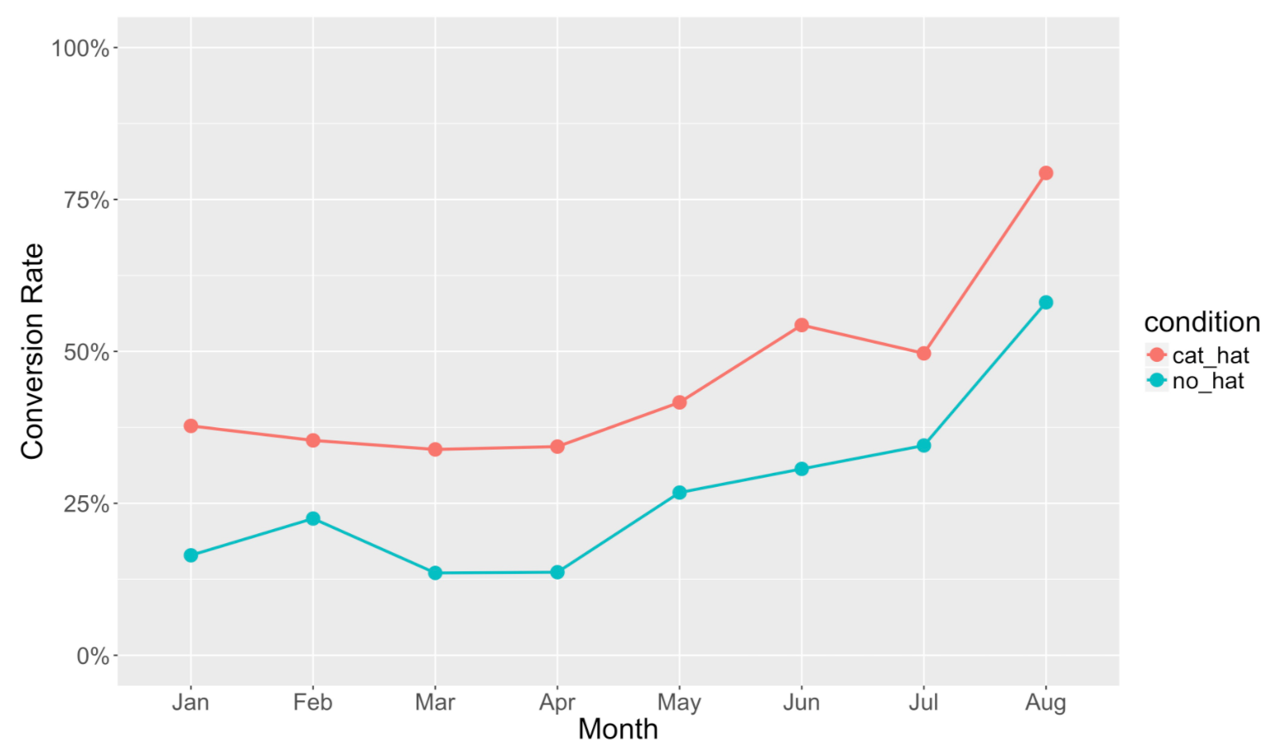

1. Check in average how much increase the factor and with what variability.

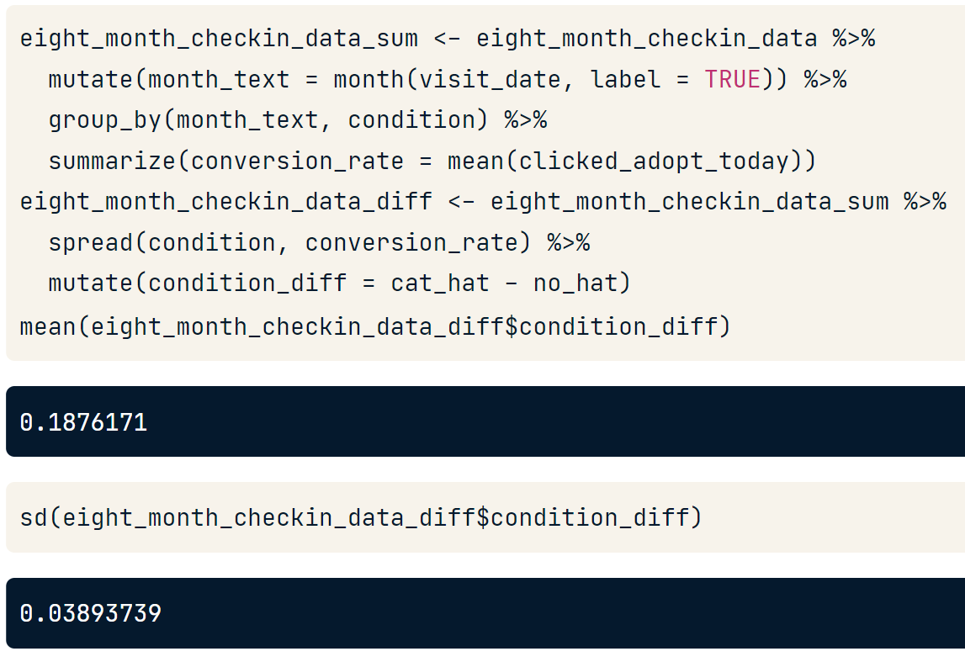

1. If variability is low we can take the value from last year and sum the average rate increase to make an estimation.

### Power or sample size calculation

1. k is the number of groups in the comparison
2. n is the number of observations per group
3. f or d is the effect size

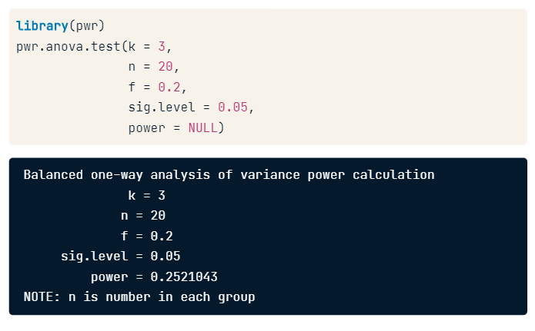

# Load the pwr package

library(pwr)

# Use the correct function from pwr to find the sample size

pwr.t.test(d = 0.2, sig.level = 0.05, power = 0.8,

type = "two.sample", alternative = "two.sided")

1. **Significance level:** Probability of the null hypothesis being rejected when it is true. Normally a **5% to be wrong.**

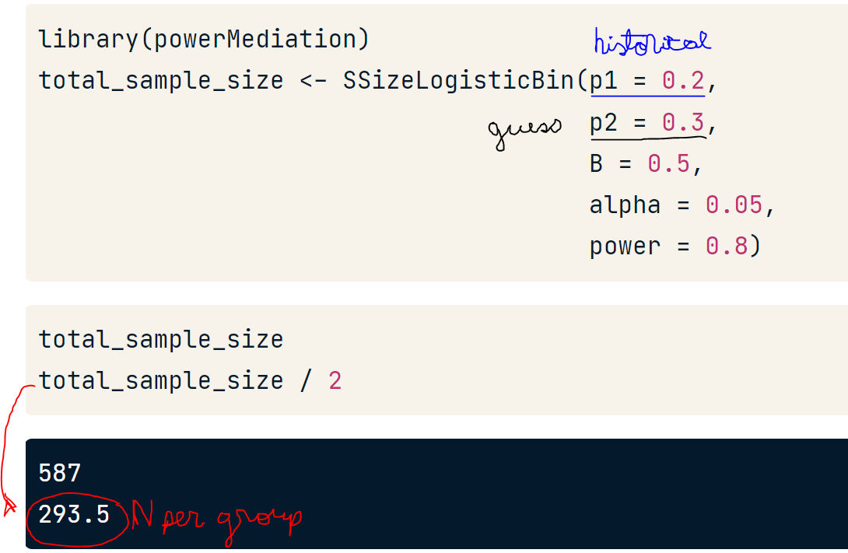

If we don’t have data for p1 we can make an estimation.

### Early experiment stopping

Sometimes *we don’t need to run all experiment to see a* ***significant difference***. If we see a significant difference before we can stop the experiment as we can see in the next example.

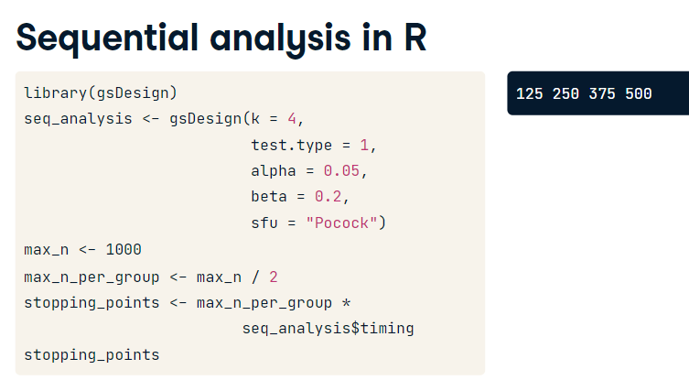

To avoid p-hacking the will need to use **0.0193** instead of **0.05** as our significant level.

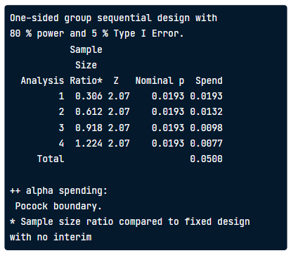

We have 3 possible solutions:

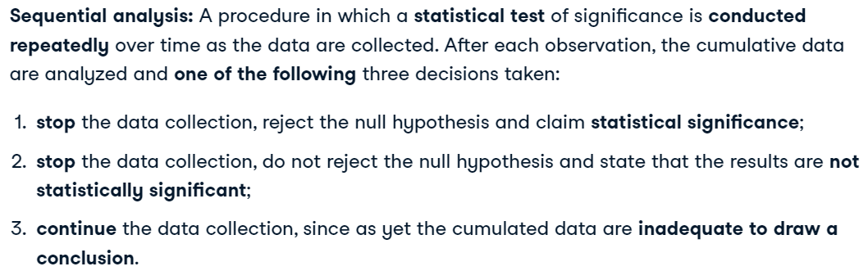

## Getting confidence intervals with bootstrap

It is good to know that bootstrap doesn’t improve mean estimation.

1. Define n

nrow(coffee_sample) = n = 500

1. Get the sample distribution

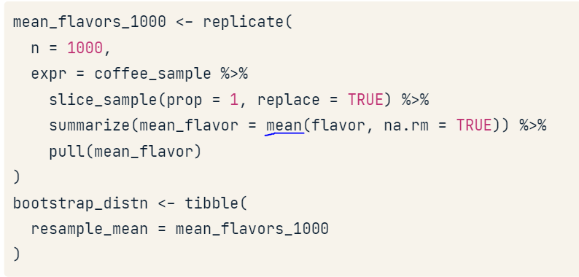

1. Estimate interval with the quantile method

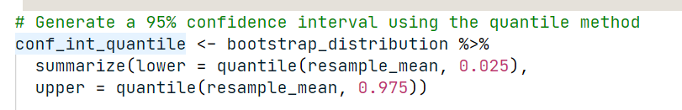

1. Estimate interval with the standard error method

We need a large sample of size to assume the distribution as normal

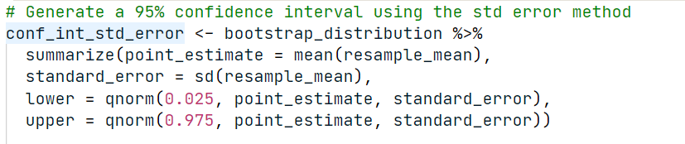

1. Calculate the standard error and solve for the population standard deviation

|  |  |  |
| --- | --- | --- |
|  |  |  |

## Type

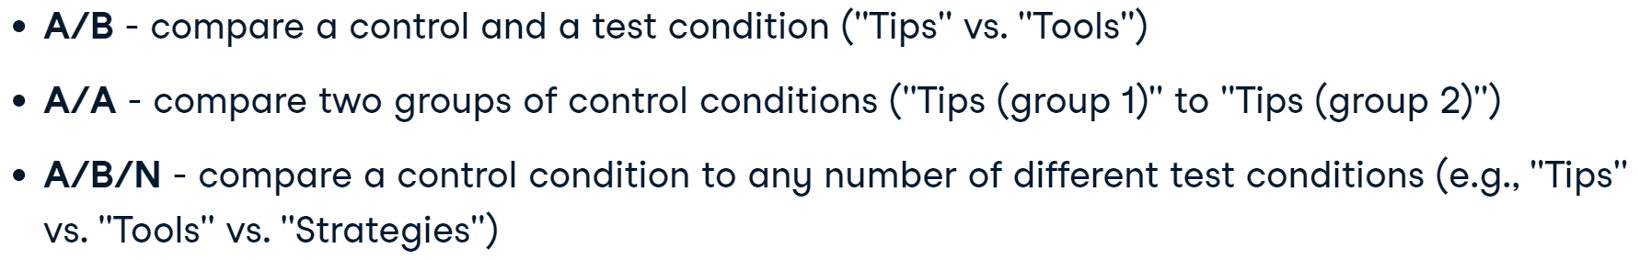

## Randomized Complete Block Design (RCBD)

### One blocking factor

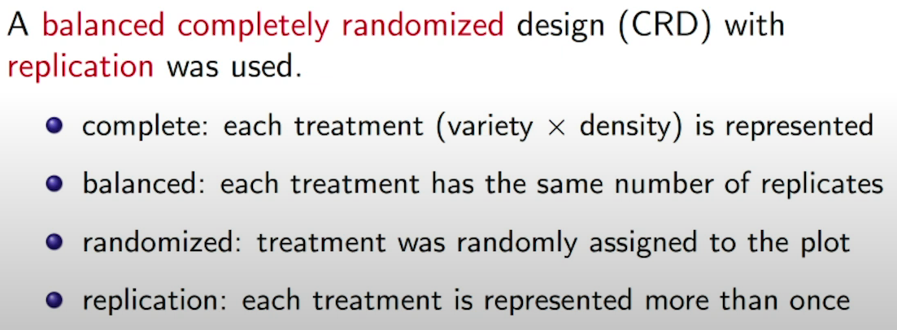



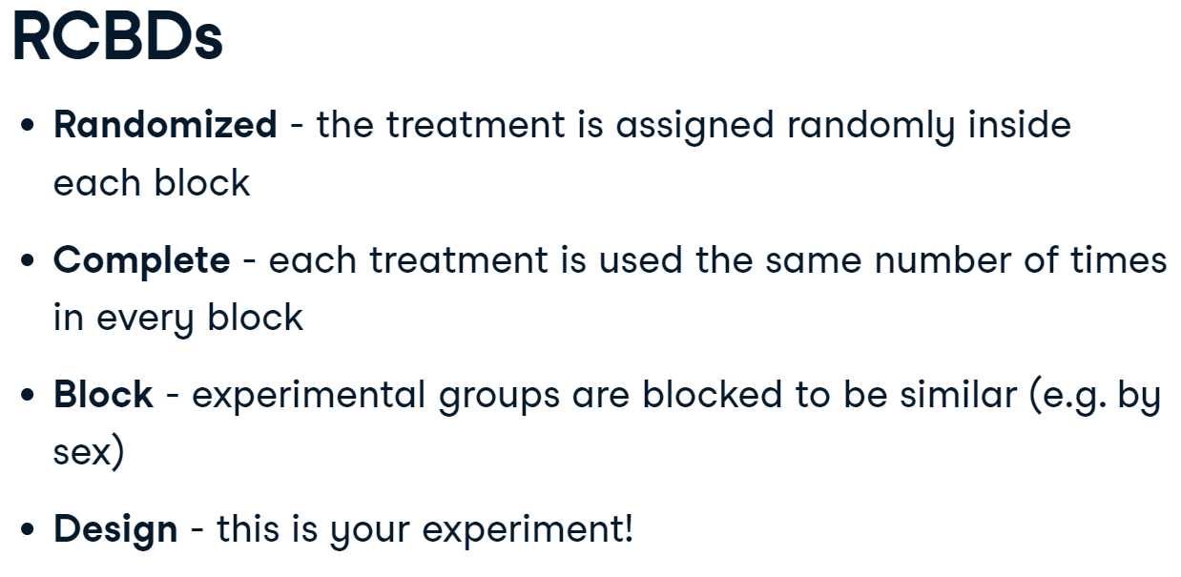

*"Block what you can, randomize what you can't."*

|  |  |
| --- | --- |
|  | A picture containing text  Description automatically generated  El numero de bloques es igual numero de repeticiones |

In this RCBD, we have 4 blocks (each row of the output). Inside of each block, each treatment "A", "B", "C", and "D" is used, because this is a complete design. So if these 4 blocks/rows of the output were four fields of a farmer's, they should give the first field the "D" treatment in the first season, then "C", then "A", then "B".

### Latin squares (2 blocking factors)

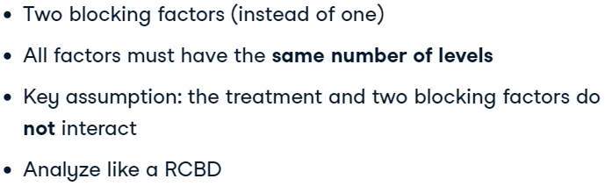



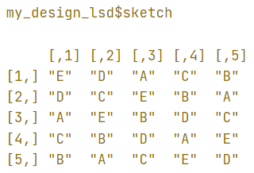

1. Las rows representa a un factor de bloque de 5 niveles.
2. Las columnas representan otro factor de bloque de 5 niveles
3. Cada letra representa los 5 niveles del factor que se quiere estudiar.

### Graeco-Latin squares (3 blocking factors)

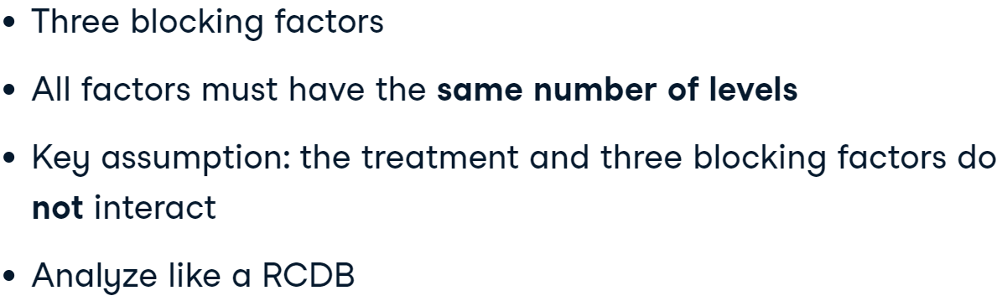

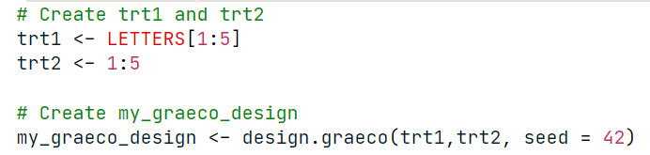

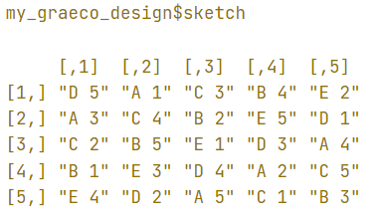

En este diseño cada numero representa el ultimo factor de bloqueo.

## Balanced Incomplete Block Designs (BIBD)



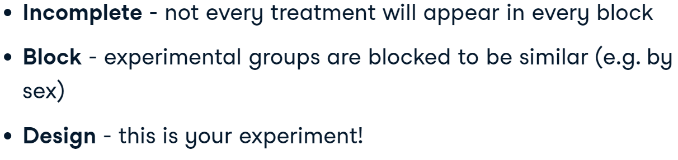

Let’s calculate if a basic design is possible with the next formula donde lambda debe ser un número entero.

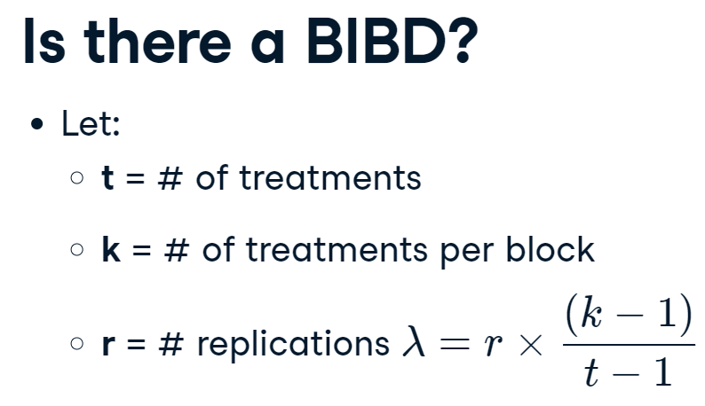

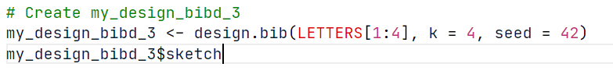

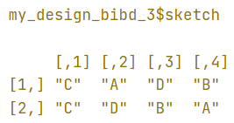

## 2^k factorial experiments

This experiments can see interactions.

Running a 2k experiment with many 2-level factor variables is a strategy employed to find the factors that are important in your experiment quickly

Only if we have replication we will be able to measure **interactions**.



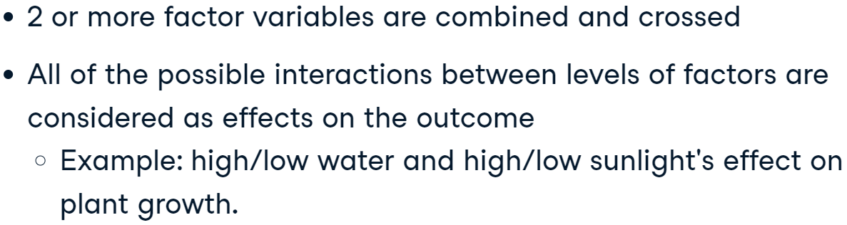

## Central limit theorem and sample size

1. Averages of independent samples have approximately normal distributions as the sample size increases.

# A/B testing

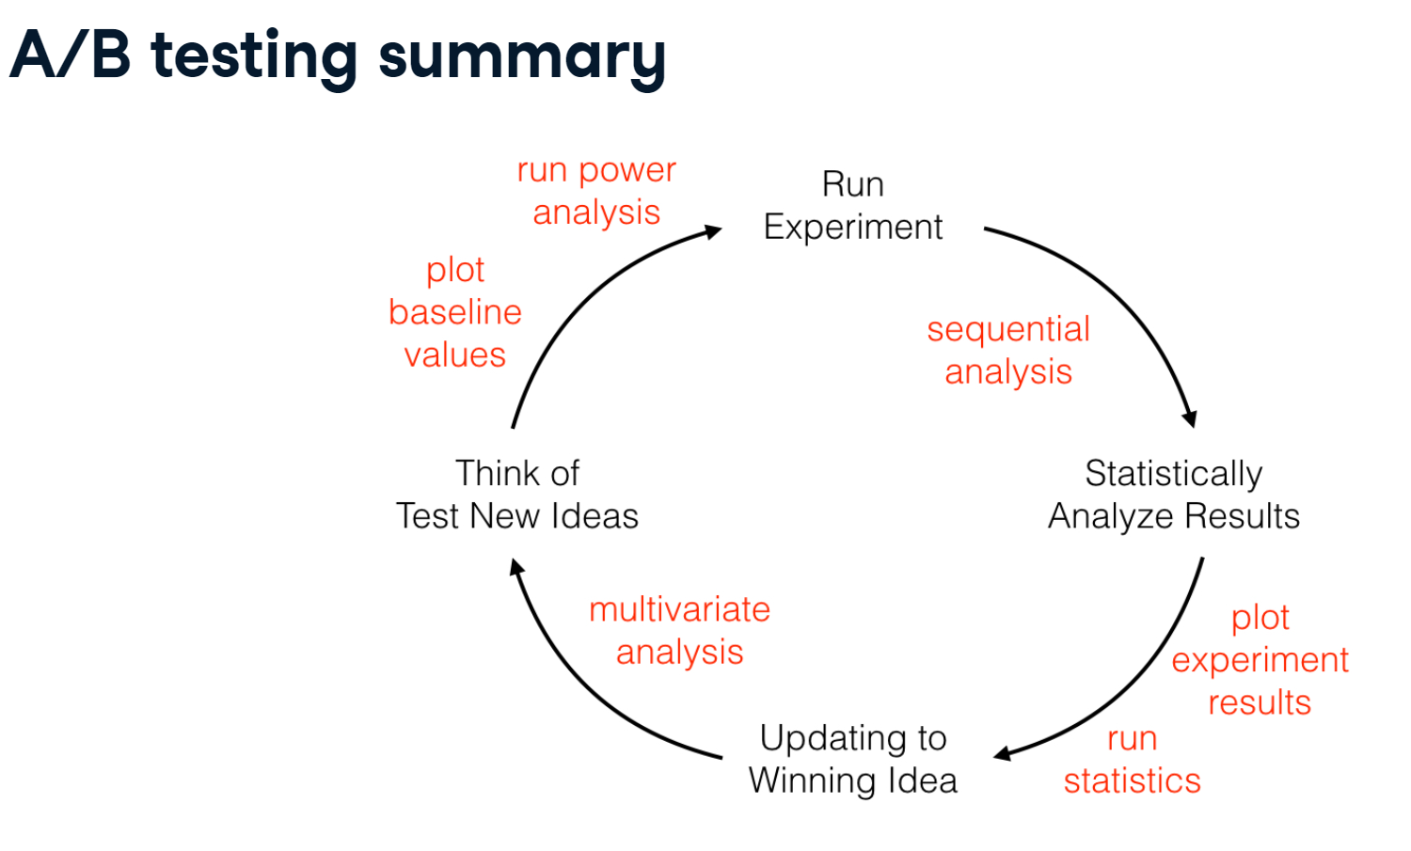

## Exploring results

1. See general mean or median in the data

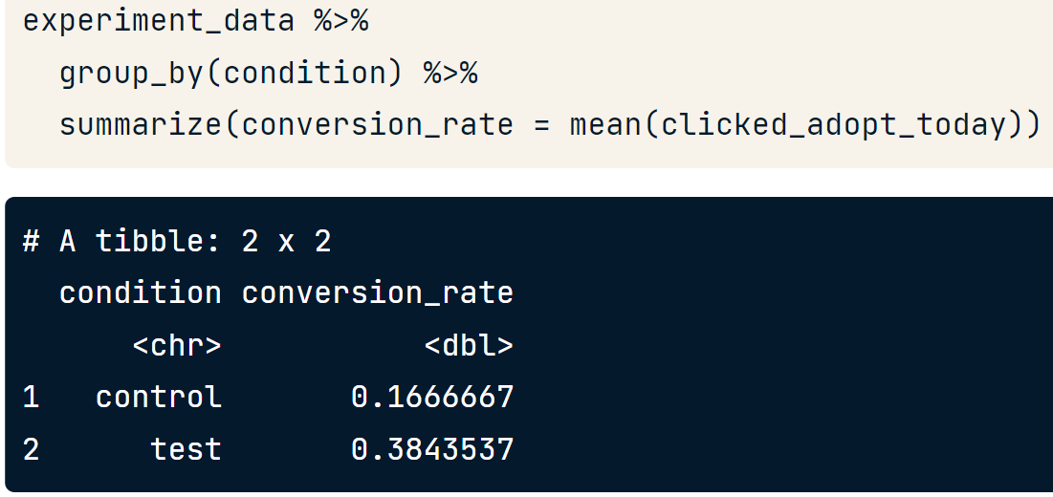

1. See the data with minimal transformation. Here we can see the percentage of conversion every day and we can see that must of the time the test did better than the control one.

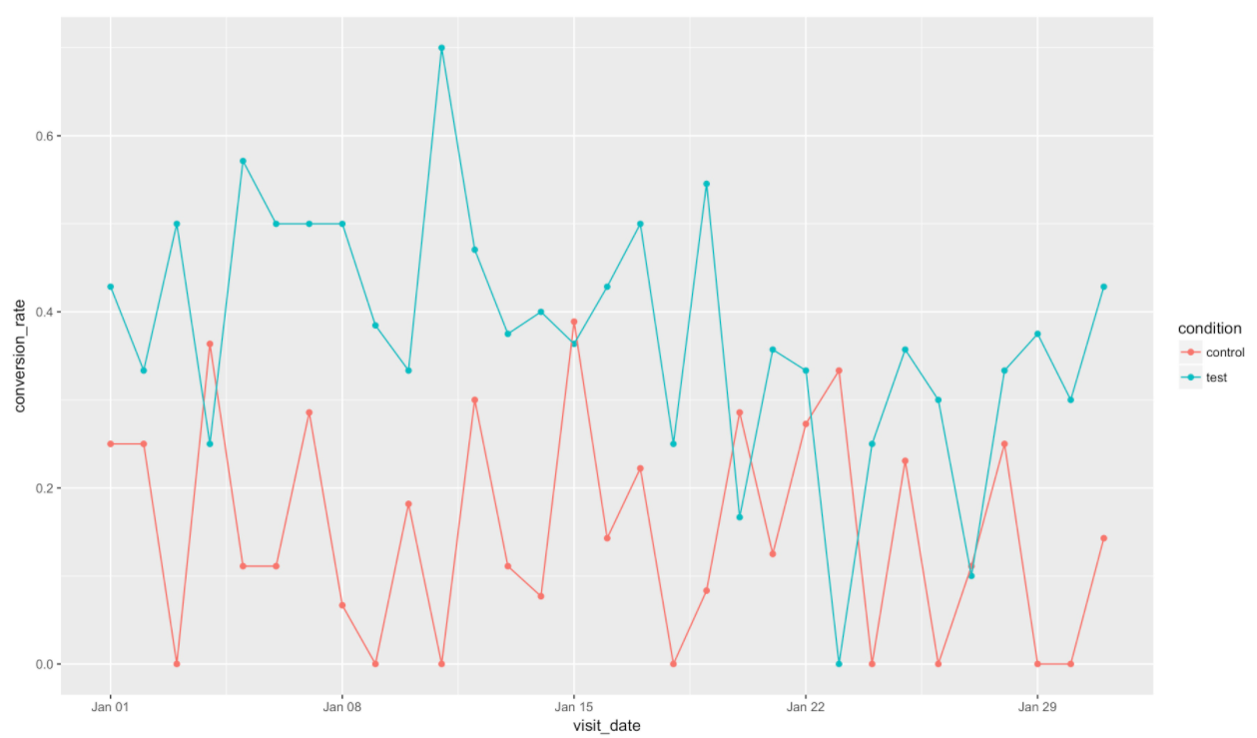

## Problems at testing



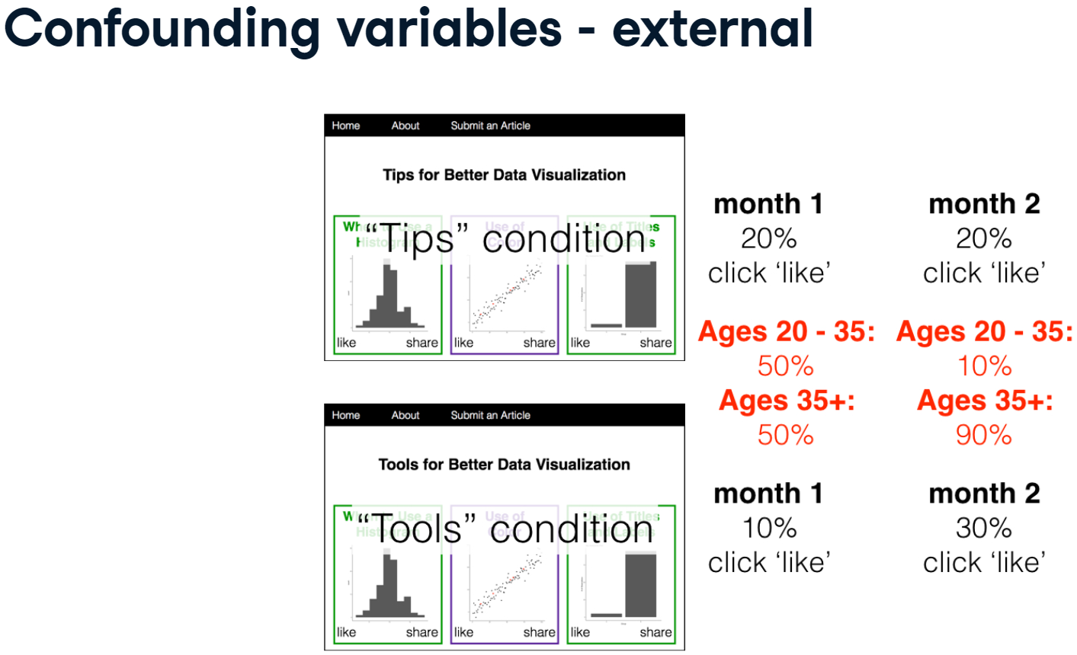



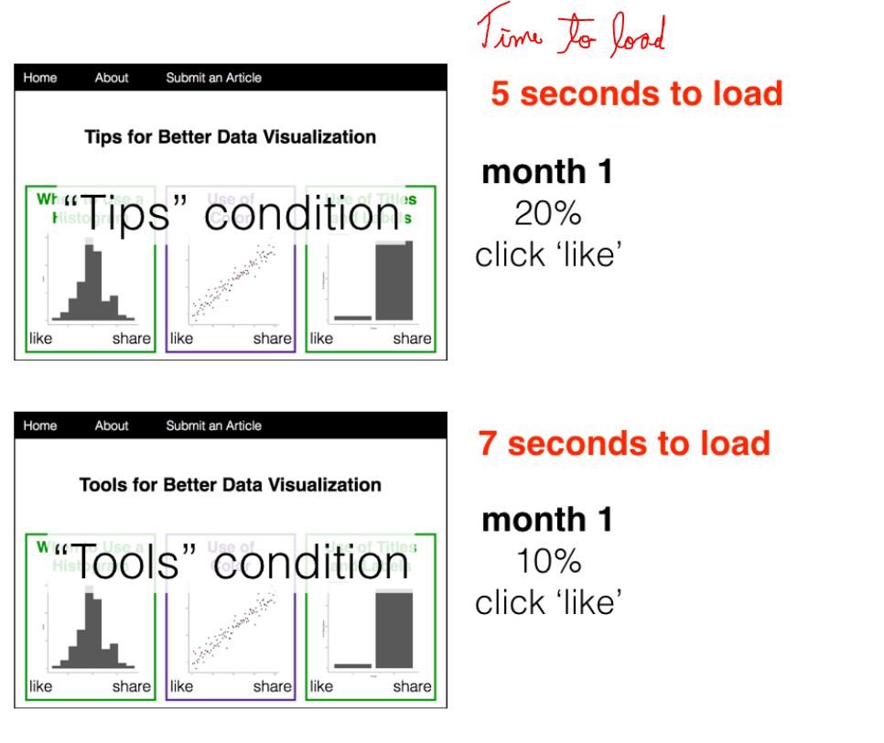

## Not parametric testing

Hypothesis tests that don't assume a *probability distribution* for the test statistic are called non-parametric tests.

### Simulation based

Simulation has a benefit that it works well even when you have **small samples** or **imbalanced data**.

#### The grammar of hypothesis tests



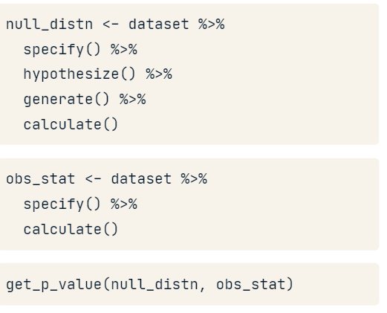

**specify():** Works like dplyr's select, returning only the response and explanatory columns.

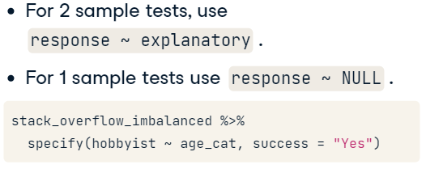

**hypothesize():** Declares the type of null hypothesis. We use independence to to check if all groups are the same.

|  |  |
| --- | --- |
|  |  |

**\*generate():** Creates a simulation.

*Permute type:* If we assume the null hypothesis is true, then it shouldn't matter which hobbyist value is matched up to each age category, since the proportion of hobbyists is the same in each age category. So permute **shufflers the response** values while keeping the **explanatory values the same**.

|  |  |
| --- | --- |
|  |  |

**calculate():** this function will return the observed statistic specified with the stat argument. If provided the output of generate(), the function will calculate the supplied stat for each replicate known as *null distribution*.

*stat:* A string giving the type of the statistic to calculate. Current options include:

1. "mean", "median", "sum", "sd", "prop", "count", "diff in means", "diff in medians", "diff in props", "Chisq" (or "chisq"), "F" (or "f"), "t", "z", "ratio of props", "slope", "odds ratio", and "correlation".

*order:* If order = c("first", "second") means ("first" - "second")

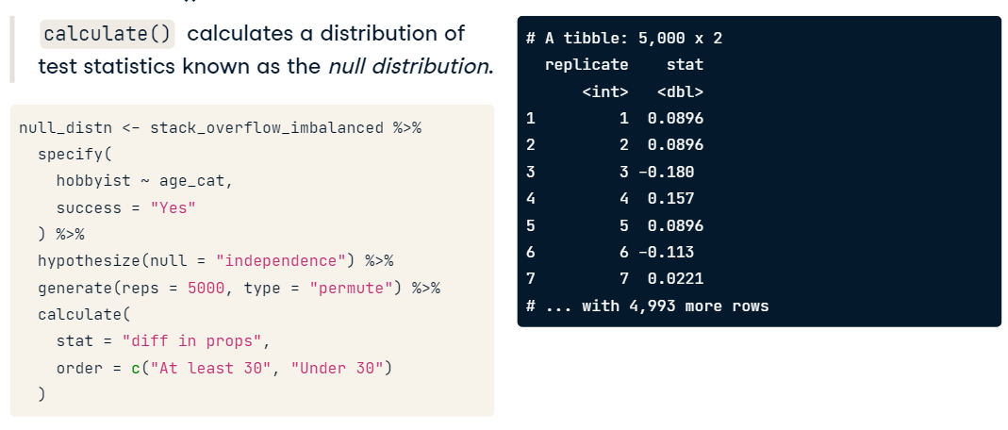

**visualize():** Shows an histogram to let us know if we could run a parametric test.

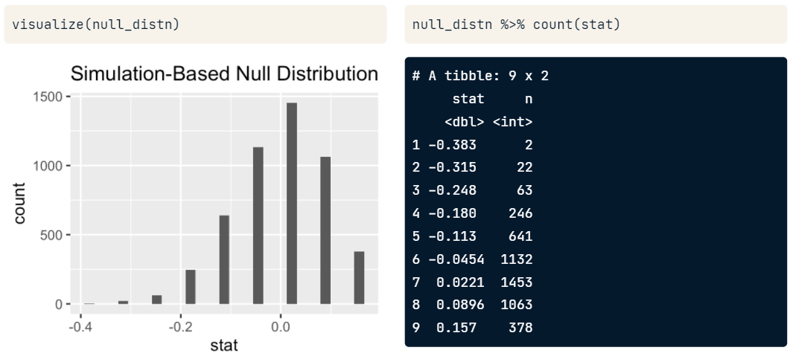

**Getting results of the model**

we need to compare the null distribution to the test statistic from the *original dataset*.

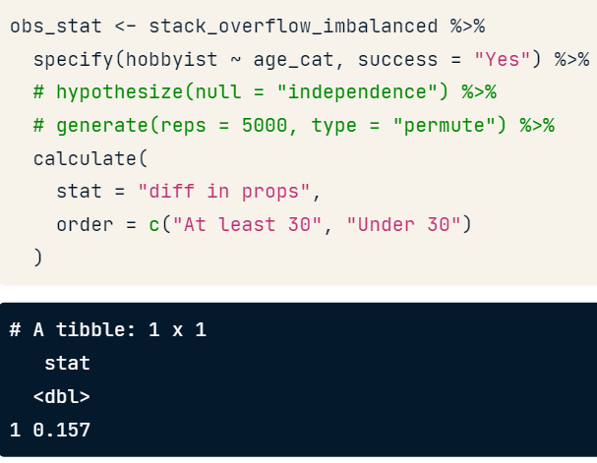

Then we need to compare this value in the null distribution.

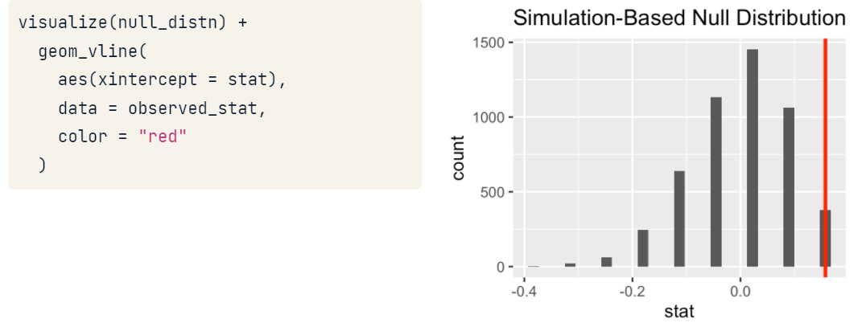

Then now we can calculate the p-value.

|  |  |
| --- | --- |
|  | *direction:*  A character string. Options are:   1. "less" 2. "greater" 3. "two-sided" |

### Rank-based

#### Wilcoxon-Mann-Whitney test

Is a t-test on ranked data.

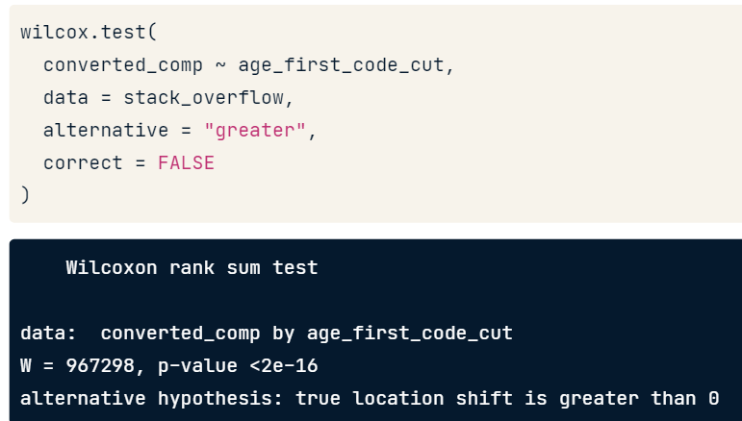

#### Kruskal-Wallis test

Is an ANOVA on ranked data.

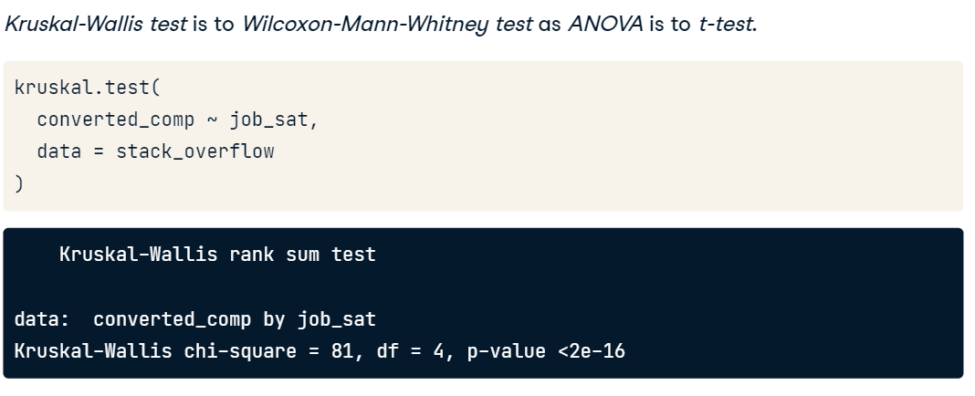

# Spatial statistics

## Plotting point in base R

So spatial plots should have scales so that one unit in the X axis is the same size as one unit on the Y axis.

aspect ratio = 1:1

mapxy <- function(a = NA){

plot(x, y, asp = a)

rect(xmin, ymin, xmax, ymax)}

mapxy(1:1)

**disc()** function, that creates a circular window.

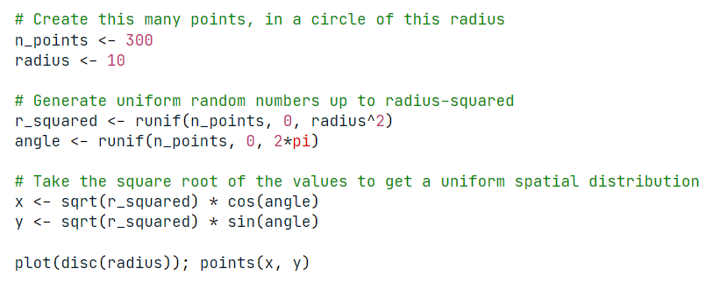

## Quadrat (count) test (spatstat package)

The simplest point process model is "**complete spatial randomness**", or "**CSR**" for short.

In which the window is divided into parts - typically 20 or so squares - and then the number of points in each square are counted. If the process is completely spatially random, then the numbers of points in the subregions comes from a Poisson distribution. The differences between observed counts and expected counts lead to a test statistic with a chi-squared distribution.

|  |  |
| --- | --- |
|  |  |

1. Create a ppp object with the points

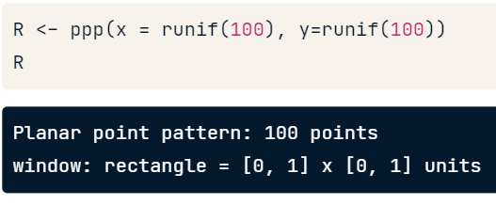

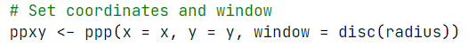

1. We take the ppp object into quadrat.test

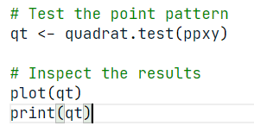

Tremendous testing! The p-value of the quadrat test is much bigger than 0.05, so you can not reject the hypothesis that the points are completely spatially random.

**area()** function of spatstat will compute the area of a window

**rpoispp()** function given an intensity and a window, that are not conditioned on the total.

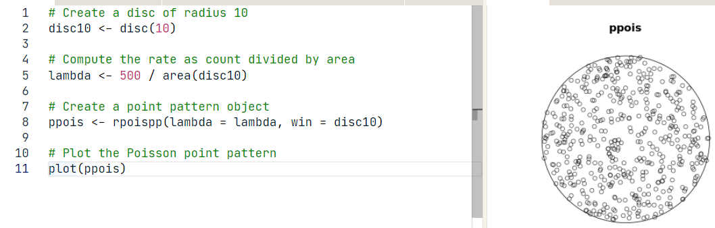

# Linear Regression

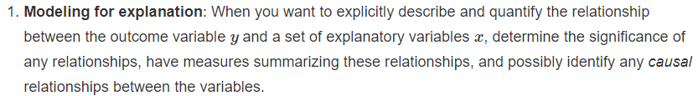

* Most crucially, looking at the raw data values.
* Computing summary statistics, such as means, medians, and interquartile ranges
* Creating data visualizations.

At the end, it should have:

* A sense of the distributions of the individual variables in your data
* Whether there are outliers and/or missing value
* Whether any potential relationships exist between variables

library(moderndive)

## Min number of observations per coefficient

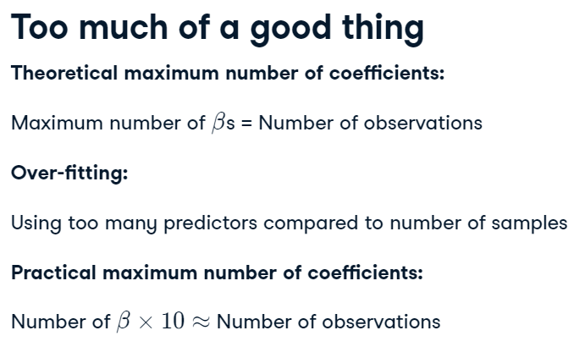

## Correlation calculation

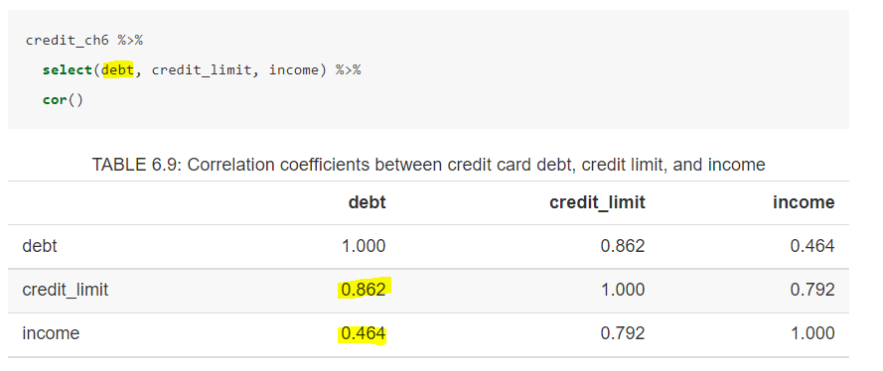

## Model Creation

### 1 numerical explanatory variable

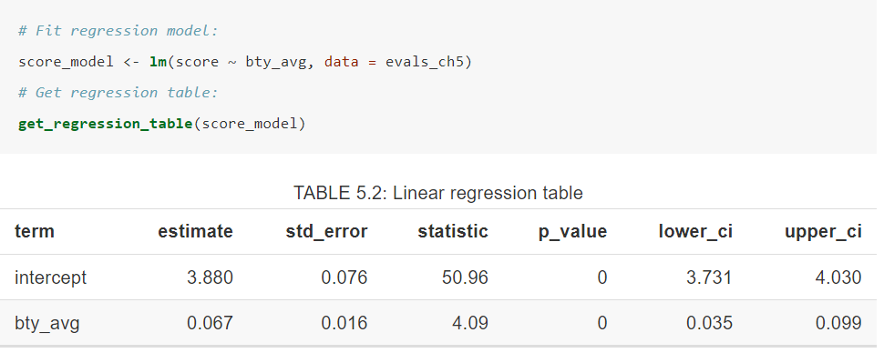

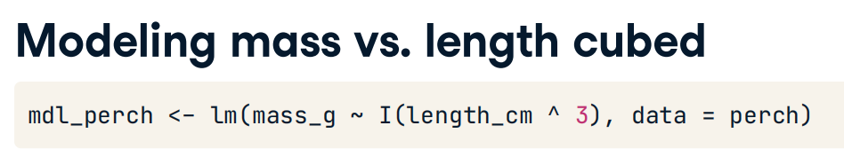

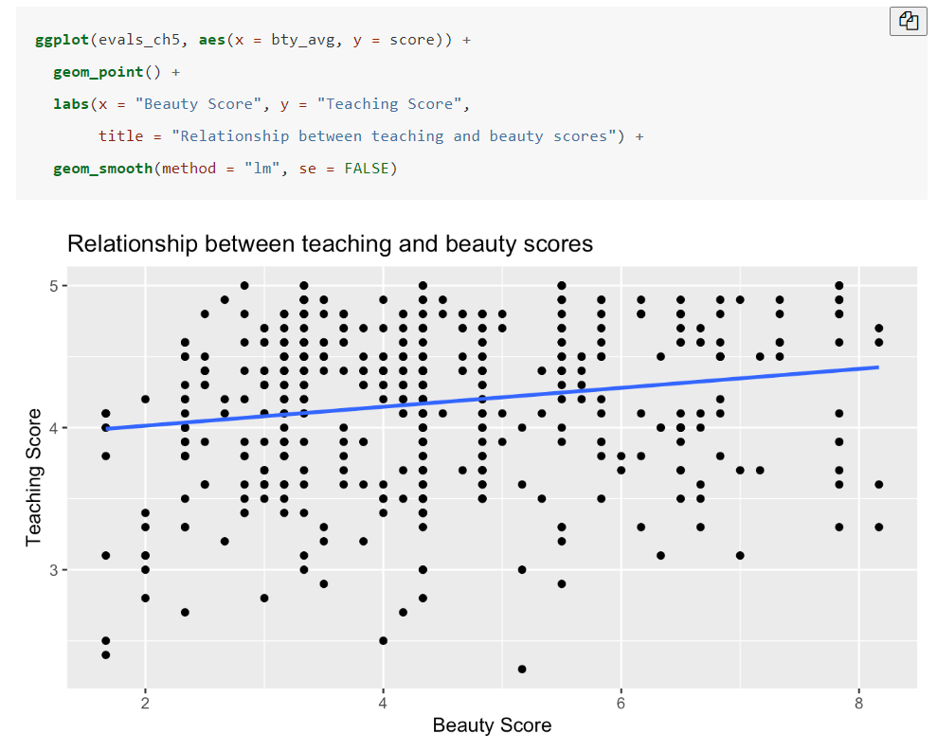

### 1 categorical explanatory variable

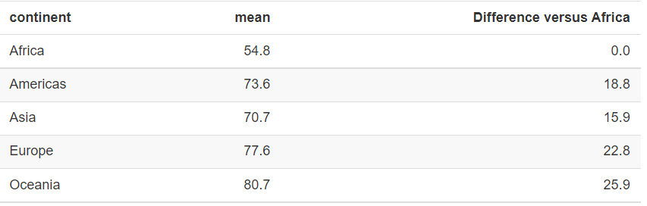

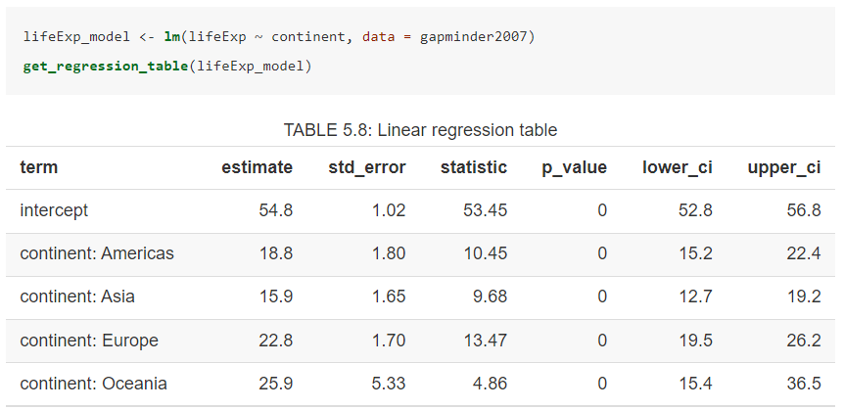

We can also eliminate the Intercept by writing “+0” after the variable.

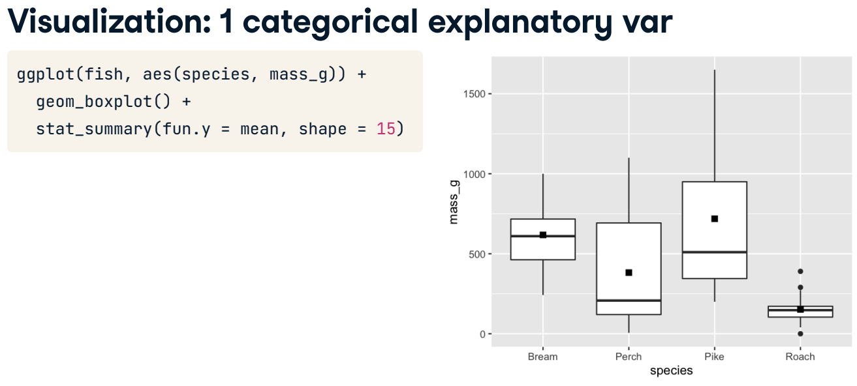



### 1 numerical and 1 categorical

+ allows us to get one slope for both categories.

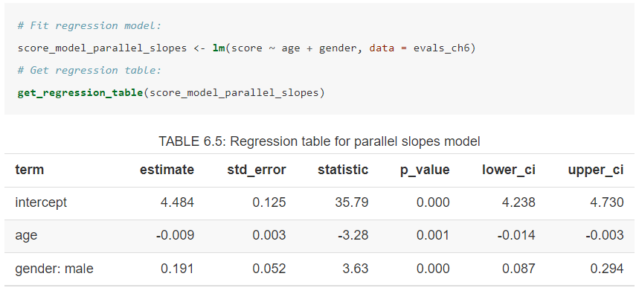

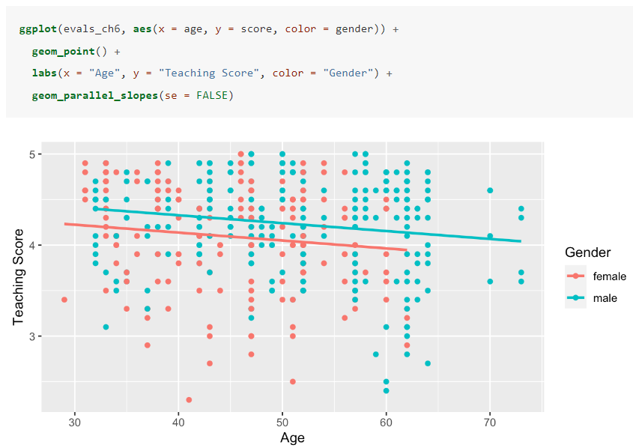

* allows us to get all model interactions. In this case we will have an interception and one slope for each categorical variable.

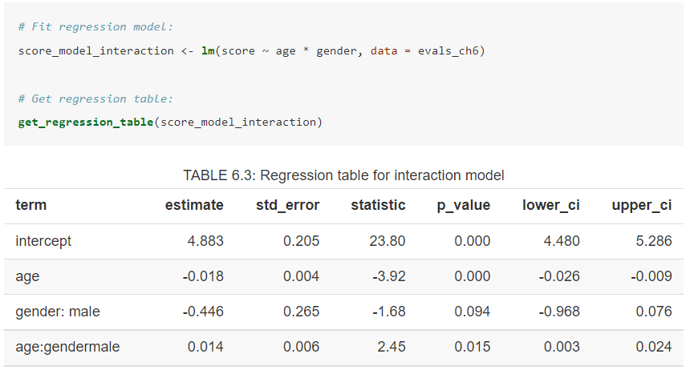

We can get the same result by writing the interaction by hand.

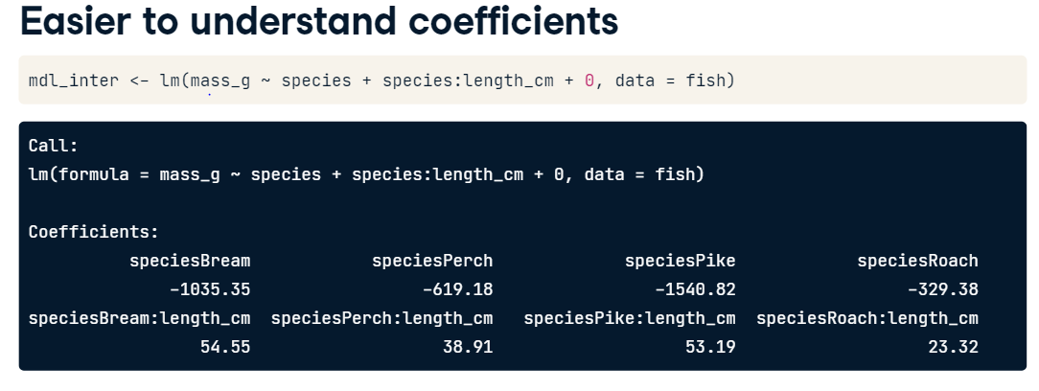

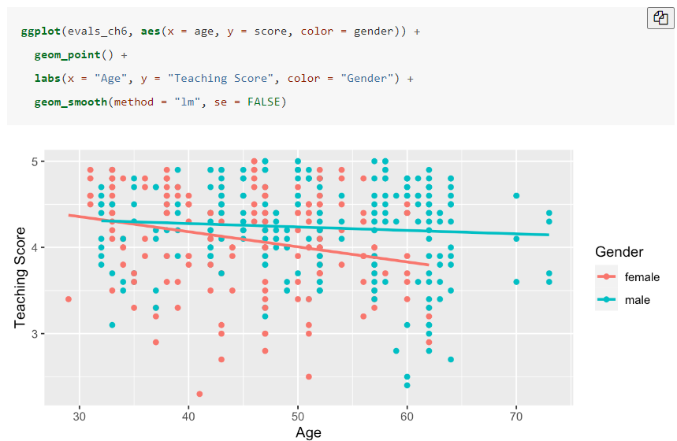

We can limit interaction level using the next syntax

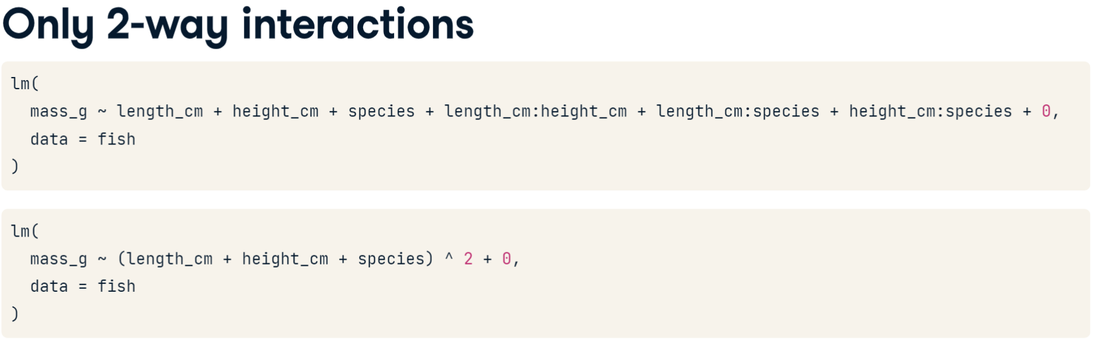

### 2 Numerical variables

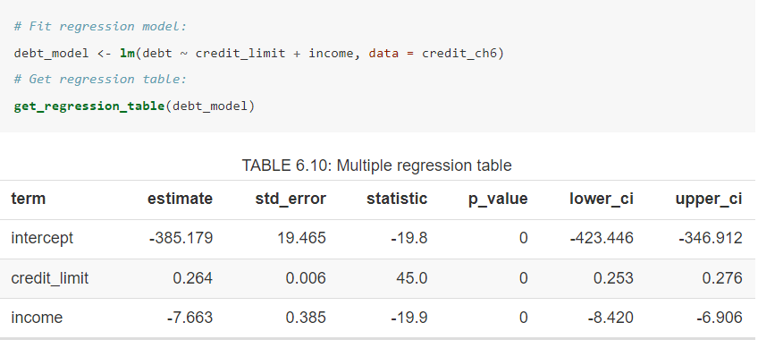

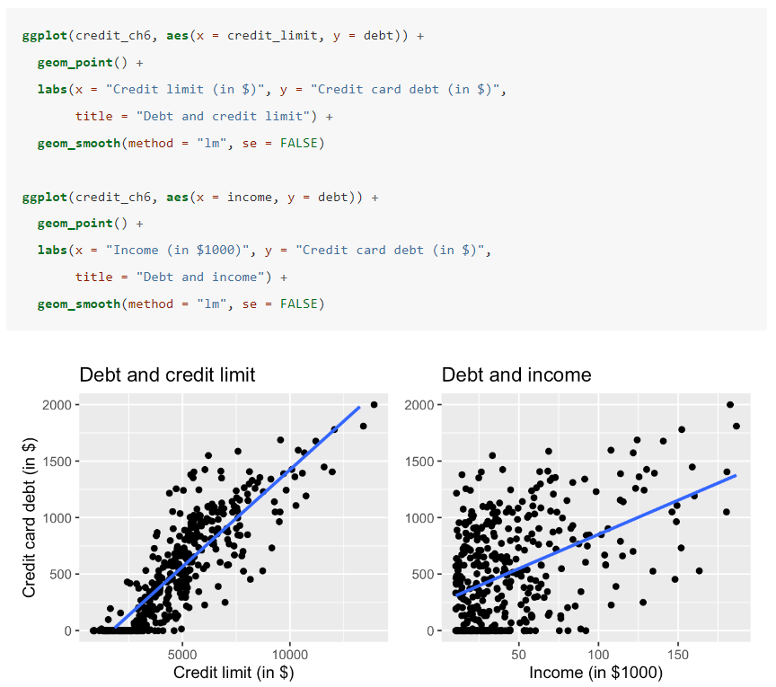

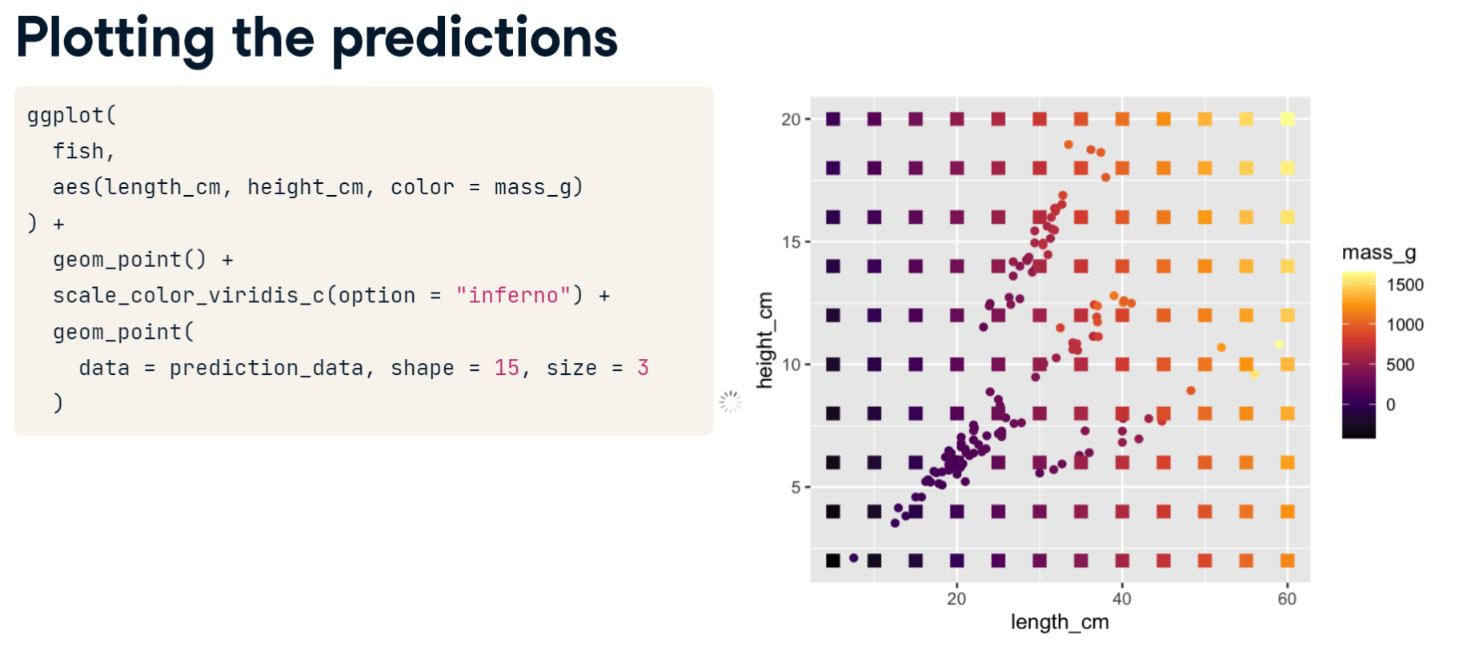

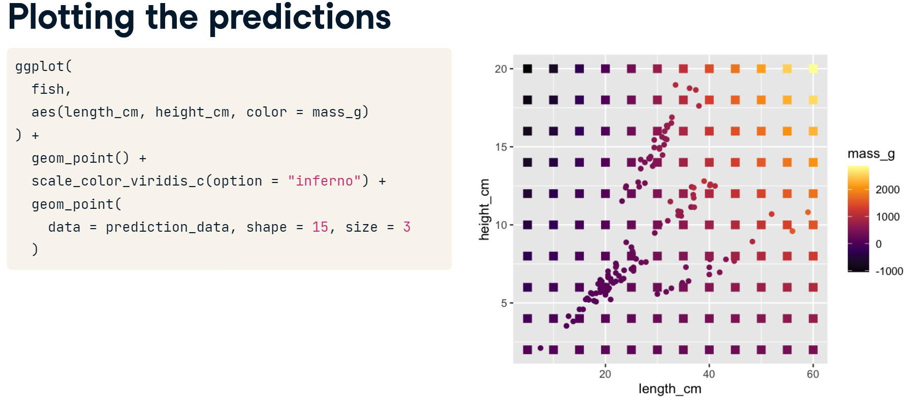

## Model selection

We should try to keep the model as simple as possible. Here is an example where adding the interaction doesn’t affect the result too much.

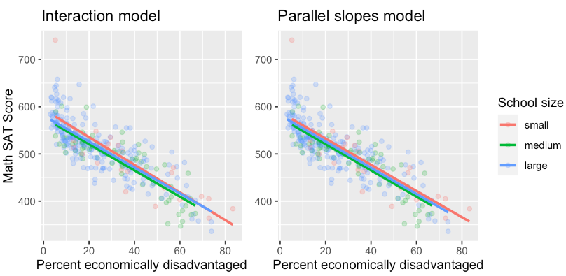

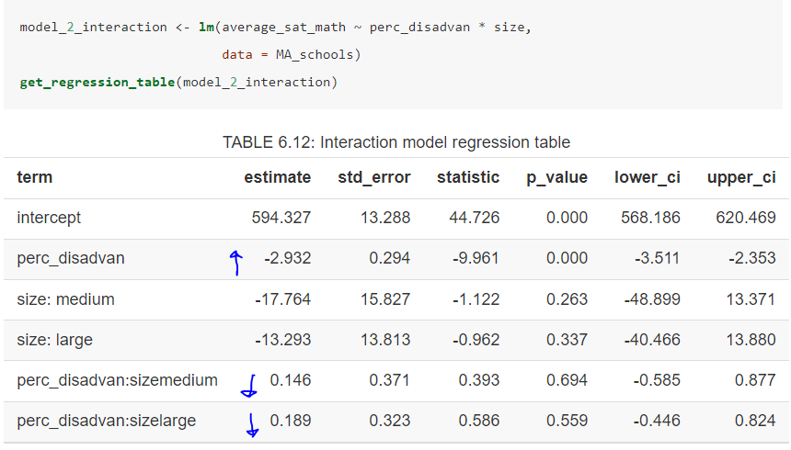

## Math under regression

Sum of squared (SS) residuals around the mean.

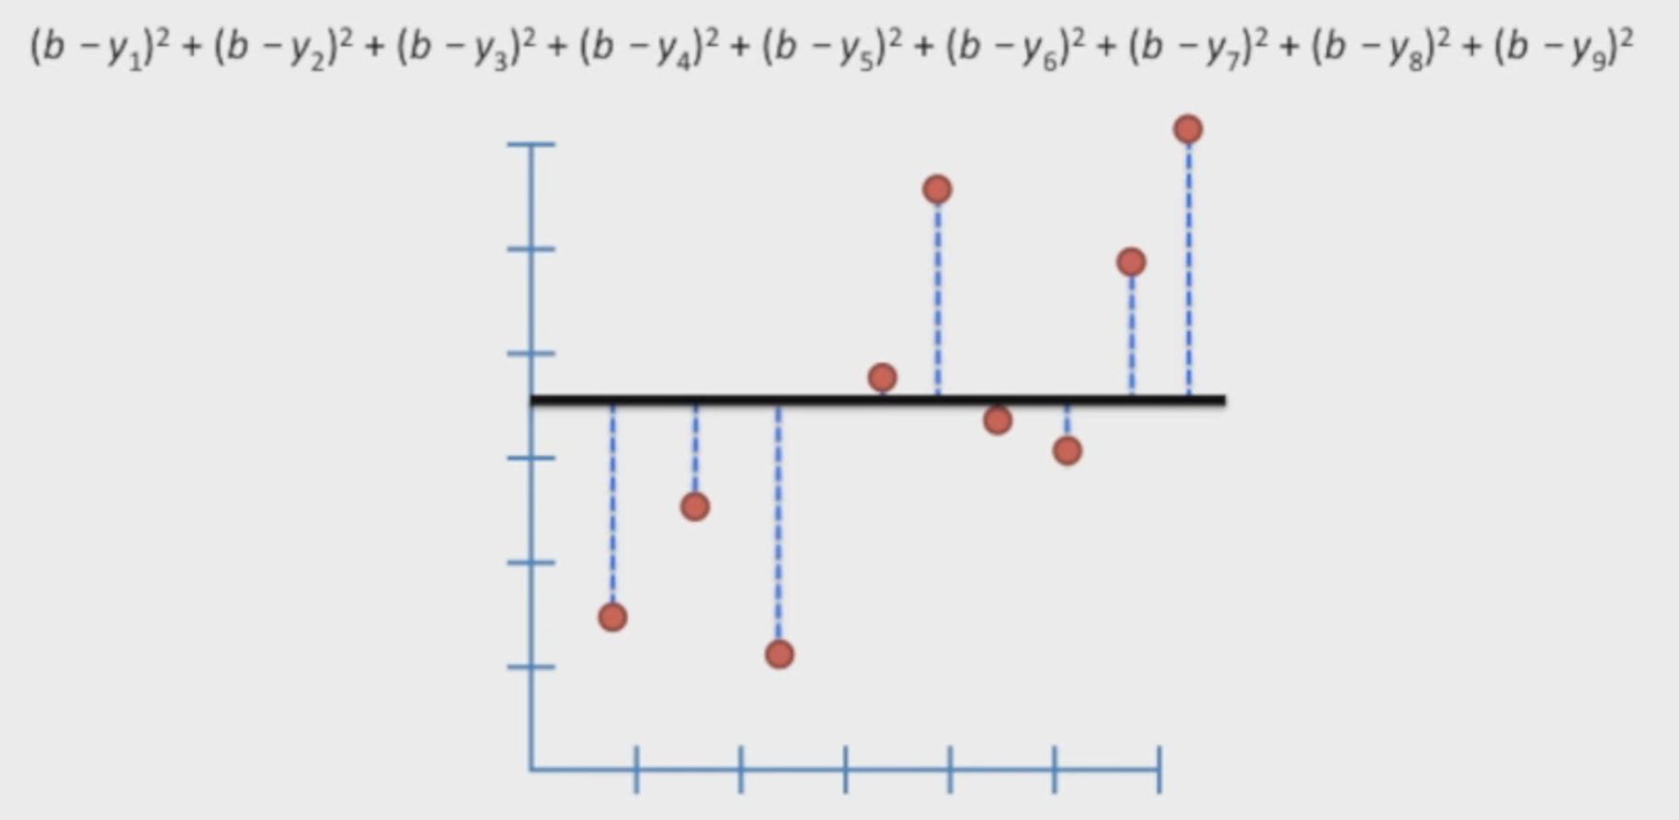

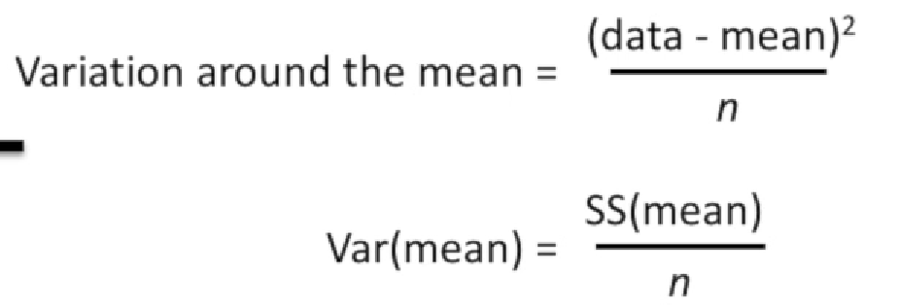

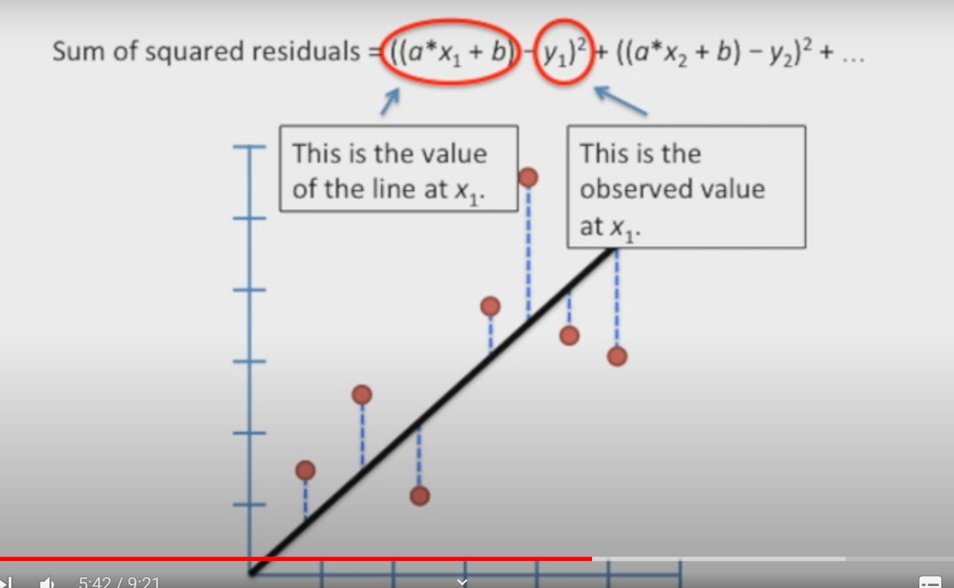

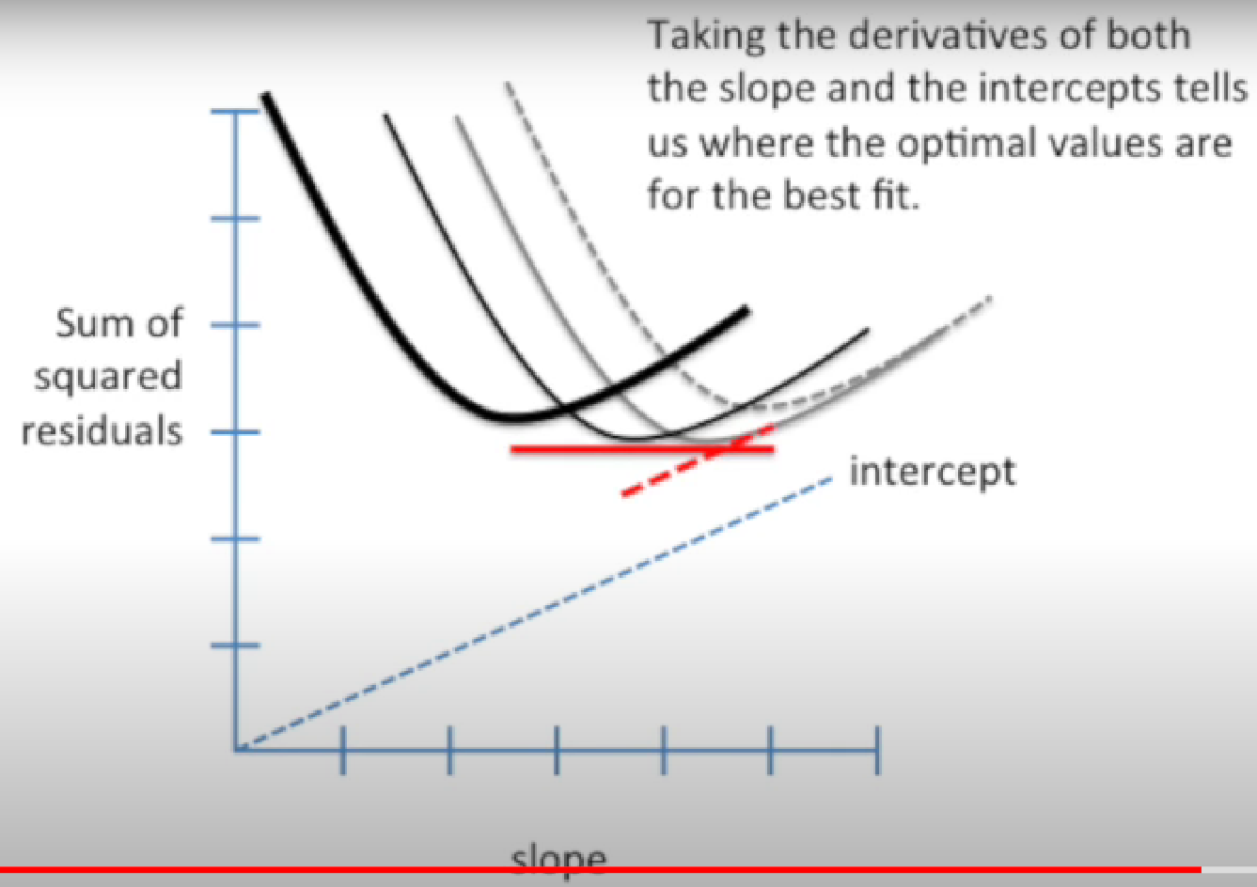

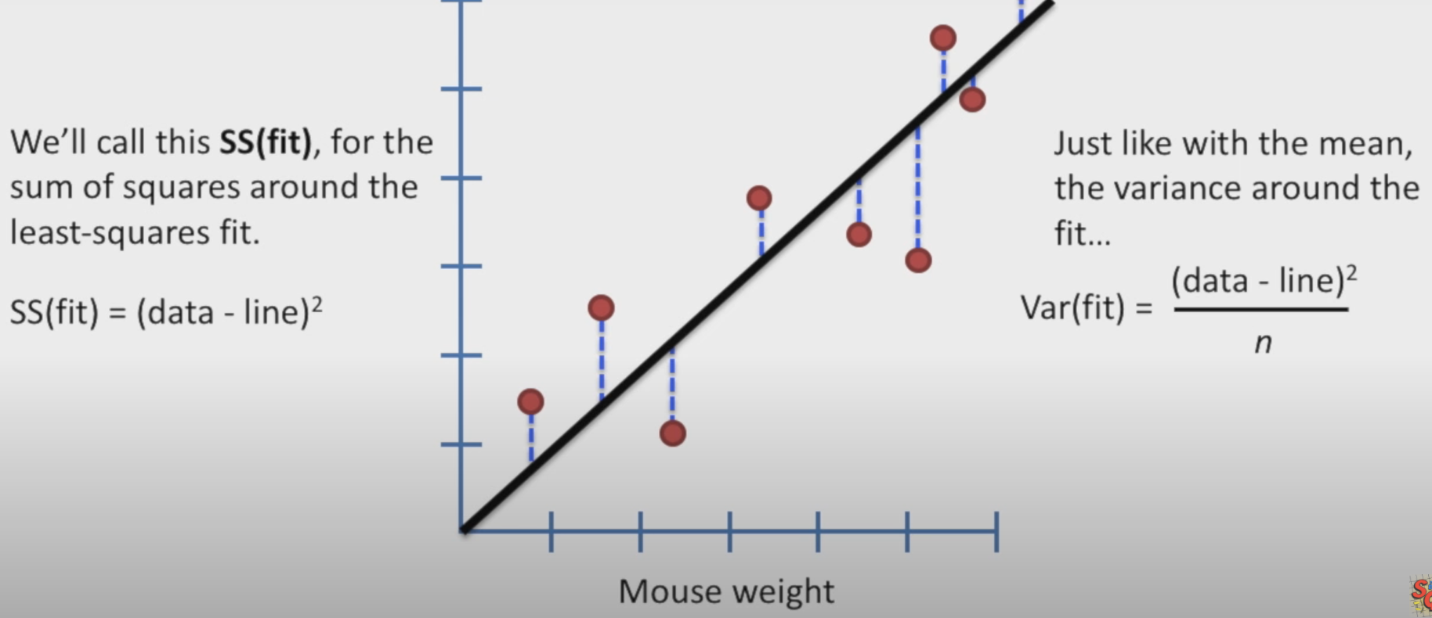

|  |  |
| --- | --- |
|  |  |

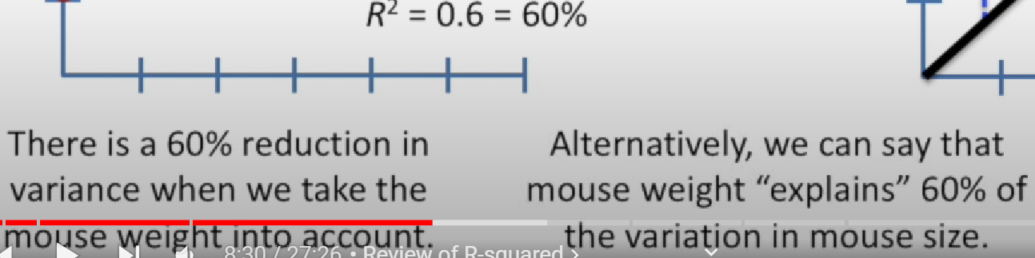

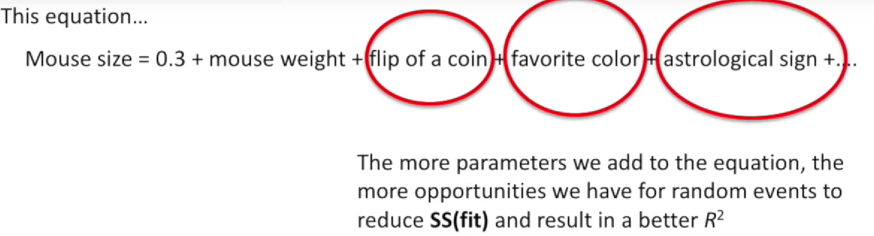

So

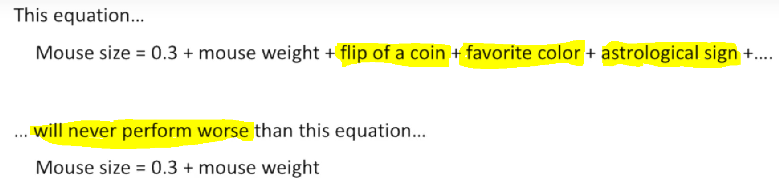

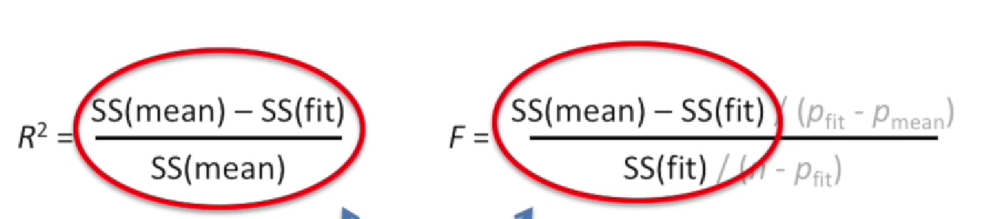

pfit: Numero de parametros en una muy simple son la pendiente y el intercepto.

pmean: Como la media es un solo valor.

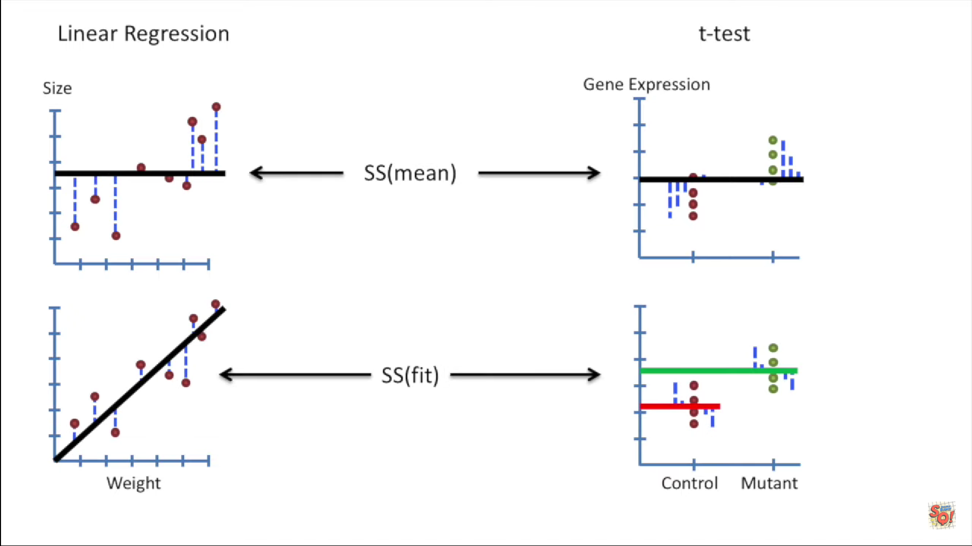

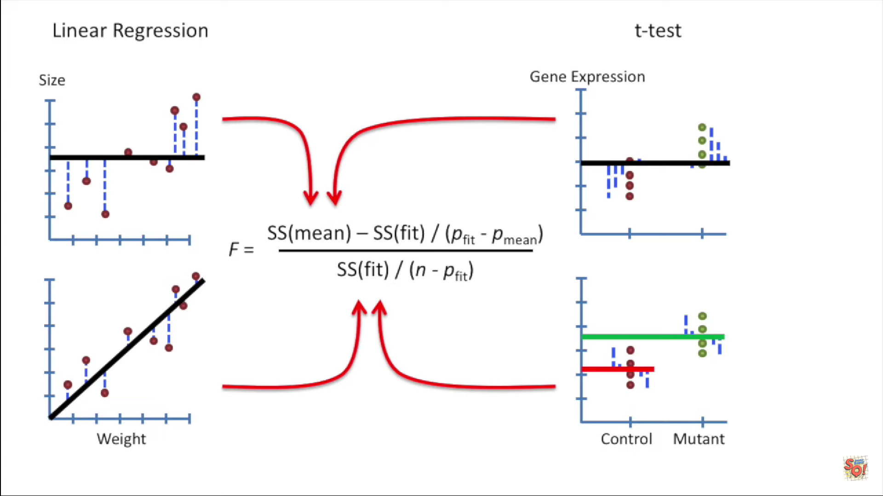

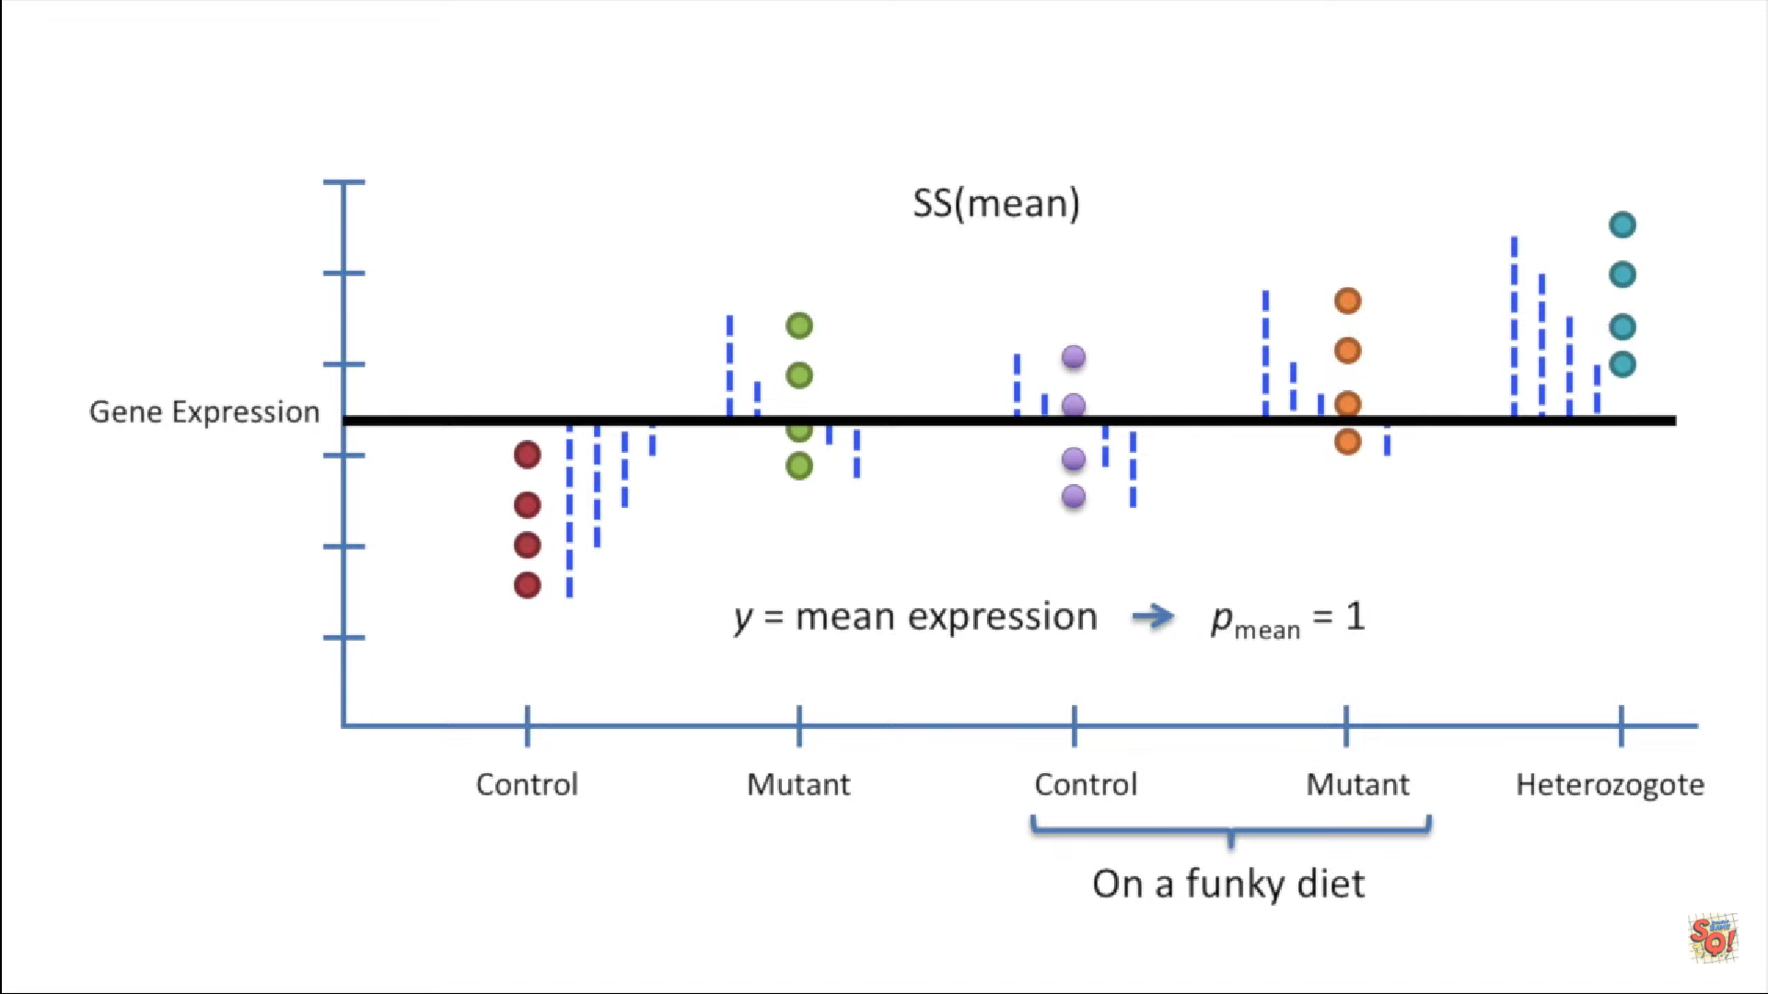

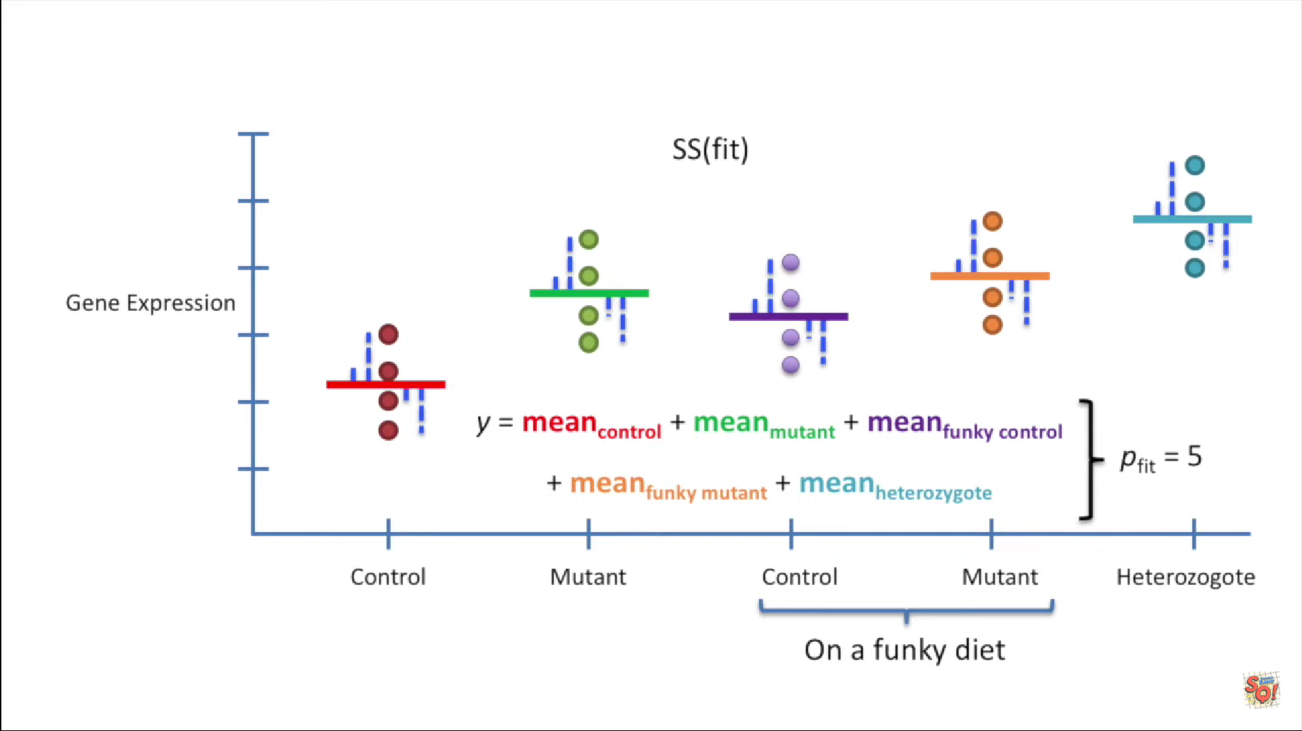

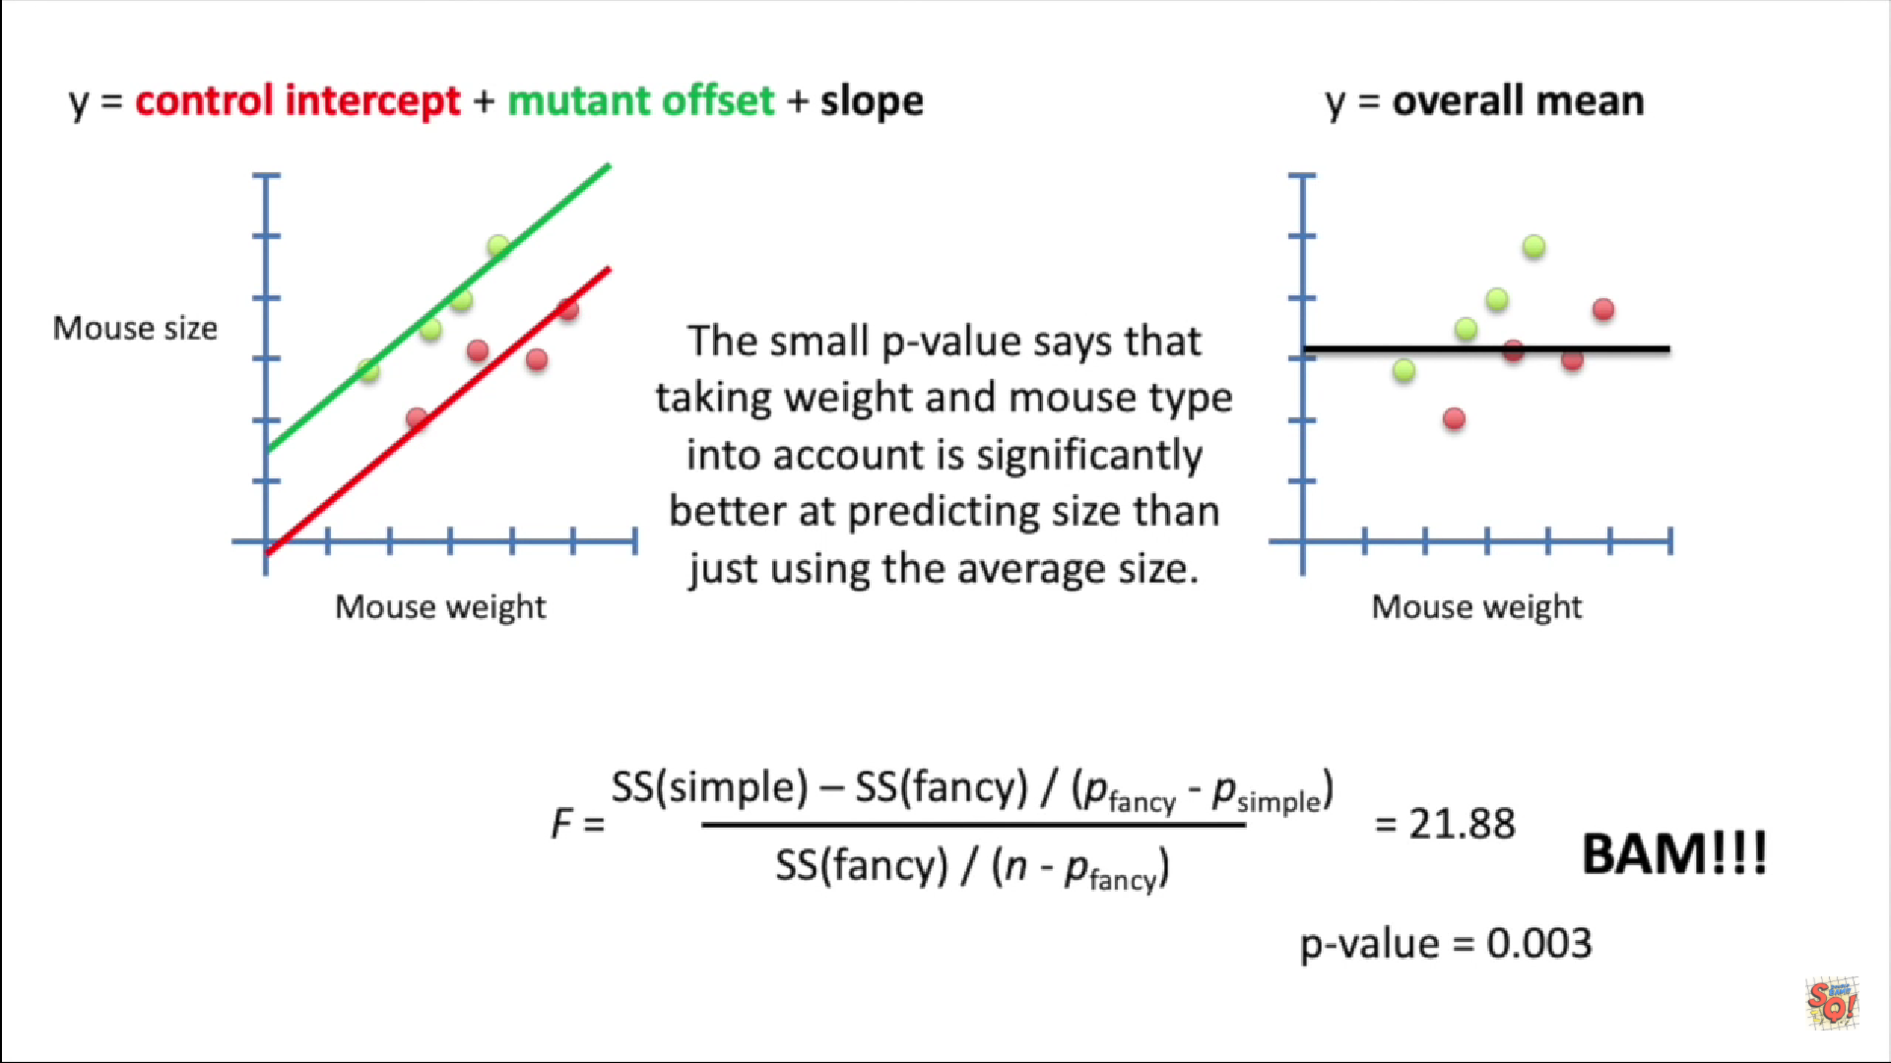

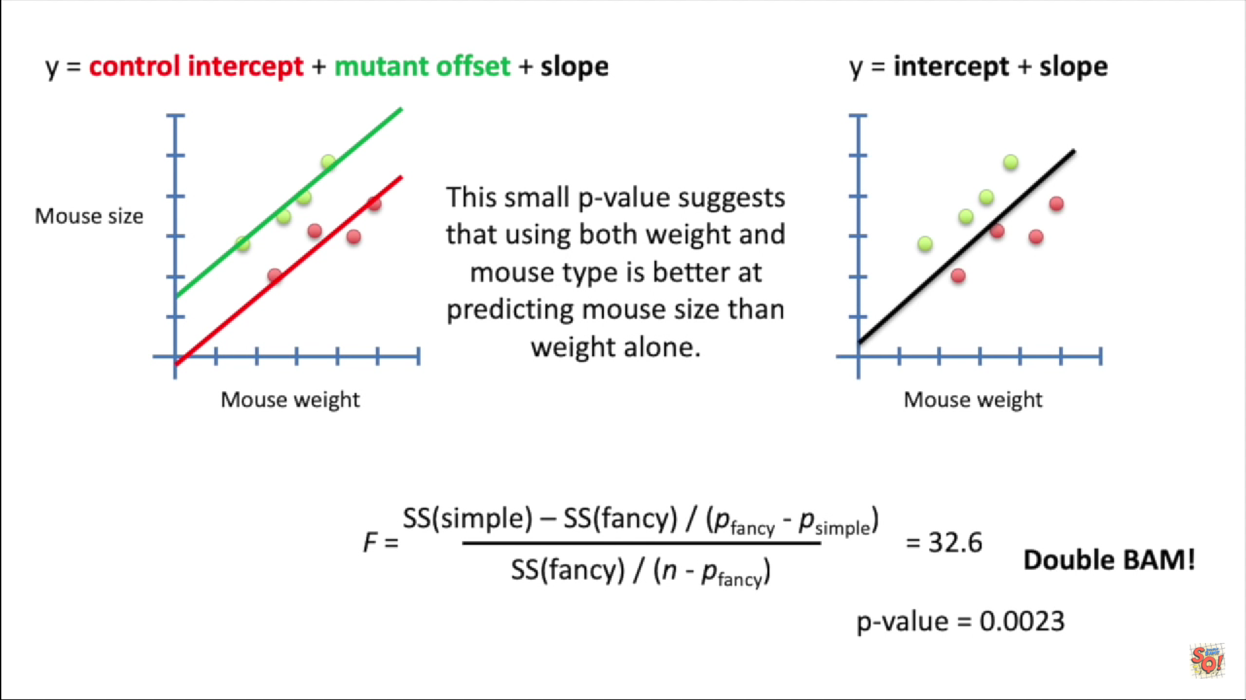

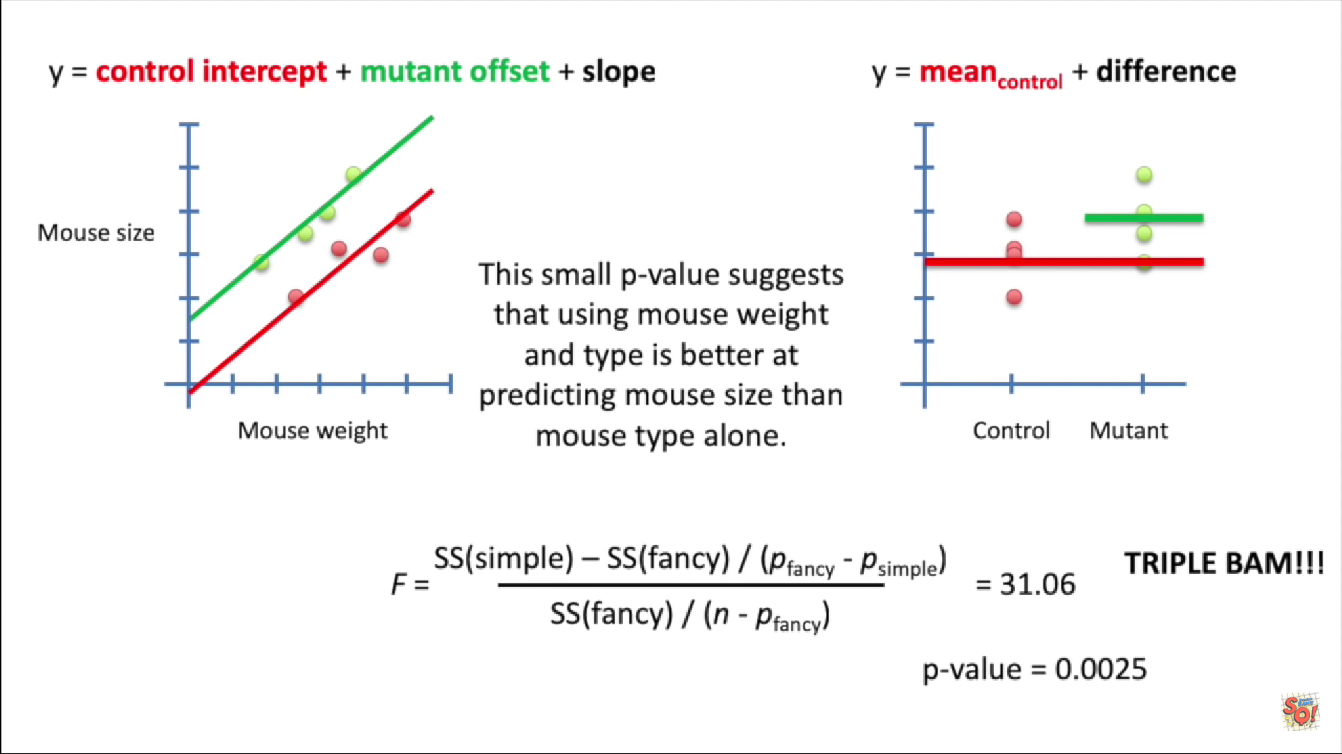

Aqui estamos bloqueando la diferencia que pueden tener los laboratorios en el estudio.

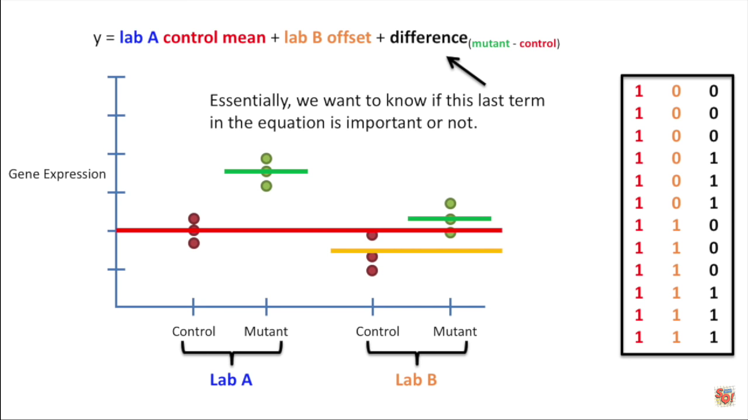

Por lo que solo nos consetramos en el ultimo coeficiente de la ecuacion.

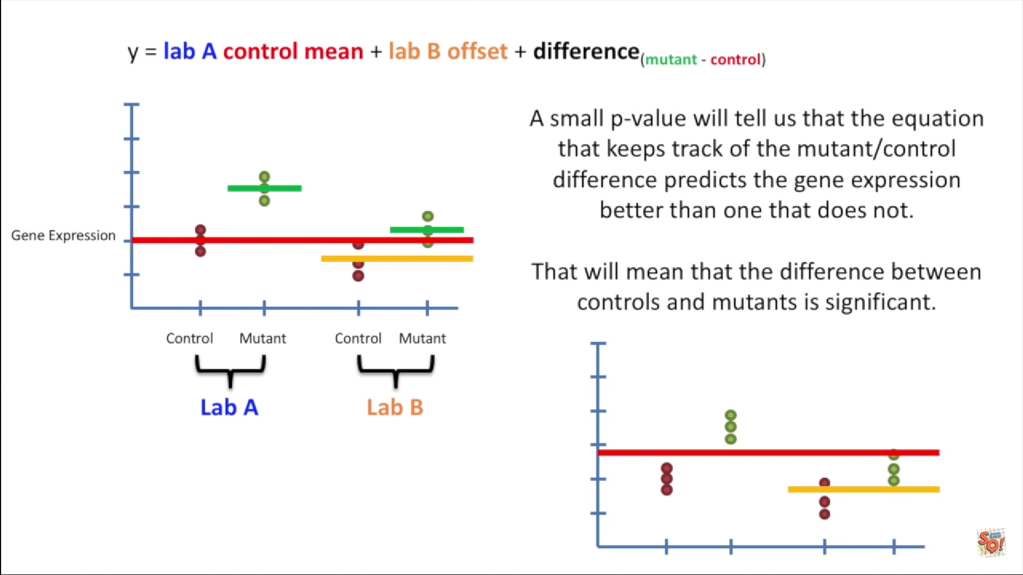

## Correlacion en Xs y sus efectos

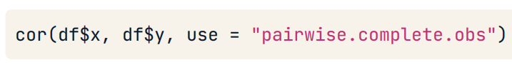

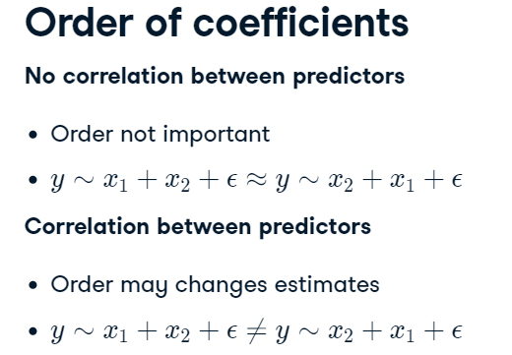

## Transformaciones iniciales para normalizar datos

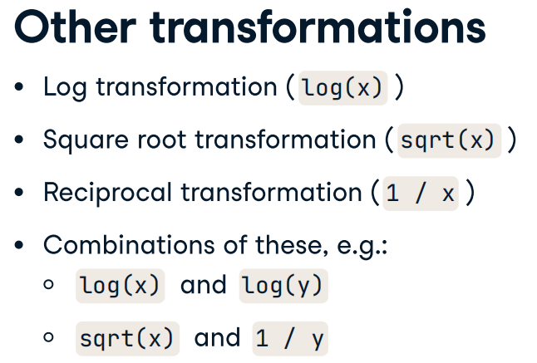

## Extraer partes del modelo

### Base R

*Extraer los coeficientes*

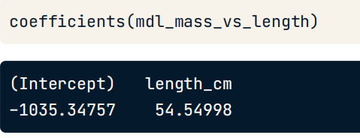

*Extraer la predicciones con la data de entrenamiento*

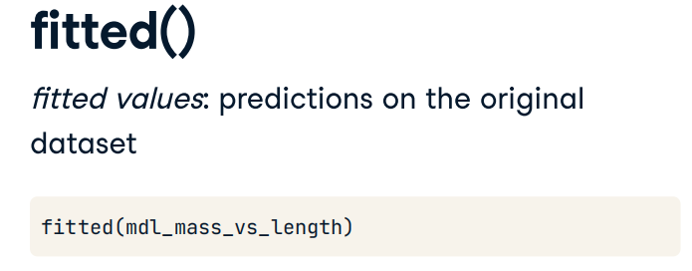

*Extraer los residuales del modelo*

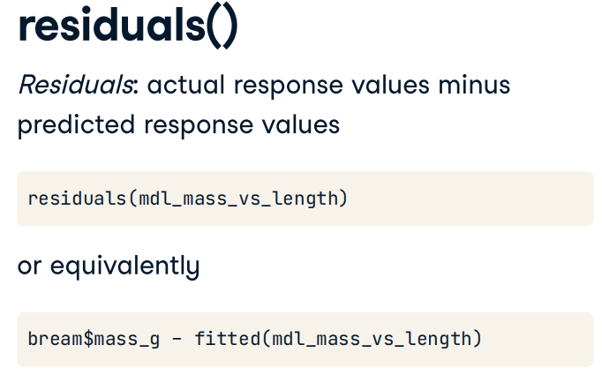

*Resumen del modelo con la data de entrenamiento*

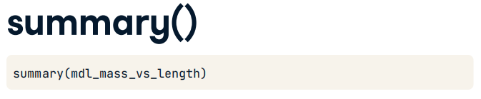

### Broom package

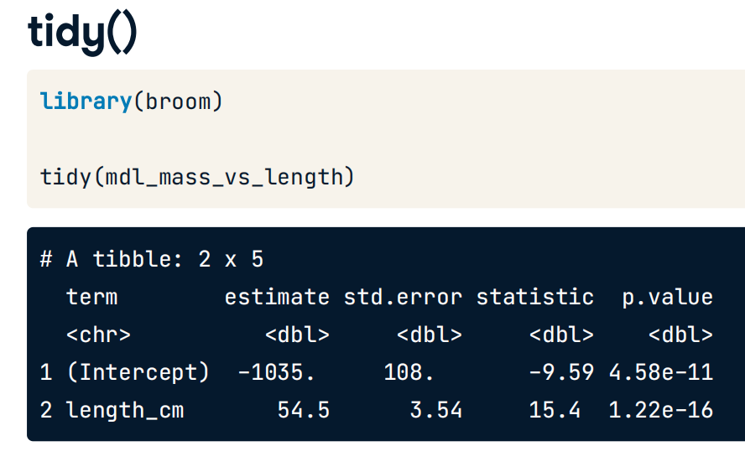

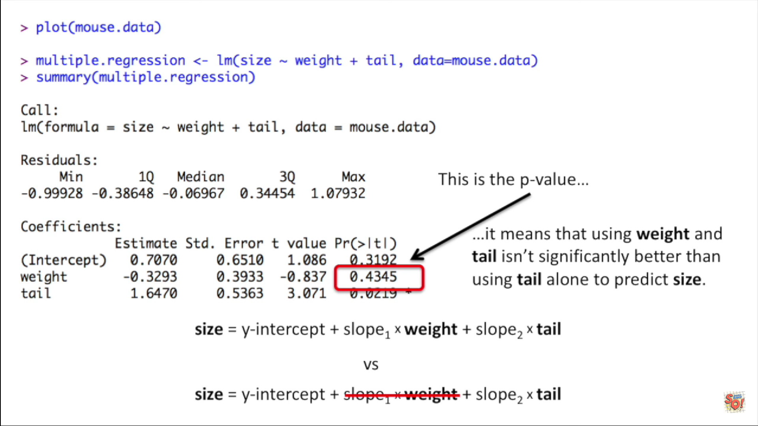



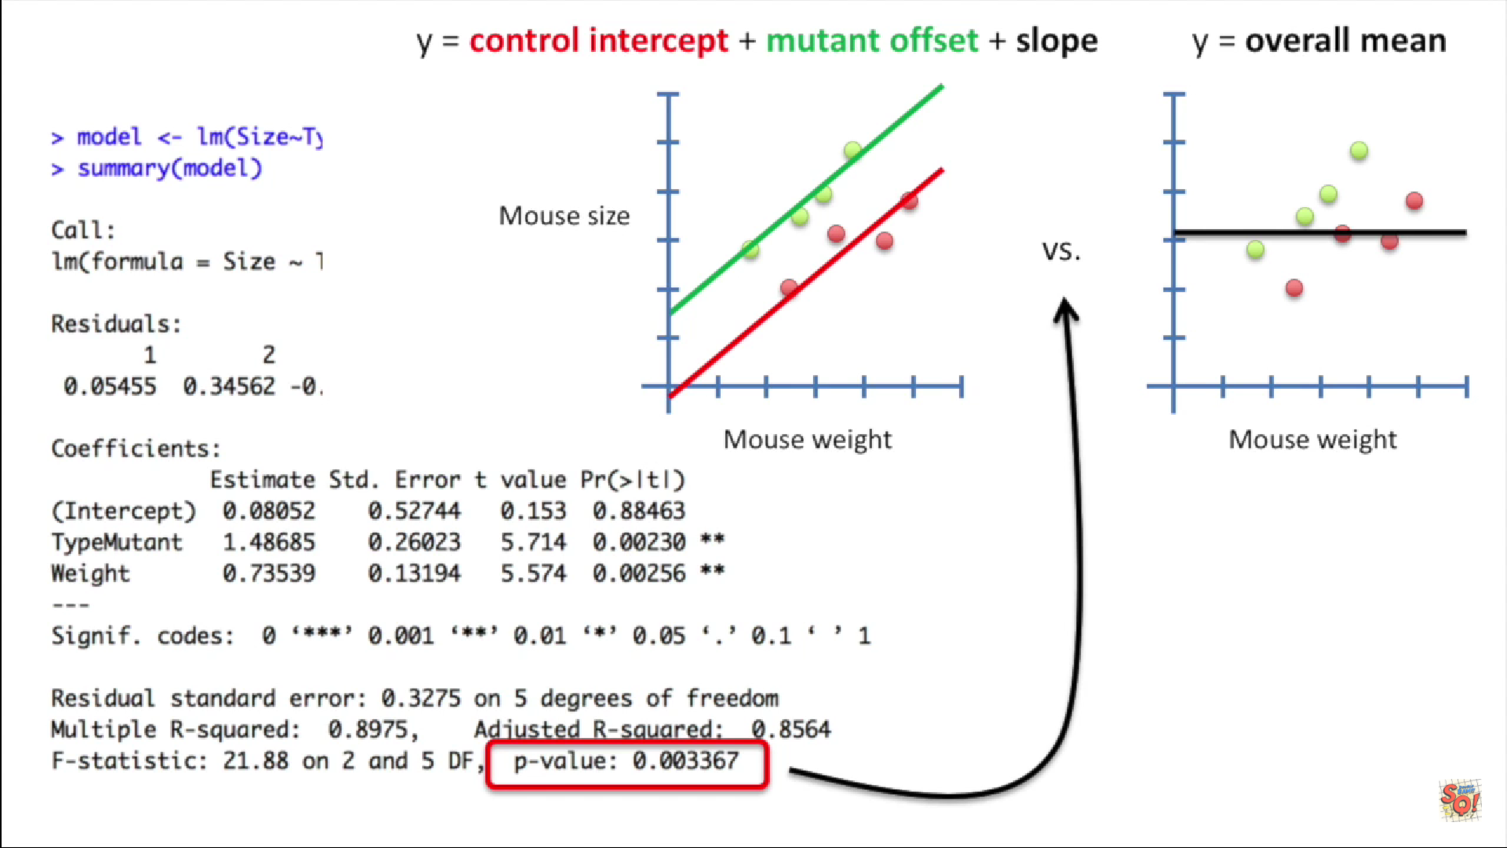

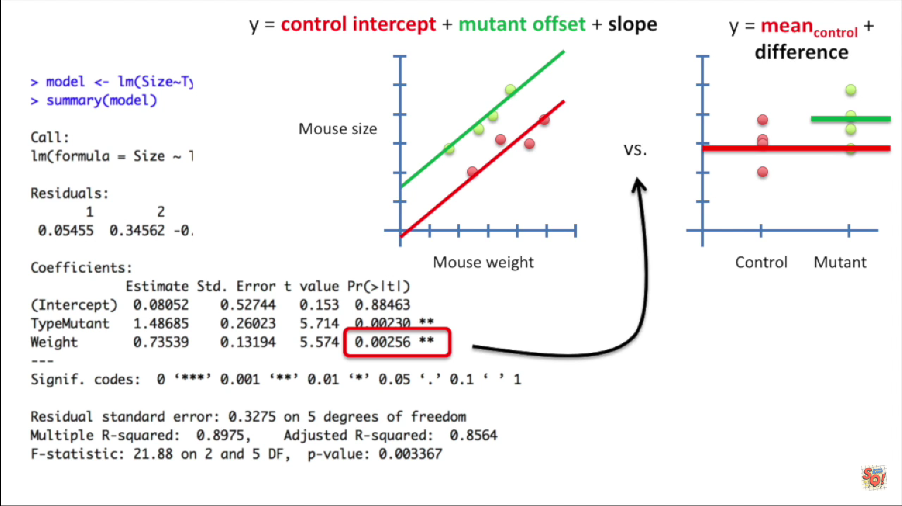

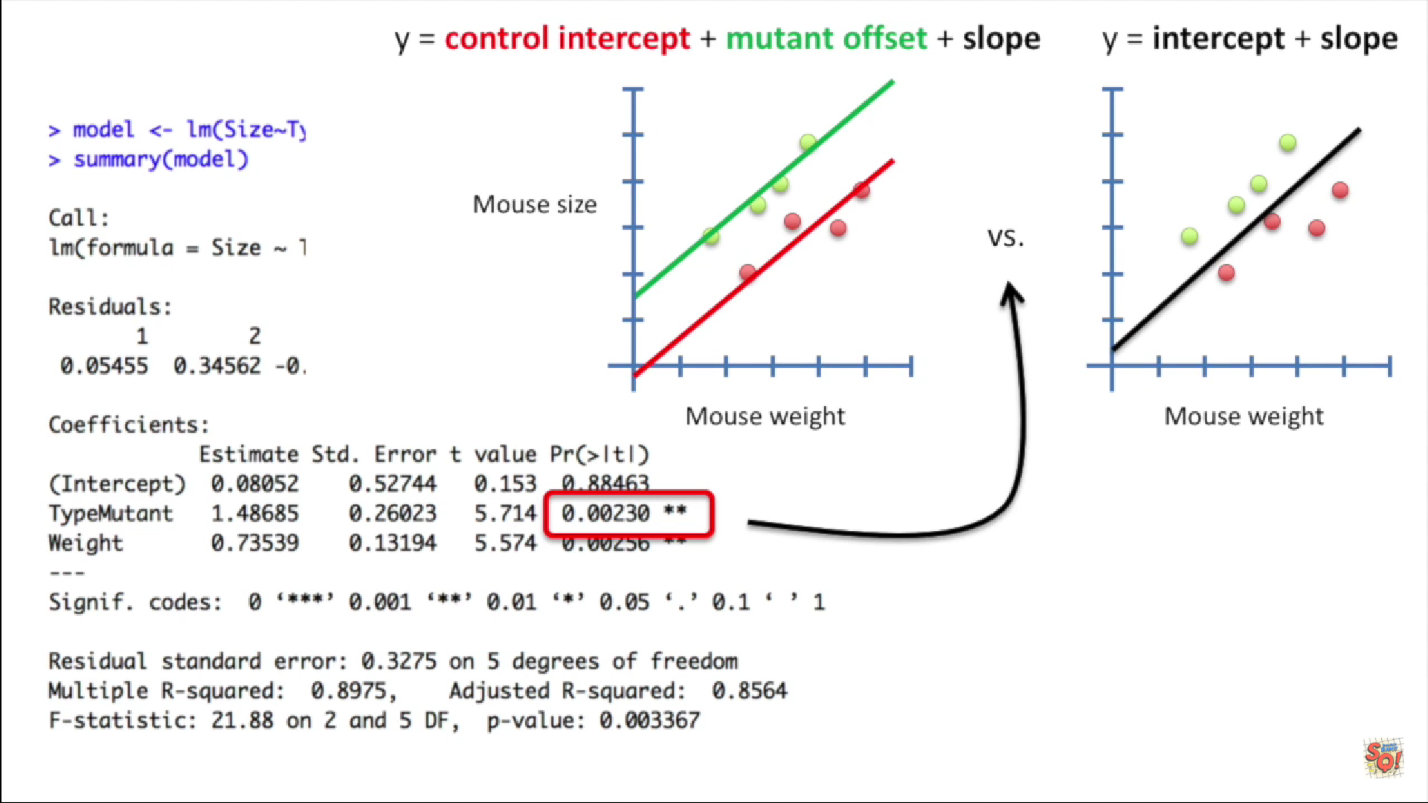

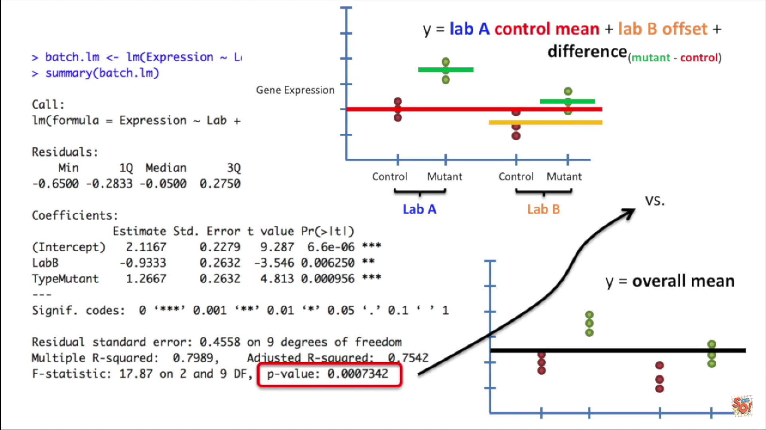

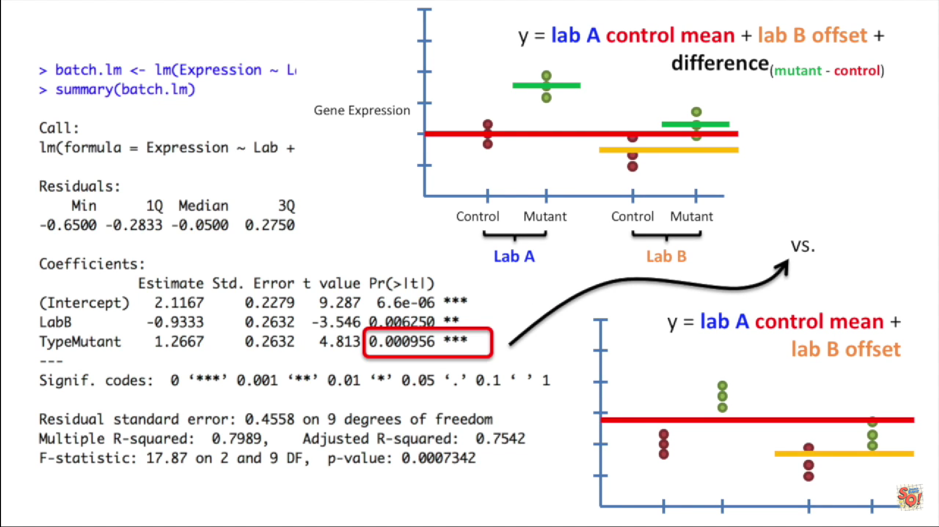

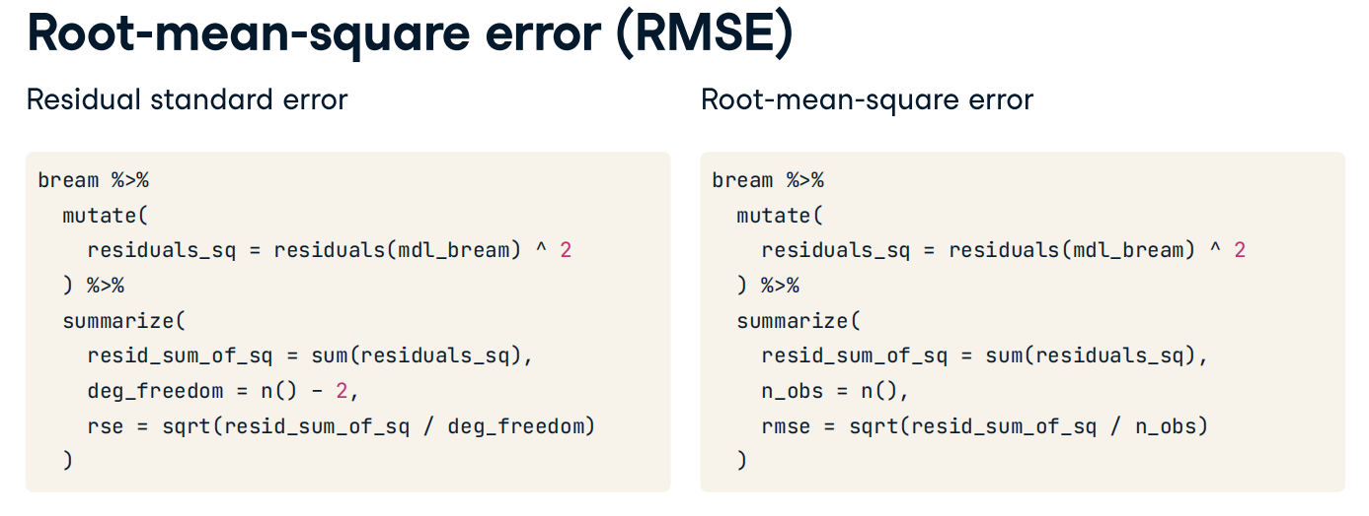



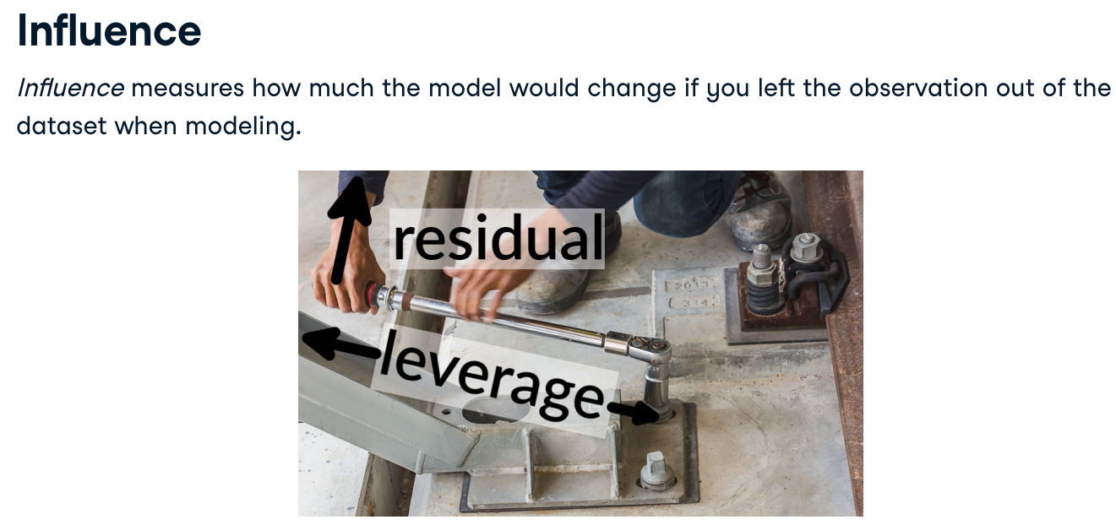

RSE == sigma

Leverage == .hat

Influence == .cooksd

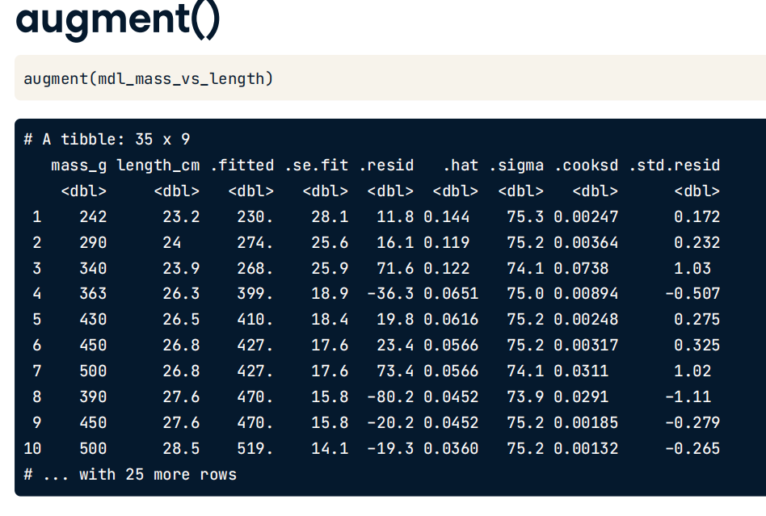

**R2**

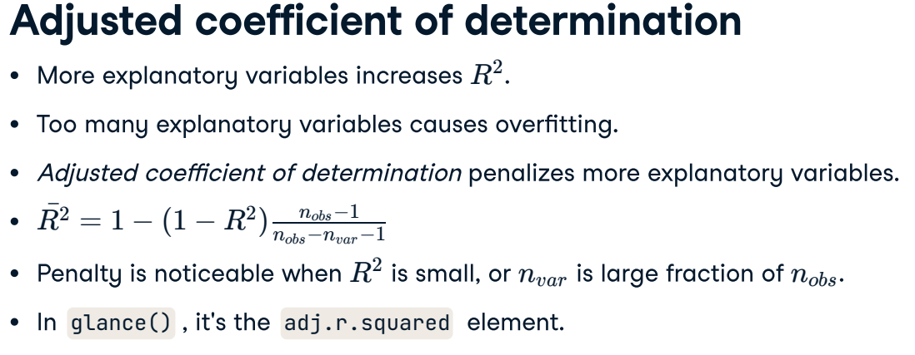

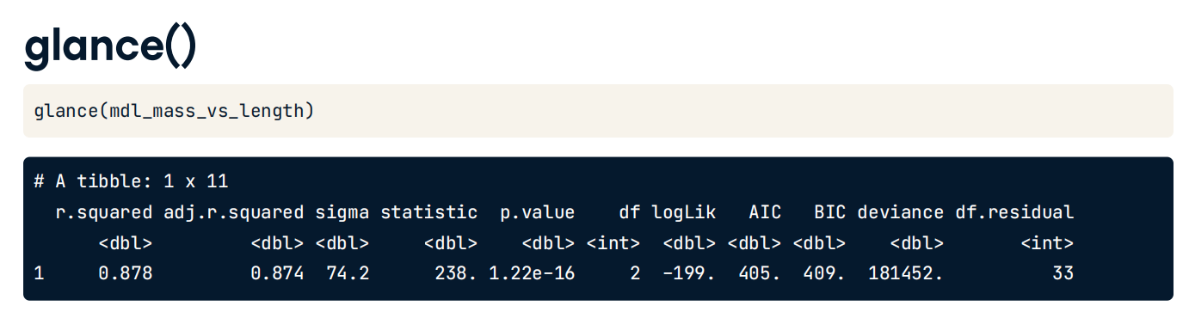

### ggfortify for quality regressions plots

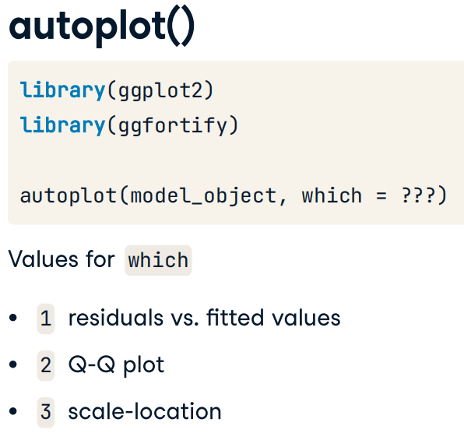

## Predecir nuevos datos

### Una variable predictiva

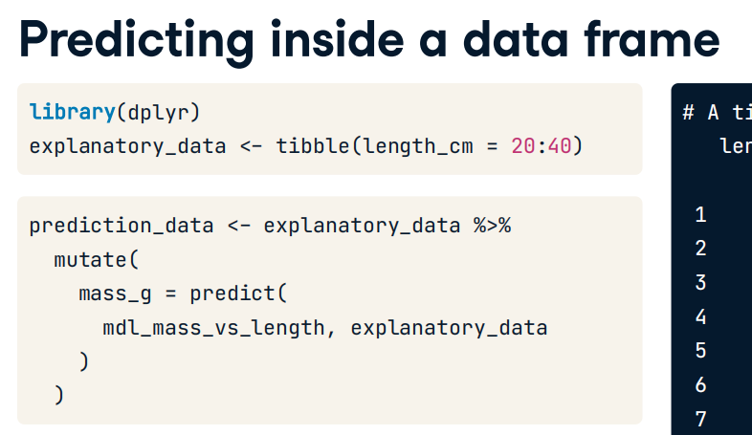

### Varias variables

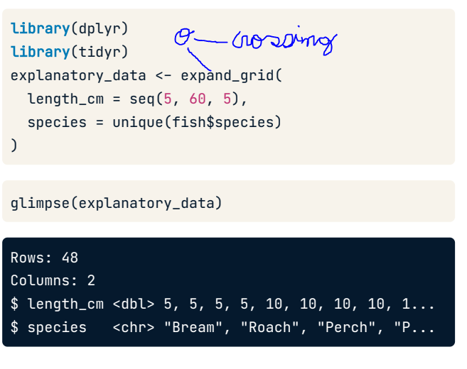



### Una variable transformada

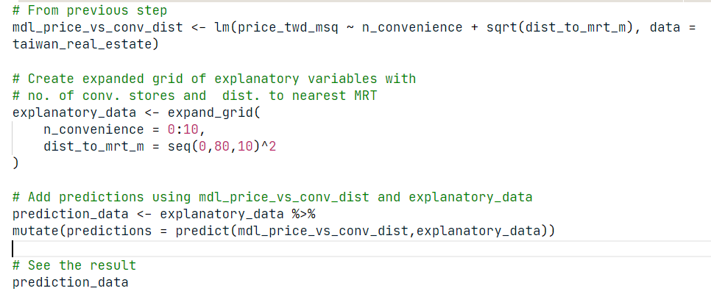

## Graficar las predicciones del modelo

### 1 con

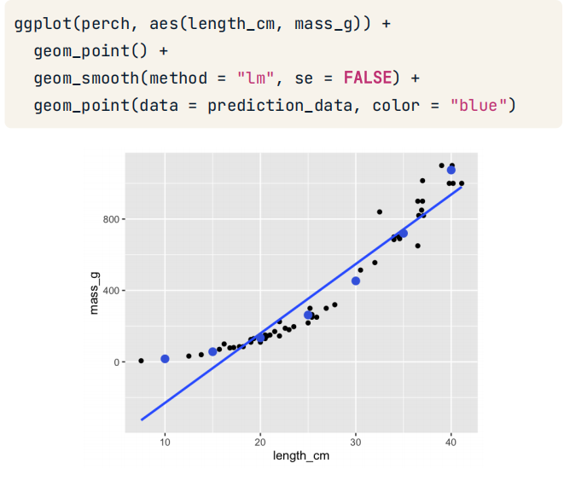

### 1 cat

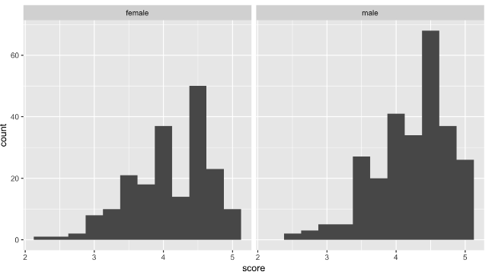

### 1 cat y 1 con

Sin interacción

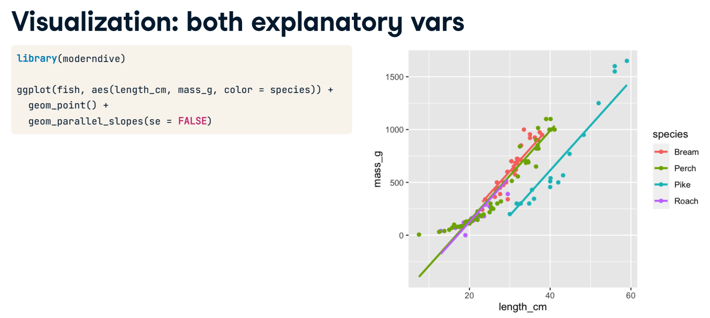



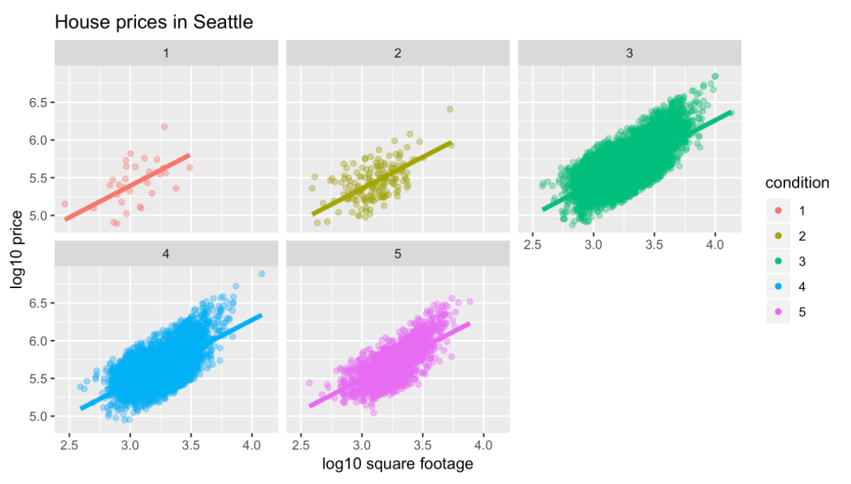

Con interapción

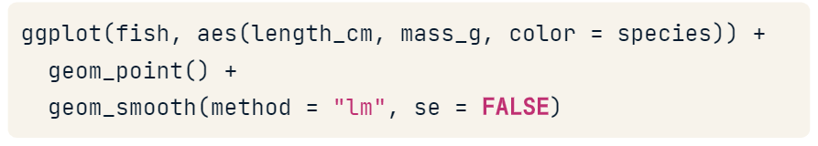

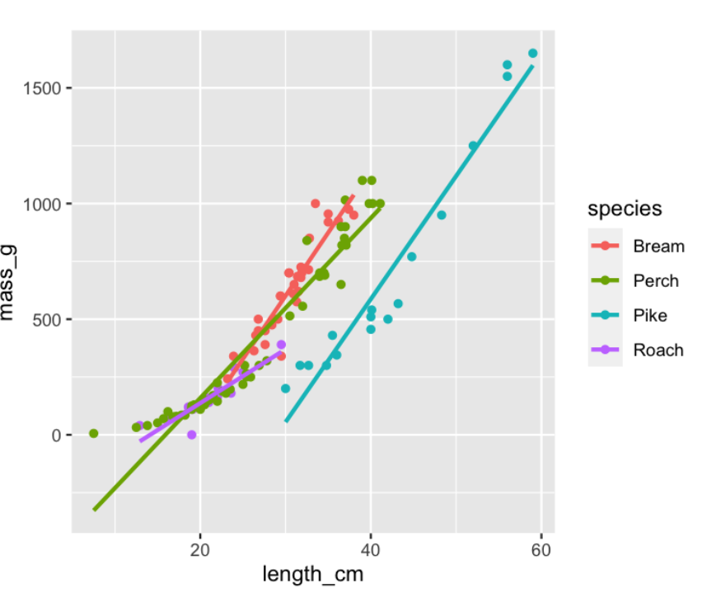

### 2 con

### 2 con y 1 cat

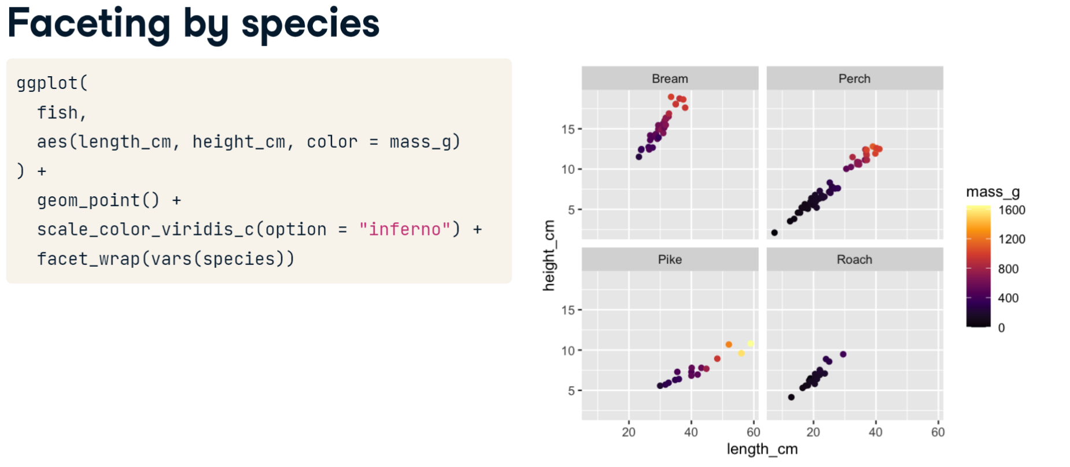

### Simpson’s Paradox

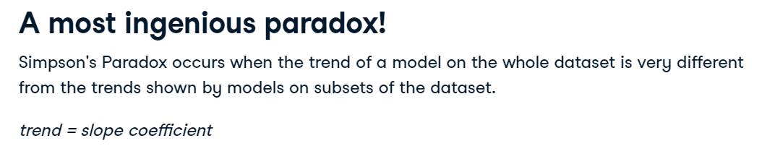

Simpson's paradox occurs when adding or removing a coefficient changes the results of analysis and is important for regressions.

**To avoid problems**

* Articulate a question before you start modeling.
* Allow the question to select the model
* Try to plot the dataset y different ways
* Add more variables to the model and create charts

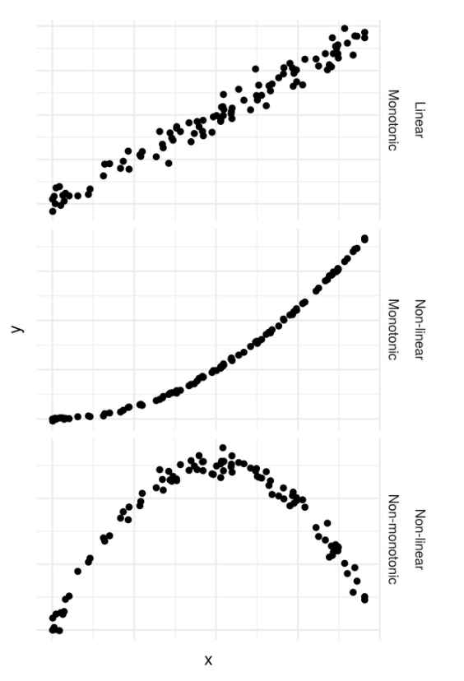

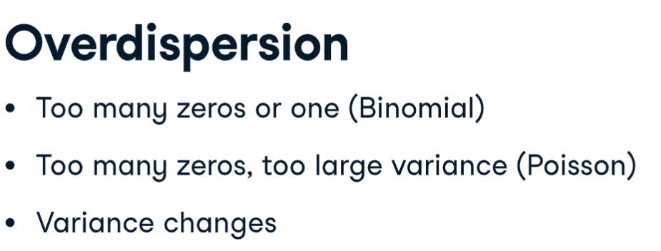

**Example 1**

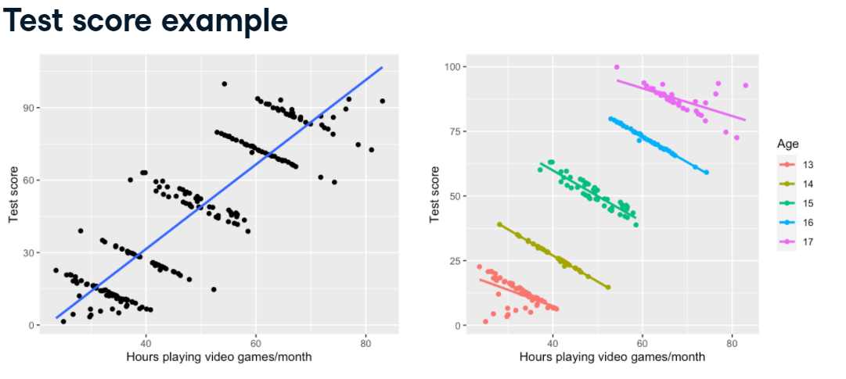

Modeling the whole dataset suggests that playing more video games is related to a higher test score. If we reveal that each group represents the age of the child taking the test, it changes the interpretation. Now older children score more highly in the test, and playing lots of video games is related to a lower score.

**Example 2**

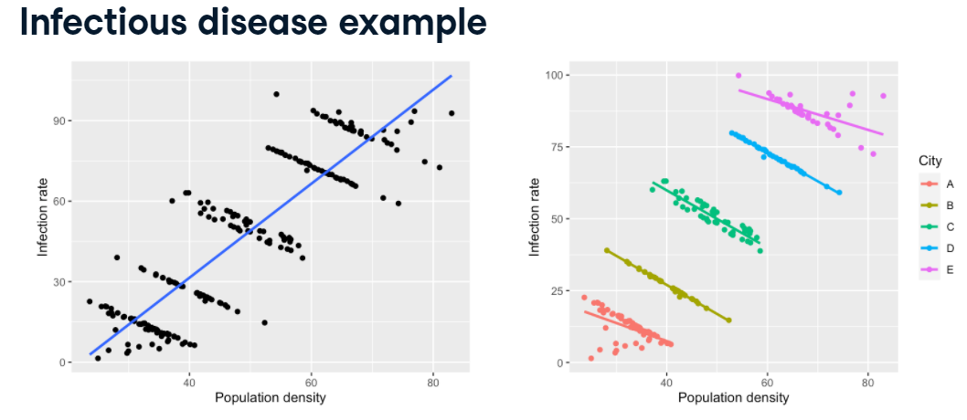

In this plot, each point represents a neighborhood in a city. Splitting by city reveals that the highest density areas of each city have lower infection rates. However, this may be due to other things that you haven't included in the model, like the wealth and demographics of the residents. That's an interesting insight, but "increasing population density is related to increased infection rate" is arguably more important.

**Example 3**

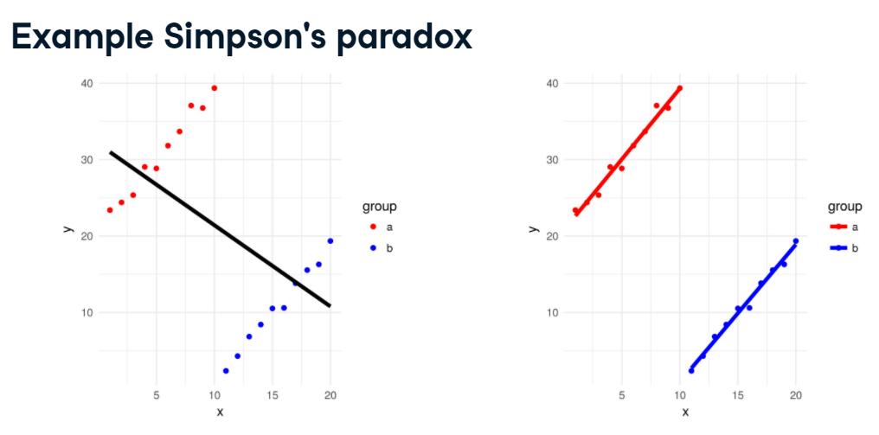

**Example 4**

Simpson's paradox occurs when adding or removing a coefficient changes the results of analysis and is important for regressions. The 1973 Graduate School admission data from UC-Berkeley illustrates this point. At first glace, it appears females are less likely to be admitted to graduate programs. However, including Department as a coefficient causes gender's significance to disappear. As it turns out, prospective female students applied to more competitive programs than males.

# Logistic regression

## Calculate sample size





## Entrenar el modelo largo

|  |  |
| --- | --- |
|  |  |

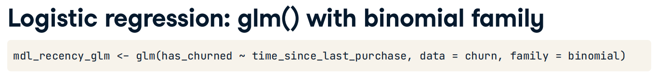

## Entrenar modelo amplio

|  |  |
| --- | --- |
|  |  |

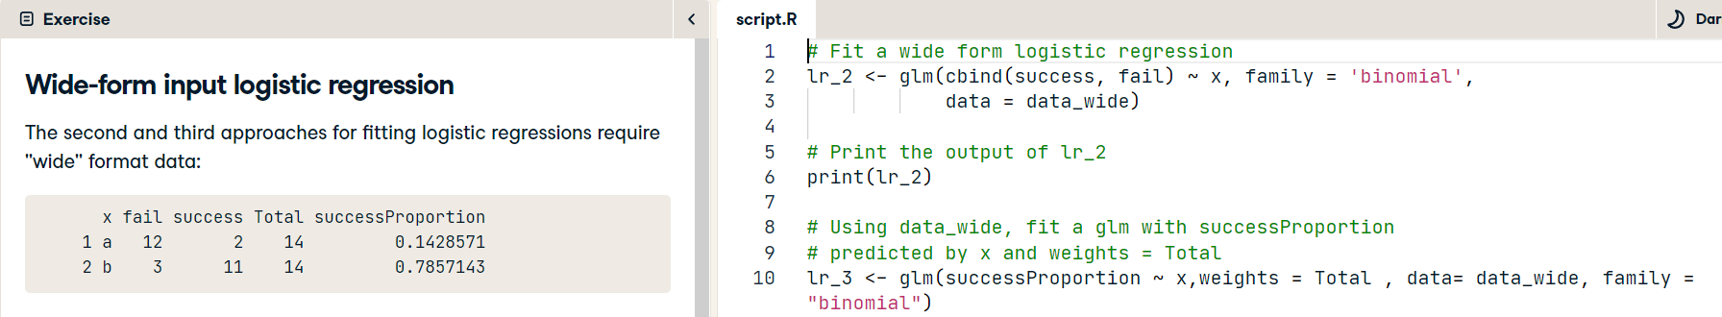



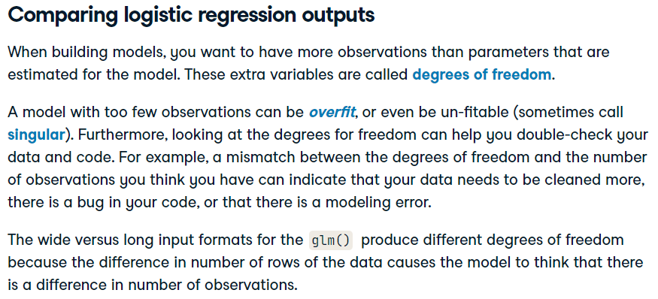



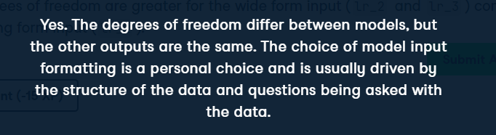

### Probit vs logit regressions

However, the logit has "fatter tails", that is to say the left and right ends of the curve approach their limits a little bit slower than a probit. This can make the **logit** better at modeling outliers or rare events.

A wide (or sometimes fat) tail distribution means the distribution is more dispersed than a skinny distribution. A wide tail corresponds to a distribution predicting more outlier or extreme events than a skinny distribution. This is one reason some people prefer the logit over the probit.

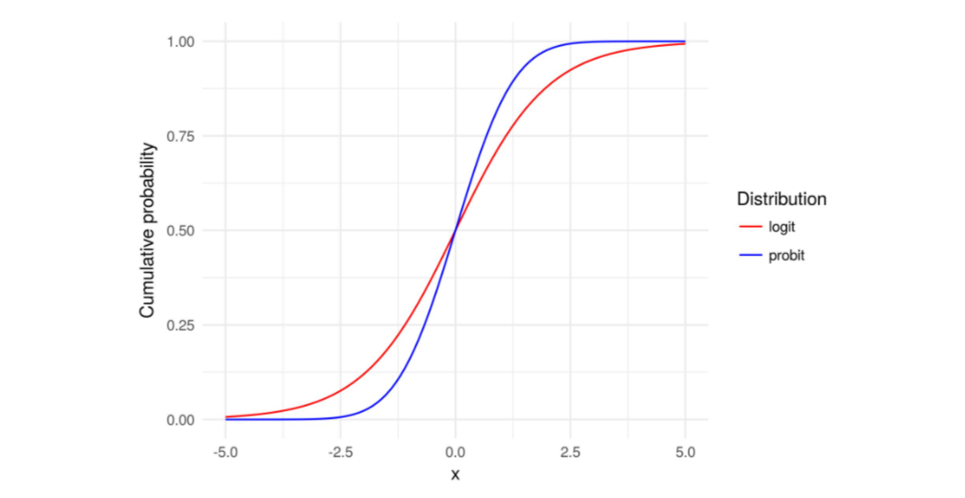

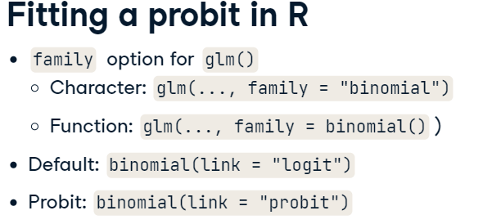

Notice how both models produce the same statistical result, but have different coefficient estimates because both models have different link functions. Usually, probit and logit models produce similar qualitative results. The choice between the two is largely a modeler's choice based upon their preference.

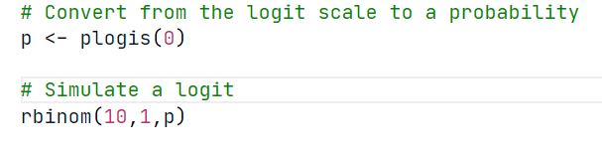

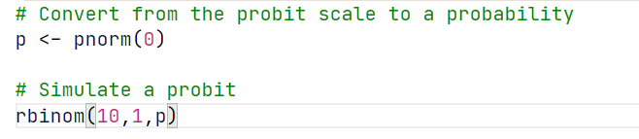

## Extraer partes del modelo

### Base R

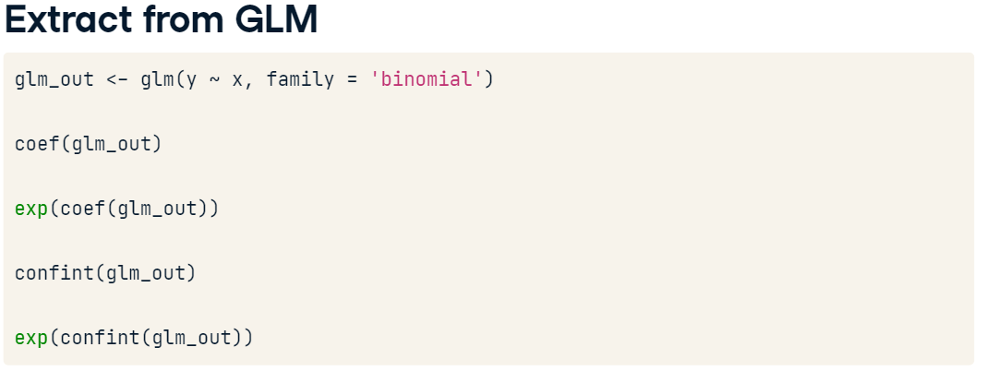

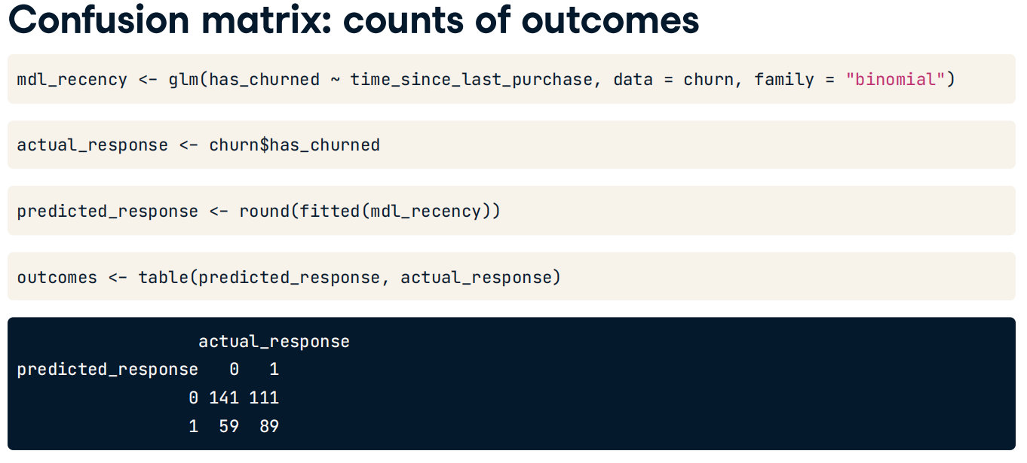

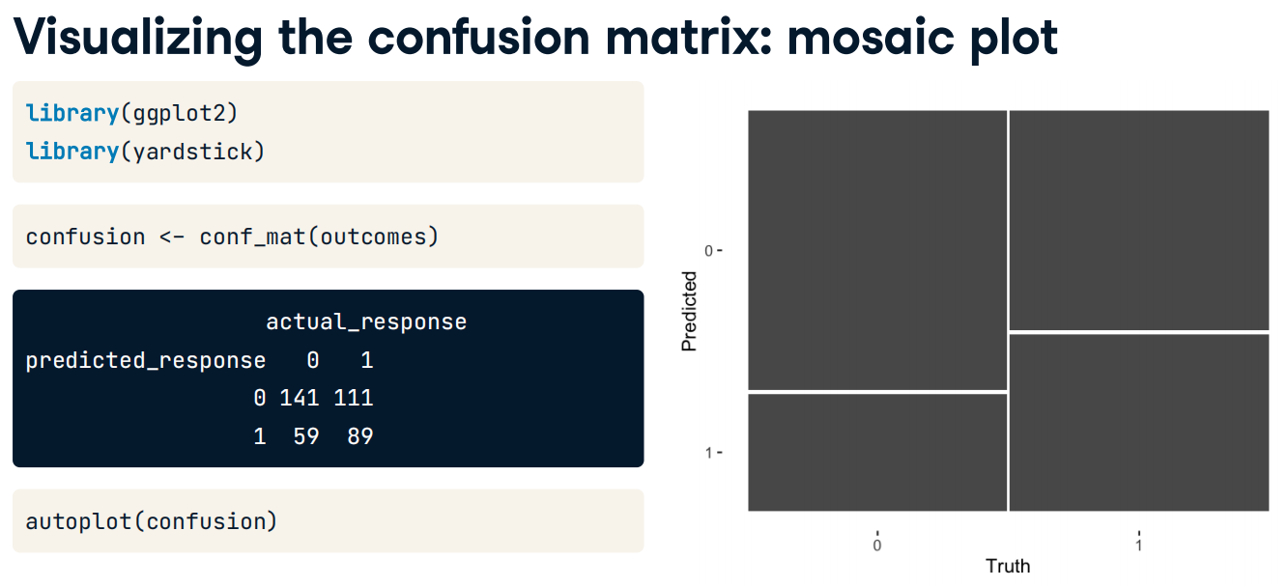

|  |  |
| --- | --- |
|  |  |
|  |  |

### Broom package

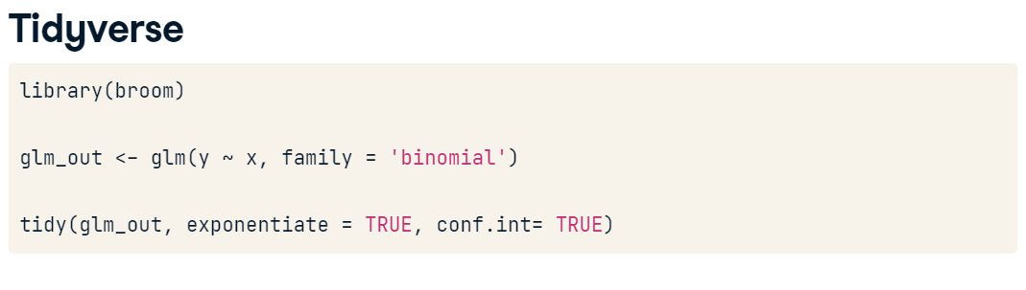

|  |  |
| --- | --- |
|  |  |

## Predecir nuevos datos

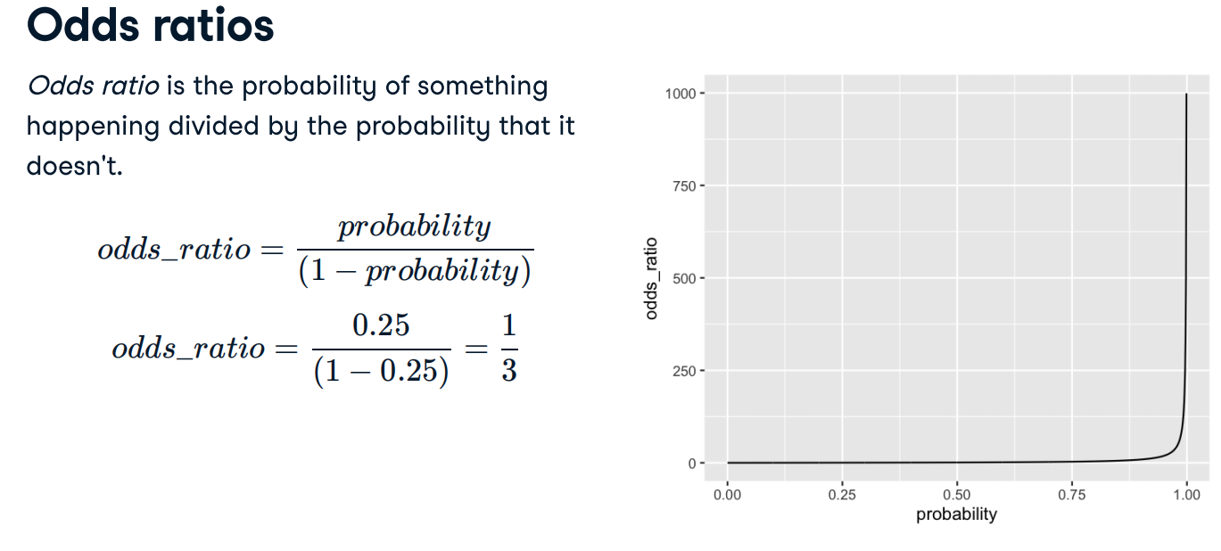

|  |  |
| --- | --- |
|  |  |

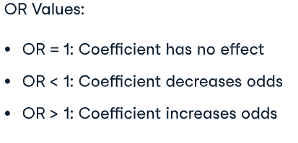

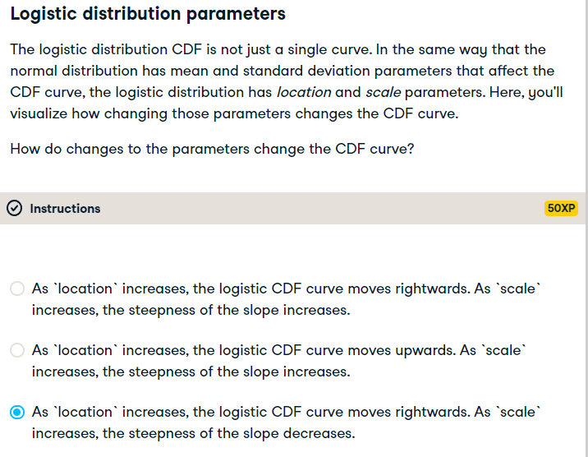

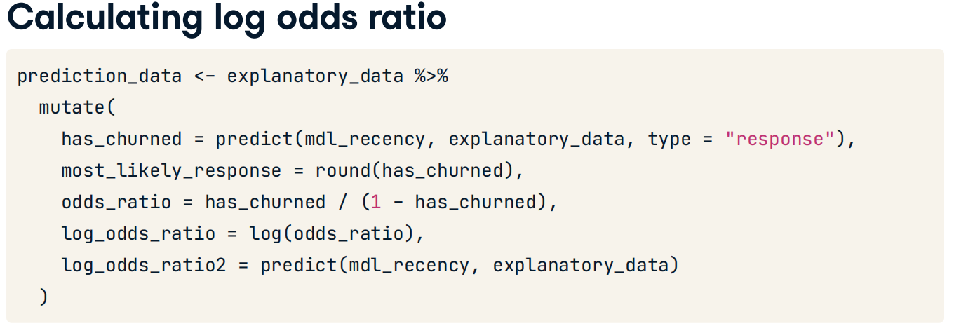

## Graficar los resultados del modelo

|  |  |
| --- | --- |
|  |  |

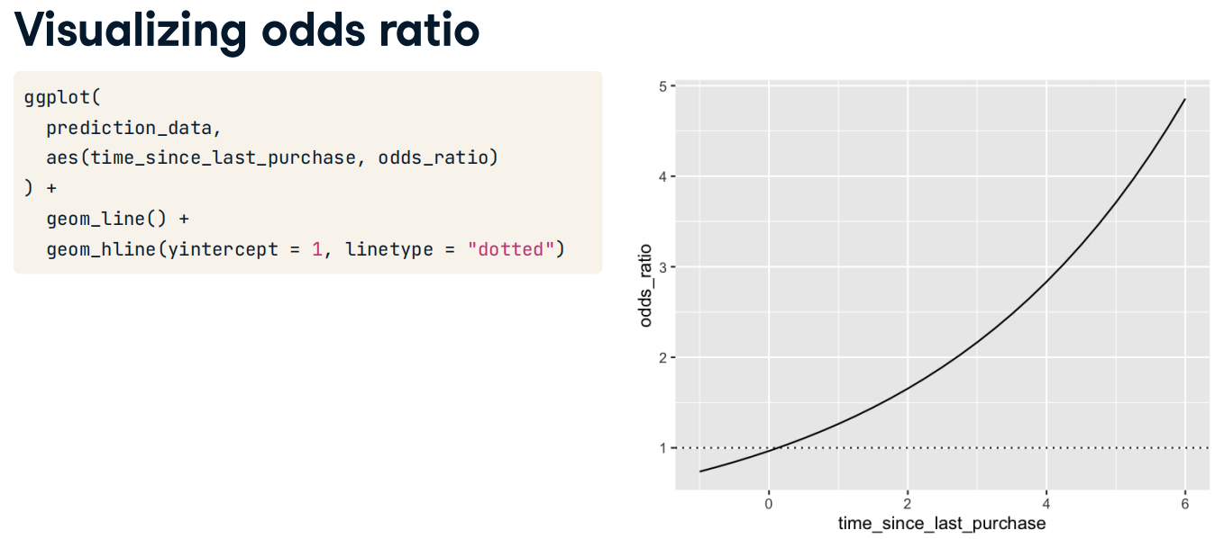

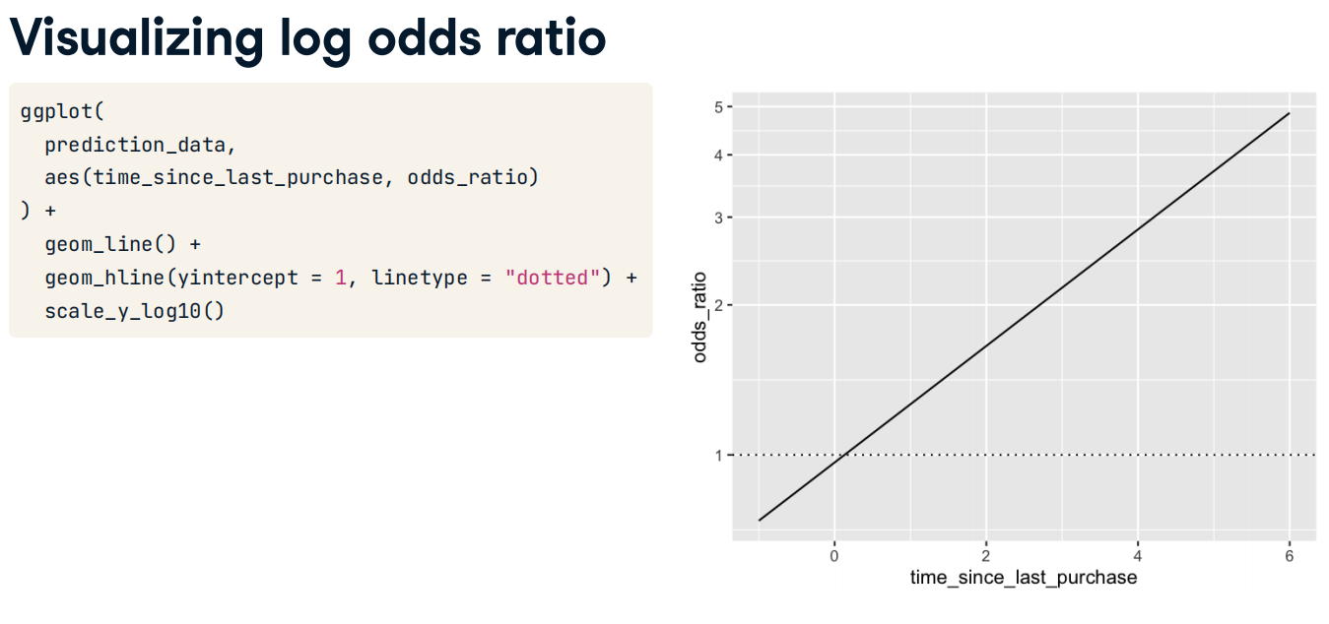

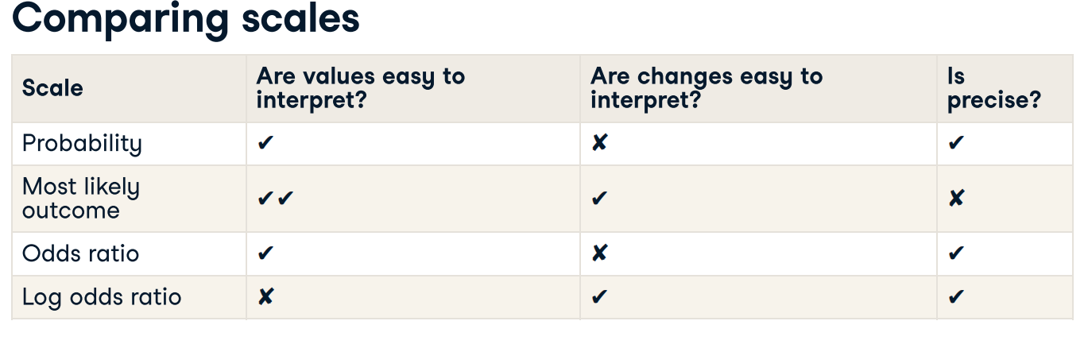

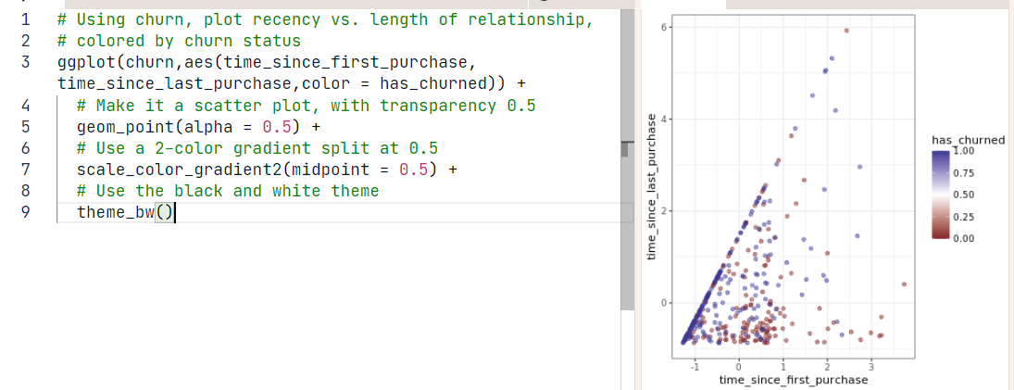

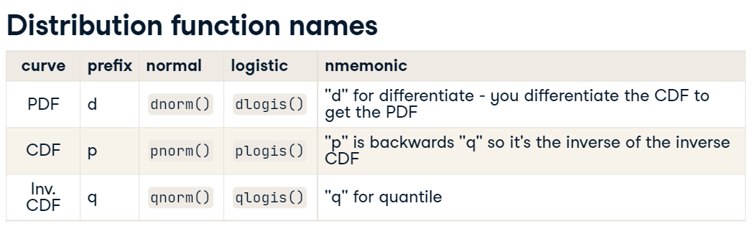

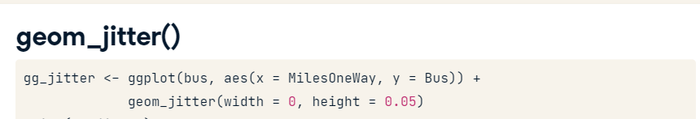

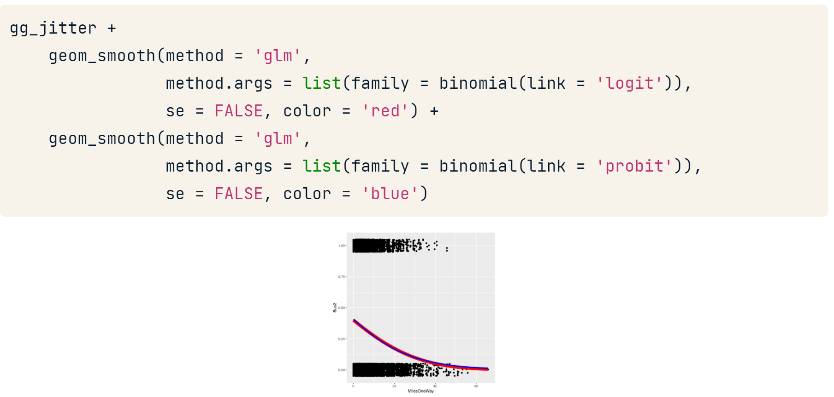

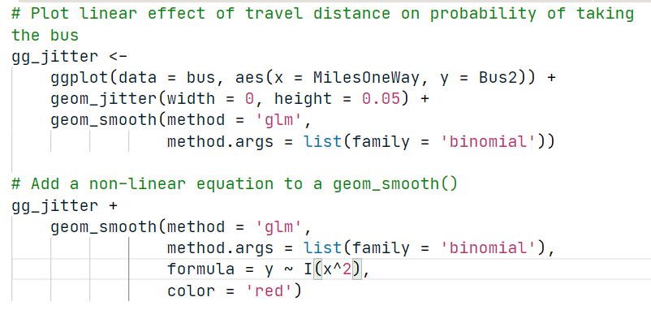

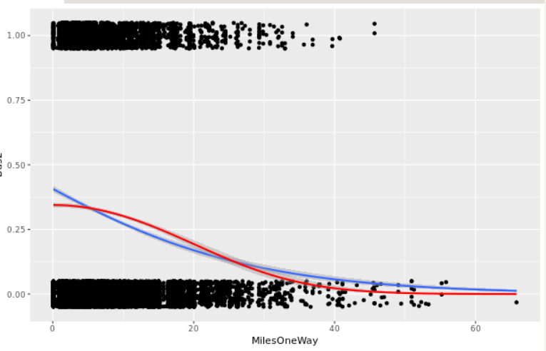

Las dos líneas son similares entre sí. Sin embargo, con la línea no lineal (roja), la probabilidad de viajar se mantiene bastante constante para los viajes diarios <10 millas. Por encima de esta distancia, la probabilidad disminuye. Esto sugiere una tendencia no lineal en los datos y la necesidad de más investigación o conocimiento para su cliente.

# Poisson regression

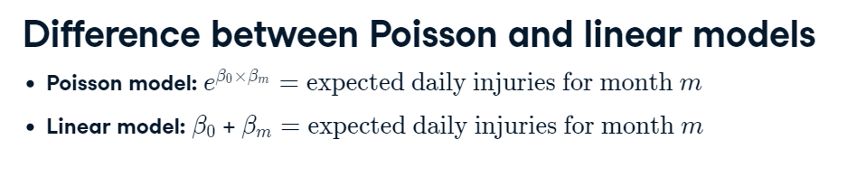



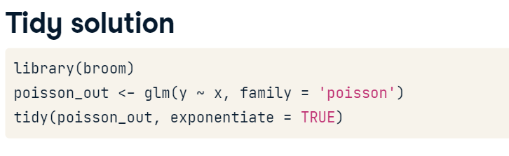

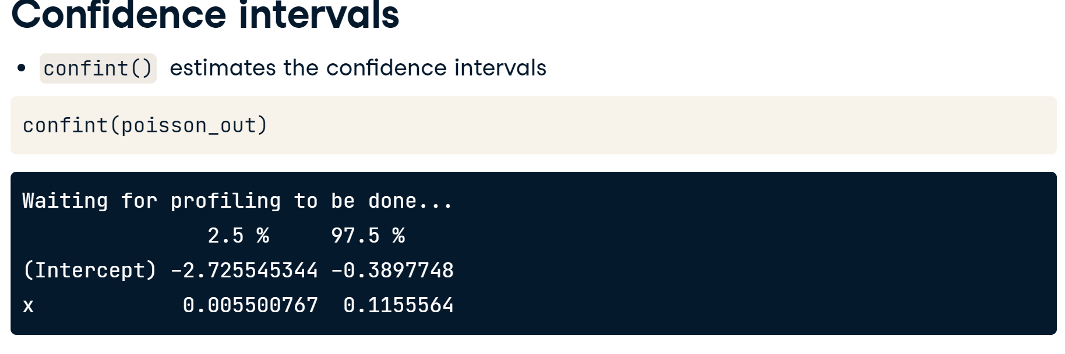



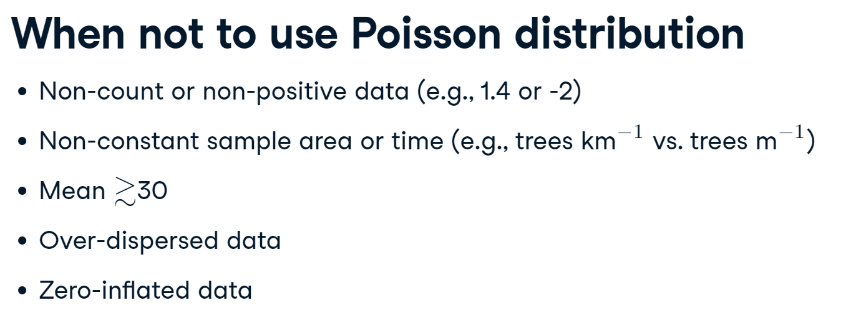

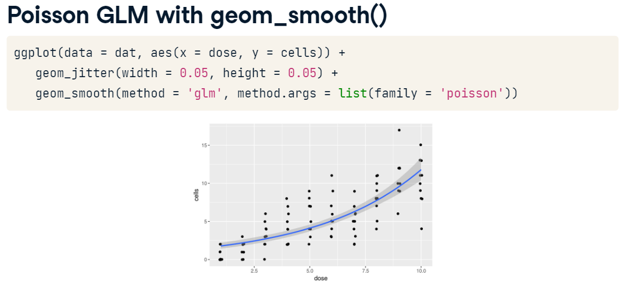

# Optimization in R

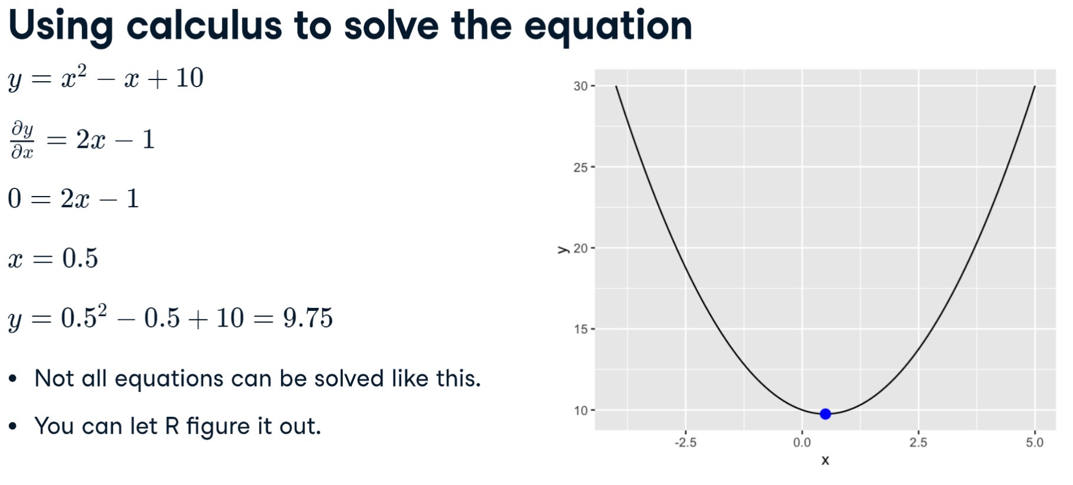

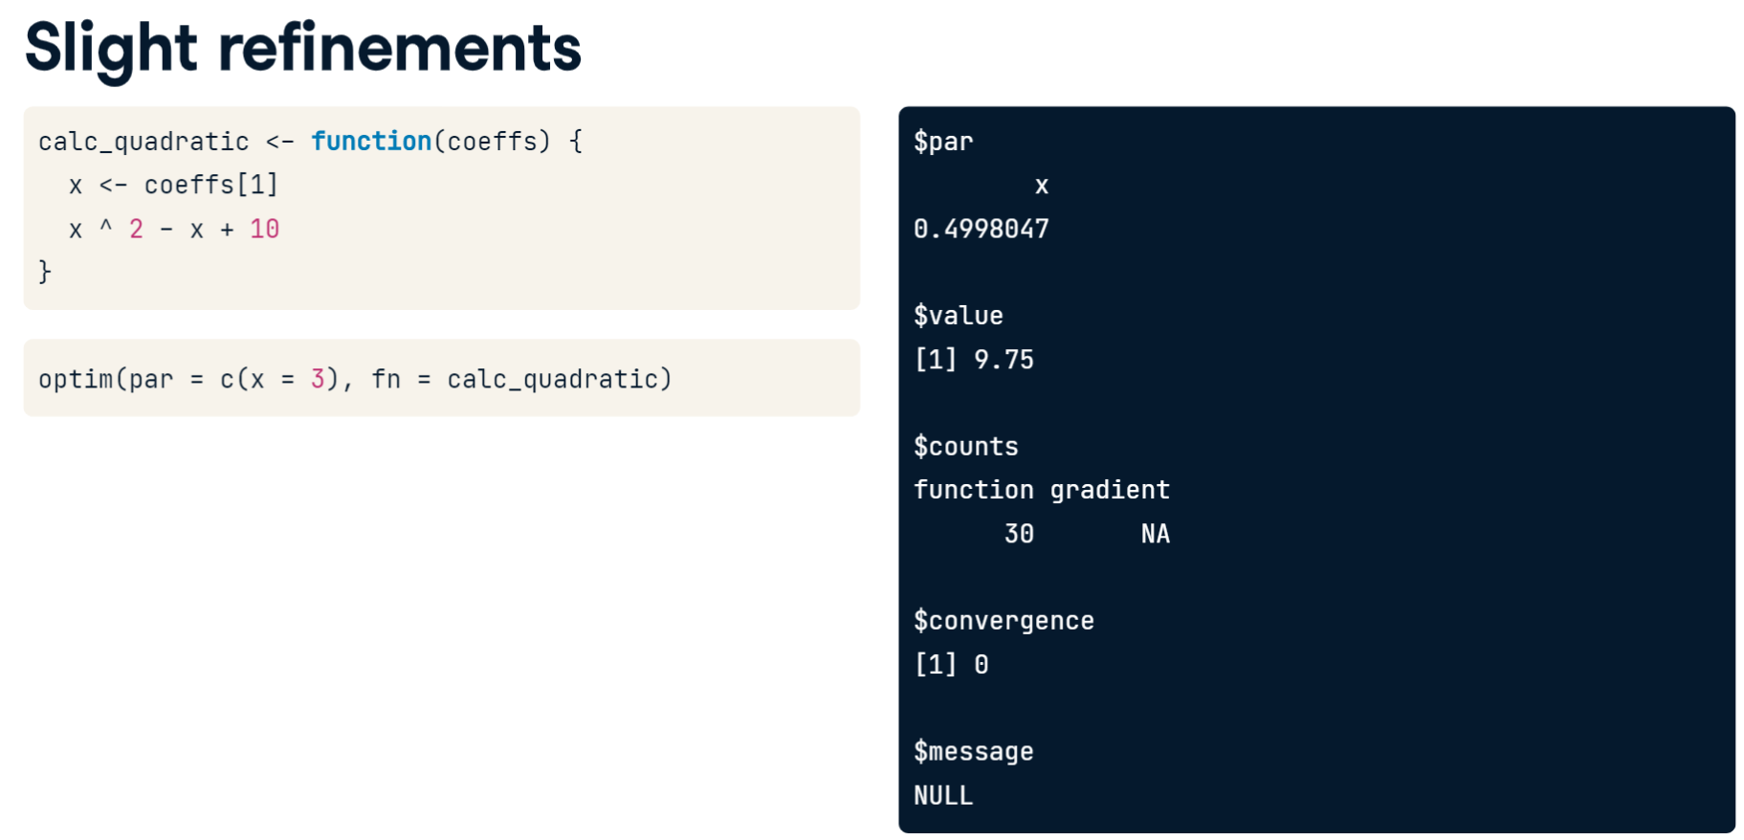

In this regression we optimize the likelihood

